**PROTEUS VSM**

**INTRODUCTION**

**ABOUT PROTEUS VSM**

Traditionally, circuit simulation has been a non-interactive affair. In the early days, netlists were prepared by hand, and output consisted of reams of numbers. If you were lucky, you got a pseudo-graphical output plotted with asterisks to show the voltage and current waveforms.

More recently, schematic capture and on screen graphing have become the norm, but the simulation process is still non-interactive - you draw the circuit, press go, and then study the results in some kind of post processor.This is fine if the circuit you are testing is essentially static in its behaviour e.g. an oscillator which sits there and oscillates nicely at 1Mhz. However,if you are designing a burglar alarm, and want to find out what happens when a would-be burglar keys the wrong PIN into the keypad, the setting up required becomes quite impractical and one must resort to a physical prototype. This is a shame, as working ‘in cyberspace’ has so much to offer in terms of design productivity.

Only in educational circles has an attempt been made to present circuit simulation like real life electronics where it is possible to interact with the circuit whilst it is being simulated.The problem here has been that the animated component models have been hard coded into the program. Only limited numbers of simple devices such as switches, light bulbs, electric motors etc. have been offered, and these are of little use to the professional user.In addition, the quality of circuit simulation has often left much to be desired. For example, one major product of this type has no timing information within its digital models.

PROTEUS VSM brings you the best of both worlds. It combines a superb mixed mode circuit simulator based on the industry standard SPICE3F5 with animated component models. And it provides an architecture in which additional animated models may be created by anyone, including end users. Indeed, many types of animated model can be produced without resort to coding.Consequently PROTEUS VSM allows professional engineers to run interactive simulations of real designs, and to reap the rewards of this approach to circuit simulation.

And then, if that were not enough, we have created a range of simulator models for popular micro-controllers and a set of animated models for related peripheral devices such as LED and LCD displays, keypads, an RS232 terminal and more. Suddenly it is possible to simulate complete micro-controller systems and thus to develop the software for them without access to a physical prototype. In a world where time to market is becoming more and more important this is a real advantage.

It is also worth pointing out that the processing power of the modern PC is truly awesome. A 300MHz Pentium II PC can simulate simple micro-controller designs in real time, or even faster in some cases. And even where things slow down somewhat, the response time is more often that not useable for software development. If you are serious about this game, you can go out and buy a 2GHz dual processor PC, which is far, far faster. This, then, debunks the other obvious objection to interactive simulation - that it would not be fast enough.

**INTRODUCTION**

**ABOUT THE DOCUMENTATION**

This manual is intended to complement the information provided in the context sensitive help.Whereas the manual contains background information and tutorials, the help provides context sensitive information related to specific icons, commands and dialog forms. Pointing with the mouse and pressing F1 can obtain help on most objects in the user interface.

PROTEUS VSM can be used in two rather distinct ways - either for *Interactive Simulation* or for *Graph Based Simulation* and this is reflected in the structure of the manual. Typically, you will use interactive simulation to see if a design works at all, and graph based simulation to investigate why it doesn’t or to take very detailed measurements. However, there are no hard and fast rules. Some elements of the system, such as *Generators* are relevant to both modes of use and are given their own chapters for this reason.

Detailed, step by step tutorials are provided which take you through both types of simulation exercise. We strongly recommend that you work through these as they will demonstrate all the basic techniques required to get going with the software.

 Information on creating VSM models is provided separately in the VSM Software Development Kit (SDK), an on-line resource which is installed as standard with the Professional Version of Proteus.

**INTERACTIVE SIMULATION TUTORIAL**

**Introduction**

The purpose of this tutorial is to show you, through the creation of a simple schematic, how to conduct an interactive simulation using Proteus VSM. While we will concentrate on the use of *Active Components* and the debugging facilities of the ISIS Editor we will also look at the basics of laying out a schematic and general circuit management. Full coverage of these ics can be found in the ISIS Manual.

The circuit we will be using for the simulation is a pair of traffic lights connected to a PIC16F84 micro-controller as shown below.

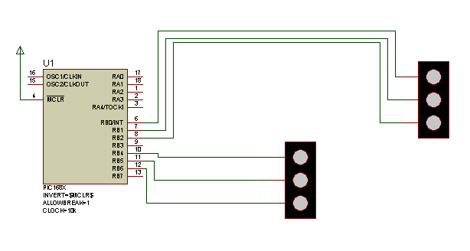

Whilst we will be drawing the schematic from scratch, the completed version can be found as "Samples\Tutorials\Traffic.DSN" within your Proteus installation.Users who are familiar with the general operating procedures in ISIS may choose to use this ready made design and move on to the section on the micro-controller program. . Please note, however, that this design file contains a deliberate error - read on for more information.

If you are unfamiliar with ISIS, the interface and basic usage are discussed at length in A Guided tour of the ISIS Editor and although we will touch on these issues in the following section you should take the time to familiarise yourself with the program before proceeding.

**Drawing the Circuit**

***Placing the Components:***

We will start by placing two sets of traffic lights and a PIC16F84 on a new schematic layout. Start a fresh design, select the Component icons (all the icons have both tool-tip text and context-sensitive help to assist in their use) and then left click on the letter ‘P’ above the *Object Selector* to launch the Library Browser. The Library Browser will now appear over the Editing Window (see Basic Schematic Entry in the ISIS Manual For more information).

Press the 'P' button on the keyboard and type in 'Traffic' in the Key words field and double click on the result to place the traffic lights in to the Object Selector. Do the same for the PIC16F84A.

Once you have selected both TRAFFIC LIGHTS and PIC16F84 into the design close the Library Browser and click left once on the PIC16F84 in the Object Selector

(this should highlight your selection and a preview of the component will appear in the Overview Window at theright of the screen). Now left click on the Editing Window to place the component on the schematic - repeat the process to place two sets of traffic lights on the schematic.

***Movement and Orientation:***

We now have the building blocks on the schematic but the chances are they are not ideally positioned. To move a component, point the mouse over it and right click (this should highlight the component), then depress the left mouse button and drag (you should see the component outline ‘follow’ the mouse pointer) to the desired position. When you have the outline where you want release the left mouse button and the component will move to the specified position. Note that at this point the component is still highlighted - right click on any empty area of the *Editing Window* to restore the component to it’s normal status.

To orient a component, right click over it in the same way as before then click on one of the Rotation icons. This will rotate the component through 90 degrees - repeat as necessary. Again, it is good practice to right click on an empty area of the schematic when you are finished to restore the component to it’s original state.

Set out the schematic in a sensible fashion ( perhaps based on the sample given ), moving and orientating the components as required. If you are having problems we advise you to work through the tutorial in the ISIS manual - ISIS Tutorial

For our purposes , we will ignore the 2D Graphics involved in the road junction and concentrate on creating a simulatable circuit - for those who are interested a full discourse on the Graphics capabilities of ISIS can be foundhere - 2D Graphics

***Zooming and Snapping:***

In order to wire up the schematic it is useful to be able to zoom in to a specific area. Hitting the F6 key or the Zoom In Icon will zoom around the current position of the mouse, or, alternatively, holding down the SHIFT key and dragging a box with the left will zoom in on the contents of the dragged area.To zoom back out again hit the F7 key or the Zoom Out icon, or, should you wish to zoom out until you can see the entire design, hit the F8 key or use the mouse wheel to zoom out or in to the required area. Corresponding commands can be accessed through the View Menu.

ISIS has a very powerful feature called Real Time Snap. When the mouse pointer is positioned near to pin ends or wires, the cursor location will be snapped onto these objects. This allows for easy editing and manipulation of the schematic. This feature can be found in the Tools Menu and is enabled by default.

More information on zooming and snapping can be found in The Editing Window in the ISIS manual.

***Wiring Up:***

The easiest way to wire a circuit is to use the Wire Auto Router option on the Tools Menu. Make sure that this is enabled ( a tick should be visible to the left of the menu option ). For more information see The Wire Auto Router in the ISIS manual. Zoom in to the PIC until all the pins are comfortably visible and then place the mouse pointer over the end of pin 6 (RB0/INT). You should see a small‘x’ cursor on the end of the mouse. This indicates that the mouse is at the correct position to connect a wire to this pin.Left click the mouse to start a wire and then move the mouse to the pin connected to the red light on one of the sets of Traffic Lights. When you get an ‘x’ cursor again over this pin left click to complete the connection. Repeat the process to wire up both sets of Traffic Lights as given on the sample circuit.

There are a couple of points worth mentioning about the wiring up process:

• You can wire up in any mode - ISIS is clever enough to determine what you are doing.

• When enabled, the Wire Autorouter will route around obstacles and generally find a sensible path between connections. This means that, as a general rule, all you need to do is left click at both end points and let ISIS take care of the path between them.

• ISIS will automatically pan the screen is you nudge the edge of the Editing Window while placing a wire. This means that you can zoom in to the most suitable level and, so long as you know the approximate position of the target component, simply nudge the screen over until it is in view. Alternatively, you can zoom in and out while placing wires ( using the F6 and F7 keys ).

Finally, we have to wire pin 4 to a power terminal. Select the Terminal icon and highlight ‘POWER’ in the Object Selector. Now left click on a suitable spot and place the terminal. Select the appropriate orientation and wire the terminal to pin 4 using the same techniques as before.

More useful information on wiring up can be found at the following places in the ISIS manual:

• Wire Placement

• Wire Repeat

• Dragging Wires

 At this point we recommend that you load the completed version of the circuit – this will avoid any confusion arising if the version you have drawn is in any way different from ours! Also, if you have not purchased the PIC Microprocessor Model Library, you must load the pre-prepared sample file in order to proceed.

**Writing the Program**

***Source Listing***

For the purposes of our tutorial, we have prepared the following program which will enable the PIC to control the traffic lights. This program is provided in a file called TL.ASM and can be found in the "Samples\Tutorials" directory.

**LISTp=16F84 ; PIC16F844 is the target processor**

**#include "P16F84.INC" ; Include header file**

**CBLOCK 0x10 ; Temporary storage**

**state**

**l1,l2**

**ENDC**

**org 0 ; Start up vector.**

**gotosetports; Go to start up code.**

**org 4 ; Interrupt vector.**

**halt gotohalt; Sit in endless loop and do nothing.**

**setports clrw; Zero in to W.**

**movwf PORTA ; Ensure PORTA is zero before we enable it.**

**movwf PORTB ; Ensure PORTB is zero before we enable it.**

**bsf STATUS,RP0; Select Bank 1**

**clrw; Mask for all bits as outputs.**

**movwf TRISB ; Set TRISB register.**

**bcf STATUS,RP0; Reselect Bank 0.**

**initialise clrw; Initial state.**

**movwf state ; Set it.**

**loop callgetmask ; Convert state to bitmask.**

**movwf PORTB ; Write it to port.**

**incfstate,W ; Increment state in to W.**

**andlw 0x04; Wrap it around.**

**movwf state ; Put it back in to memory.**

**callwait; Wait :-)**

**gotoloop; And loop :-)**

**; Function to return bitmask for output port for current state.**

**; Thenibble contains the bits for one set of lights and the**

**; lower nibble the bits for the other set. Bit 1 is red, 2 is amber**

**; and bit three is green. Bit four is not used.**

**getmaskmovfstate,W ; Get state in to W.**

**addwf PCL,F ; Add offset in W to PCL to calc. goto.**

**retlw 0x41; state==0 is Green and Red.**

**retlw 0x23; state==1 is Amber and Red/Amber**

**retlw 0x14; state==3 is Red and Green**

**retlw 0x32; state==4 is Red/Amber and Amber.**

**; Function using two loops to achieve a delay.**

**wait movlw 5**

**movwf l1**

**w1 callwait2**

**decfszl1**

**gotow1**

**return**

**wait2clrfl2**

**w2 decfszl2**

**gotow2**

**return**

**END**

 There is, in fact, a deliberate mistake in the above code, but more of that later…

***Attaching the Source File***

The next stage is to attach the program to our design in order that we can successfully simulate its behaviour. We do this through the commands on the *Source Menu*. Go to the *Source Menu* now and select the *Add/Remove Source Files* Command. Click on the *New* button, , browse until you reach the "Samples\Tutorials" directory and select the TL.ASM file. Click open and the file should appear in the *Source Code Filename* drop down listbox.

We now need to select the code generation tool for the file. For our purposes the MPASM tool will suffice. This option should be available from the drop down listbox and so left clicking will select it in the usual fashion. (Note that If you are planning to use a new assembler or compiler for the first time, you will need to register it using the *Define Code Generation Tools* command).

Finally, it is necessary to specify which file the processor is to run. In our example this will be tl.hex ( the hex file produced from MPASM subsequent to assembling tl.asm). To attach thisfile to the processor, right click on the schematic part for the PIC and then left click on the part. This will bring up the *Edit Component* dialogue form which contains a field for *Program File.* If it is not already specified as tl.hex either enter the path to the file manually or browse to the location of the file via the ‘?’ button to the right of the field. Once you have specified the hex file to be run hit ok to exit the dialogue form

We have now attached the source file to the design and specified which *Code Generation Tool* will be used. A more detailed explanation on theSource Code Control Systemis available later in this documentation.

**Debugging the Program**

***Simulating the Circuit***

In order to simulate the circuit point the mouse over the *Play Button* on the animation panel at the bottom right of the screen and click left.The status bar should appear with the time thatthe animation has been active for. You should also notice that one of the traffic lights is green while the other is red and the logic state of the pins can be seen on the schematic. You will notice, however, that the traffic lights are not changing state. This is due to a deliberate bug we have introduced into the code. At this stage it would be appropriate to debug our program and try to isolate the problem.

***Debugging Mode***

In order to ensure that we are thorough in the debugging of the circuit we will s the current simulation. Once you have done that you can start debugging by pressing CTRL+F12. Two popup windows should appear - one holding the current register values and the other holding displaying the source code for the program. Either of these can be activated from the *Debug Menu* along with a host of other informative windows. We also want to activate the *Watch Window* from which we can monitor the appropriate changes in the state variable. A full explanation of this feature is available in the section entitled The Watch Window later in this documentation.

Concentrating for now on the *Source* popup notice the red arrow at the far left. This, together with the highlighted line indicate the current position of the program counter. To set a breakpoint here hit the ENTER key ( the breakpoint will always be set at the highlighted line ). If we wanted to clear the breakpoint we could do so by hitting the ENTER key again but we will leave it set just now.

***Setting a Breakpoint***

Looking at the program it can be seen that it loops back on itself in a repeating cycle. It wouldtherefore be a good idea to set a breakpoint at the beginning of this loop before we start. You can do this by highlighting the line (at address 000E) with the mouse, and then pressing F9. Then press F12 to set the program running. You should now see a message on the *Status Bar*indicating that a digital breakpoint has been reached and the Program Counter (PC) address. This should correspond with the address of the first breakpoint we have set.

A list of the debugging keys are given in the *Debug* *Menu* but for the most part we will be using F11 to single step through the program. Hit the F11 key now and notice that the red arrow at the left has moved down to the next instruction. What we have actually done is executed the ‘clrw’ instruction and then sped. You can verify this by looking at the W register in the *Registers Window* and noticing that it has been cleared to zero.

What we now need to do is determine what we expect to happen on execution of the next instruction and then test to see if it actually does happen. For example, the next instruction should move the contents of the ‘‘w’’ register in to PORT A i.e. Port A should be cleared. Executing this instruction and checking the *Register Window* verifies that this is indeed the case. Continuing in this vein until you reach our second breakpoint you should notice that both ports have been cleared ready for output ( as dictated by the TRISB register) and that the state variable has correctly been set to 0.

As this is a function call we have the option of *Stepping Over* the function (by hitting the F10 key) but for completeness we will step through each instruction. Hitting F11 here will jump us to the first executable line of the getmask function. Stepping forward we see that the move operation was successful and that we ‘land’ in the correct place for adding an offset of zero onto our lookup table. When we return to the main program therefore, we have the mask that we would expect. Single stepping further and writing the mask to the port we can see the correct result on the schematic. Single stepping again to increment the state is also successful as evidenced by the *Register Window* where the value for the W register is incremented by 1.

The single step takes us onto the instruction designed to wrap the state around to zero when it is incremented above 3. This, as can been seen from the *Watch Window* , is not performing as it should. The state should clearly be incremented to state 1 here in order for the mask to be set correctly on the next execution of the loop.

***Finding the Bug***

Closer investigation reveals that the problem is caused by ANDing with 4 instead of with 3. The states we want are 0,1,2, 3 and any of these when ANDed with 4 gives 0. This is why when running the simulation the state of the traffic lights does not change. The solution is simply to change the problem instruction to AND the state with 3 instead of 4. This means that the state will increment to 3 and when the W register is incremented to 4 the state will wrap around to 0. An alternative solution would be to simply test for the case when the ‘W’ register hits 4 and to reset it to zero.

While this short example of the debugging techniques available in Proteus VSM illustrates the basics there is a lot of additional functionality available. It is recommended that you look at the section on Source Level Debugging for a more detailed explanation.

**GRAPH BASED SIMULATION TUTORIAL**

**Introduction**

The purpose of this tutorial is to show you, by use of a simple amplifier circuit, how to perform a graph based simulation using PROTEUS VSM. It takes you, in a step-by-step fashion, through:

• Placing graphs, probes and generators.

• Performing the actual simulation.

• Using graphs to display results and take measurements.

• A survey of the some of the analysis types that are available.

The tutorial does ***not*** cover the use of ISIS in its general sense - that is, procedures for placing components, wiring them up, tagging objects, etc. This is covered to some extent in the *Interactive Simulation Tutorial* and in much greater detail within the ISIS manual itself. If you have not already made yourself familiar with the use of ISIS then you must do so before attempting this tutorial.

We do strongly urge you to work right the way through this tutorial before you attempt to do your own graph based simulations: gaining a grasp of the concepts will make it much easier to absorb the material in the reference chapters and will save much time and frustration in the long term.

**Getting Started**

The circuit we are going to simulate is an audio amplifier based on a 741 op-amp, as shown overleaf.It shows the 741 in an unusual configuration, running from a single 5 volt supply. The feedback resistors, R3 and R4, set the gain of the stage to be about 10. The input bias components, R1, R2 and C1, set a false ground reference at the non-inverting input which is decoupled from the signal input.

As is normally the case, we shall perform a *transient analysis* on the circuit. This form of analysis is the most useful, giving a large amount of information about the circuit. Having completed the description of simulation with transient analysis, the other forms of analysis will be contrasted.

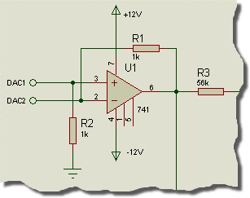

*A Screenshot if a section from the ISISTUT.DSN*

If you want, you can draw the circuit yourself, or you can load a ready made design file from "*Samples\Tutorials\ASIMTUT1.DSN*" within your Proteus installation.Whatever you choose, at this point ensure you have ISIS running and the circuit drawn.

**Generators**

To test the circuit, we need to provide it with a suitable input. We shall use a voltage source with a square wave output for our test signal. A generator object will be used to generate the required signal.

Click on the Generator icon: the Object Selector displays a list of the available generator types. For our simulation, we want a Pulse generator. Select the Pulse type, move the mouse over to the edit window, to the right of the IN terminal, and click left on the wire to place the generator.

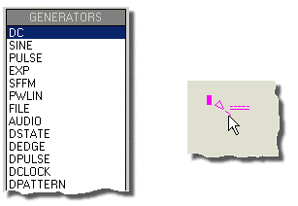

Generator objects are like most other objects in ISIS; the same procedures for previewing and orienting the generator before placement and editing, moving, re-orienting or deleting the object after placement apply (see Generators and Probes in this manual).

As well as being dropped onto an existing wire, as we just did, generators may be placed on the sheet, and wired up in the normal manner. If you drag a generator off a wire, then ISIS assumes you want to detach it, and does not drag the wire along with it, as it would do for components.

Notice how the generator is automatically assigned a reference - the terminal name IN. Whenever a generator is wired up to an object (or placed directly on an existing wire) it is assigned the name of the net to which it is connected. If the net does not have a name, then the name of the nearest component pin is used by default.

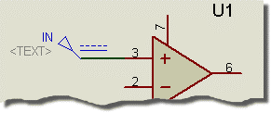

Finally, we must edit the generator to define the pulse shape that we want. To edit the generator, tag it with the right mouse button and then click left on it to access its Edit Generator dialogue form. Select the High Voltage field and set the value to 10mV. Also set the pulse width to 0.5s.

Select the OK button to accept the changes. Generators and Probes gives a complete reference of the properties recognised by all the types of generator. For this circuit only one generator is needed, but there is no limit on the number which may be placed.

**Probes**

Having defined the input to our circuit using a generator, we must now place probes at the points we wish to monitor. We are obviously interested in the output, and the input after it has been biased is also a useful point to probe. If needs be, more probes can always be added at key points and the simulation repeated.

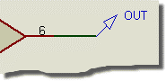

To place a probe, click left on the Voltage Probe icon (ensure you have not selected a current probe by accident - we shall come to these later). Probes can be placed onto wires, or placed and then wired, in the same manner as generators. Move the mouse over to the edit window, to the left of U1 pin 3, and click left to place the probe on the wire joining pin 3 to R1 and R2. Be sure to place the probe on the wire, as it cannot be placed on the pin itself. Notice the name it acquires is the name of the nearest device to which it is connected, with the pin name in brackets. Now place the second probe by clicking left just to the left of the OUT terminal, on the wire between the junction dot and the terminal pin.

Probe objects are like generators and most other objects in ISIS; the same procedures for previewing and orienting the probe before placement, and editing, moving, re-orienting or deleting the probe after placement apply (see the section on Probes for more information). Probes may be edited in order to change their reference labels. The names assigned by default are fine in our case, but a useful tip when tagging probes is to aim for the tip of the probe, not the body or reference label.

Now that we have set up the circuit ready for simulation, we need to place a graph to display the results on.

**Graphs**

Graphs play an important part in simulation: they not only act as a display medium for results but actually define what simulations are carried out. By placing one or more graphs and indicating what sort of data you expect to see on the graph (digital, voltage, impedance, etc.) ISIS knows what type or types of simulations to perform and which parts of a circuit need to be included in the simulation. For a transient analysis we need an *Analogue* type graph. It is termed analogue rather than transient in order to distinguish it from the *Digital* graph type, which is used to display results from a digital analysis, which is really a specialised form of transient analysis. Both can be displayed against the same time axis using a *Mixed* graph.

To place a graph, first select the *Gadgets Mode* icon, and then the *Graph* icon: the *Object Selector* displays a list of the available graph types. Select the *Analogue* type, move the mouse over to the edit window, click (and hold down) the left mouse button, drag out a rectangle of the appropriate size, and then release the mouse button to place the graph.

Graphs behave like most objects in ISIS, though they do have a few subtleties. We will cover the features pertinent to the tutorial as they occur, but the reference chapter on graphs is well worth a read. You can tag a graph in the usual way with the right mouse button, and then (using the left mouse button) drag one of the handles, or the graph as a whole, about to resize and/or reposition the graph.

We now need to add our generator and probes on to the graph. Each generator has a probe associated with it, so there is no need to place probes directly on generators to see the input wave forms. There are three ways of adding probes and generators to graphs:

• The first method is to tag each probe/generator in turn and drag it over the graph and release it - exactly as if we were repositioning the object. ISIS detects that you are trying to place the probe/generator over the graph, restores the probe/generator to its original position, and adds a trace to the graph with the same reference as that of the probe/generator. Traces may be associated with the left or right axes in an analogue graph, and probes/generators will add to the axis nearest the side they were dropped. Regardless of where you drop the probe/generator, the new trace is always added at the bottom of any existing traces.

The second and third method of adding probes/generators to a graph both use the *Add Trace* command on the graph menu; this command always adds probes to the current graph (when there is more than one graph, the current graph is the one currently selected on the *Graph* menu).

• If the Add Trace command is invoked without any tagged probes or generators, then the *Add Transient Trace* dialogue form is displayed, and a probe can be selected from a list of all probes in the design (including probes on other sheets).

• If there are tagged probes/generators, invoking the Add Trace command causes you to be prompted to *Quick Add* the tagged probes to the current graph; selecting the *No* option invokes the *Add Transient Trace* dialogue form as previously described. Selecting the *Yes* option adds all tagged probes/generators to the current graph in alphabetical order.

We will *Quick Add* our probes and the generator to the graph. Either tag the probes and generators individually, or, more quickly, drag a tag box around the entire circuit - the Quick Add feature will ignore all tagged objects other than probes and generators. Select the *Add Trace* option from the *Graph* menu and answer *Yes* to the prompt. The traces will appear on the graph (because there is only one graph, and it was the last used, it is deemed to be the *current* graph). At the moment, the traces consist of a name (on the left of the axis), and an empty data area (the main body of the graph). Ifthe traces do not appear on the graph, then it is probably too small for ISIS to draw them in. Resize the graph, by tagging it and dragging a corner, to make it sufficiently big.

As it happens, our traces (having been placed in alphabetical order) have appeared in a reasonable order. We can however, shuffle the traces about. To do this, ensure the graph is ***not***tagged, and click right over the name of a trace you want to move or edit. The trace is highlighted to show that it is tagged. You can now use the left mouse button to drag the trace up or down or to edit the trace (by clicking left without moving the mouse) and the right button to delete the trace (i.e. remove it from the graph). To untag all traces, click the right mouse button anywhere over the graph, but ***not*** over a trace label (this would tag or delete the trace).

There is one final piece of setting-up to be done before we start the simulation, and this is to set the simulation run time. ISIS will simulate the circuit according to the end time on the x-scale of the graph, and for a new graph, this defaults to one second. For our purposes, we want the input square wave to be of fairly high audio frequency, say about 10kHz. This needs a total period of 100s. Tag the graph and click left on it to bring up its *Edit Transient Graph* dialogue form. This form has fields that allow you to title the graph, specify its simulation start and s times (these correspond to the left and right most values of the x axis),label the left and right axes (these are not displayed on *Digital* graphs) and also specifies general properties for the simulation run. All we need to change is the s time from 1.00 down to 100u (you can literally type in 100u - ISIS will covert this to 100E-6) and select OK.

The design is now ready for simulation. At this point, it is probably worthwhile loading our version of the design ("*Samples\Tutorials\ASIMTUT2.DSN*")to avoid any problems during the actual simulation and subsequent sections. Alternatively, you may wish to continue with the circuit you have entered yourself, and only load the ASIMTUT2.DSN file if problems arise.

**Simulation**

To simulate the circuit, all you need do is invoke the *Simulate* command on the *Graph* menu (or use its keyboard short-cut: the space bar). The *Simulate* command causes the circuit to be simulated and the *current* graph (the one marked on the *Graph* menu) to be updated with the simulation results.

Do this now. The status bar indicates how far the simulation process has reached. When the simulation is complete, the graph is redrawn with the new data. For the current release of ISIS and simulator kernels, the start time of a graph is ignored - simulation always starts at time zero and runs until the s time is reached or until the simulator reaches a quiescent state. You can abort a simulation mid-way through by pressing the ESC key.

A simulation log is maintained for the last simulation performed. You can view this log using the *View Log* command on the *Graph* menu (or the CTRL+'V' keyboard short-cut). The simulation log of an analogue simulation rarely makes for exciting reading, unless warnings or errors were reported, in which case it is where you will find details of exactly what went wrong. In some cases, however, the simulation log provides useful information that is not easily available from the graph traces.

If you invoke the *Simulate* command a second time, you may notice something odd - no simulation occurs. This is because ISIS's partition management is clever enough to work out whether or not the part(s) of a design being probed by a particular graph have changed and thus it only performs a simulation when required. In terms of our simple circuit,nothing has changed, and therefore no simulation takes place. If for some reason you want to always re-simulate a graph, you can check the *Always Simulate* check box on the graphs *Edit Transient Analysis* dialogue form. If you are in doubt as to what was actually simulated, you can check the *Log Netlist* check box on the same dialogue form; this causes the simulator netlist to be included in the simulation log.

So the first simulation is complete. Looking at the traces on the graph, its hard to see any detail. To check that the circuit is working as expected, we need to take some measurements...

**Taking Measurements**

A graph sitting on the schematic, alongside a circuit, is referred to as being *minimised*. To take timing measurements we must first *maximise* the graph. To do this, first ensure the graph is ***not*** tagged, and then click the left mouse button on the graph's title bar; the graph is redrawn in its own window . Along theof the display, the menu bar is maintained. Below this, on the left side of the screen is an area in which the trace labels are displayed and to right of this are the traces themselves. At the bottom of the display, on the left is a toolbar, and to the right of this is a status area that displays cursor time/state information. As this is a new graph, and we have not yet taken any measurements, there are no cursors visible on the graph, and the status bar simply displays a title message.

The traces are colour coded, to match their respective labels. The OUT and U1(POS IP) traces are clustered at theof the display, whilst the IN trace lies along the bottom. To see the traces in more detail, we need to separate the IN trace from the other two. This can be achieved by using the left mouse button to drag the trace *label* to the right-hand side of the screen. This causes the right y-axis to appear, which is scaled separately from the left. The IN trace now seems much larger, but this is because ISIS has chosen a finer scaling for the right axis than the left. To clarify the graph, it is perhaps best to remove the IN trace altogether, as the U1(POS IP) is just as useful.Click right on the IN label twice to delete it. The graph now reverts to a single, left hand side, y-axis.

We shall measure two quantities:

• The voltage gain of the circuit.

• The approximate fall time of the output.

These measurements are taken using the *Cursors*.

Each graph has two cursors, referred to as the *Reference* and *Primary* cursors. The reference cursor is displayed in red, and the primary in green. A cursor is always 'locked' to a trace, the trace a cursor is locked to being indicated by a small 'X' which 'rides' the waveform. A small mark on both the x- and y-axes will follow the position of the 'X' as it moves in order to facilitate accurate reading of the axes. If moved using the keyboard, a cursor will move to the next small division in the x-axis.

Let us start by placing the *Reference* cursor. The same keys/actions are used to access both the *Reference* and *Primary* cursors. Which is actually affected is selected by use of the CTRL key on the keyboard; the *Reference* cursor, as it is the least used of the two, is always accessed with the CTRL key (on the keyboard) pressed down. To place a cursor, all you need to do is point at the trace data (***not*** the trace label - this is used for another purpose) you want to lock the cursor to, and click left. If the CTRL key is down, you will place (or move) the *Reference* cursor; if the CTRL key is not down, then you will place (or move) the *Primary* cursor. Whilst the mouse button (and the bkey for the *Reference* cursor) is held down, you can drag the cursor about. So, hold down (and keep down) the CTRL key, move the mouse pointer to the right hand side of the graph, above both traces, and press the left mouse button. The red *Reference* cursor appears. Drag the cursor (still with the CTRL key down) to about 70u or 80u on the x-axis. The title on the status bar is removed, and will now display the cursor time (in red, at the left) and the cursor voltage along with the name of the trace in question (at the right). It is the OUT trace that we want.

You can move a cursor in the X direction using the left and right cursor keys, and you can lock a cursor to the previous or next trace using the up and down cursor keys. The LEFT and RIGHT keys move the cursor to the left or right limits of the x-axis respectively. With the control key still down, try pressing the left and right arrow keys on the keyboard to move the *Reference* cursor alongsmall divisions on the time axis.

Now place the *Primary* cursor on the OUT trace between 20u and 30u. The procedure is exactly the same as for the *Reference* cursor, above, except that you do not need to hold the CTRL key down. The time and the voltage (in green) for the primary cursor are now added to the status bar.

Also displayed are the differences in both time and voltage between the positions of the two cursors. The voltage difference should be a fraction above 100mV. The input pulse was 10mV high, so the amplifier has a voltage gain of 10. Note that the value is positive because the *Primary* cursor is above the *Reference* cursor - in delta read-outs the value is *Primary* minus *Reference*.

We can also measure the fall time using the relative time value by positioning the cursors either side of the falling edge of the output pulse.This may be done either by dragging with the mouse, or by using the cursor keys (don't forget the CTRL key for the *Reference* cursor). The *Primary* cursor should be just to the right of the curve, as it straightens out, and the *Reference* cursor should be at the corner at the start of the falling edge. You should find that the falling edge is a little under 10s.

**Using Current Probes**

Now that we have finished with our measurements, we can return to the circuit - just close the graph window in the usual way, or for speed you can press ESC on the keyboard. We shall now use a current probe to examine the current flow around the feedback path, by measuring the current into R4.

Current probes are used in a similar manner to voltage probes, but with one important difference. A current probe needs to have a *direction* associated with it. Current probes work by effectively breaking a wire, and inserting themselves in the gap, so they need to know which way round to go. This is done simply by the way they are placed. In the default orientation (leaning to the right) a current probe measures current flow in a *horizontal* wire from left to right. To measure current flow in a vertical wire, the probe needs to be rotated through 90 or 270. Placing a probe at the wrong angle is an error, that will be reported when the simulation is executed. If in doubt, look at the arrow in the symbol. This points in the direction of current flow.

Select a current probe by clicking on the Current Probe icon. Click left on the clockwise *Rotation* icon such that the arrow points downwards. Then place the probe on the vertical wire between the right hand side of R4 and U1 pin 6. Add the probe to the right hand side of the graph by tagging and dragging onto the right hand side of the minimised graph. The right side is a good choice for current probes because they are normally on a scale several orders of magnitude different than the voltage probes, so a separate axis is needed to display them in detail. At the moment no trace is drawn for the current probe. Press the space bar to re-simulate the graph, and the trace appears.

Even from the minimised graph, we can see that the current in the feedback loop follows closely the wave form at the output, as you would expect for an op-amp. The current changes between 10A and 0 at the high and low parts of the trace respectively. If you wish, the graph may be maximised to examine the trace more closely.

**Frequency Analysis**

As well as transient analysis, there are several other analysis types available in analogue circuit simulation. They are all used in much the same way, with graphs, probes and generators, but they are all different variations on this theme. The next type of analysis that we shall consider is *Frequency* analysis. In frequency analysis, the x-axis becomes frequency (on a logarithmic scale), and both magnitude and phase of probed points may be displayed on the y-axes.

To perform a frequency analysis a *Frequency* graph is required. Click left on the *Graph* icon, to re-display the list of graph types in the object selector, and click on the *Frequency* graph type. Then place a graph on the schematic as before, dragging a box with the left mouse button. There is no need to remove the existing transient graph, but you may wish to do so in order to create some more space (click right twice to delete a graph).

Now to add the probes. We shall add both the voltage probes, OUT and U1(POS IP). In a frequency graph, the two y-axes (left and right) have special meanings. The left y-axis is used to display the *magnitude* of the probed signal, and the right y-axis the *phase*. In order to see both, we must add the probes to both sides of the graph. Tag and drag the OUT probe onto the left of the graph, then drag it onto the right. Each trace has a separate colour as normal, but they both have the same name. Now tag and drag the U1(POS IP) probe onto the left side of the graph only.

Magnitude and phase values must both be specified with respect to some reference quantity. In ISIS this is done by specifying a *Reference Generator*. A reference generator always has an output of 0dB (1 volt) at 0°. Any existing generator may be specified as the reference generator. All the other generators are in the circuit are ignored in a frequency analysis. To specify the IN generator as the reference in our circuit, simply tag and drag it onto the graph, as if you were adding it as a probe. ISIS assumes that, because it is a generator, you are adding it as the reference generator, and prints a message on status line confirming this. Make sure you have done this, or the simulation will not work correctly.

There is no need to edit the graph properties, as the frequency range chosen by default is fine for our purposes. However, if you do so (by pointing at the graph and pressing CTRL-E), you will see that the *Edit Frequency Graph* dialogue form is slightly different from the transient case. There is no need to label the axes, as their purpose is fixed, and there is a check box which enables the display of magnitude plots in dB or normal units. This option is best left set to dB, as the absolute values displayed otherwise will not be the actual values present in the circuit.

Now press the space bar (with the mouse over the frequency graph) to start the simulation. When it has finished, click left on the graph title bar to maximise it. Considering first the OUT magnitude trace, we can see the pass-band gain is just over 20dB (as expected), and the useable frequency range is about 50Hz to 20kHz. The cursors work in exactly the same manner as before - you may like to use the cursors to verify the above statement. The OUT phase trace shows the expected phase distortion at the extremes of the response, dropping to -90° just off the right of the graph, at the unity gain frequency. The high-pass filter effect of the input bias circuitry can be clearly seen if the U1(POS IP) magnitude trace is examined. Notice that the x-axis scale is logarithmic, and to read values from the axis it is best to use the cursors.

**Swept Variable Analysis**

It is possible with ISIS to see how the circuit is affected by changing some of the circuit parameters. There are two analysis types that enable you to do this - the *DC Sweep* and the *AC Sweep*. A *DC Sweep* graph displays a series of operating point values against the swept variable, while an *AC Sweep* graph displays a series of single point frequency analysis values, in magnitude and phase form like the *Frequency* graph.

As these forms of analysis are similar, we shall consider just one - a *DC Sweep*. The input bias resistors, R1 and R2, are affected by the small current that flows into U1. To see how altering the value of both of these resistors affects the bias point, a *DC Sweep* is used.

To begin with place a *DC Sweep* graph on an unused space on the schematic. Then tag the U1(POS IP) probe and drag it onto the left of the graph. We need to set the sweep value, and this is done by editing the graph (point at it and press CTRL-E). The *Edit DC Sweep Graph* dialogue form includes fields to set the swept variable name, its start and ending values, and the number of steps taken in the sweep. We want to sweep the resistor values across a range of say 100k to 5M, so set the *Start* field to 100k and the S field to 5M. Click on *OK* to accept the changes.

Of course, the resistors R1 and R2 need to be altered to make them swept, rather than the fixed values they already are. To do this, click right and then left on R1 to edit it, and alter the *Value* field from 470k to X. Note that the swept variable in the graph dialogue form was left at X as well. Click on OK, and repeat the editing on R2 to set its value to X.

Now you can simulate the graph by pointing at it and pressing the space-bar. Then, by maximising the graph, you can see that the bias level reduces as the resistance of the bias chain increases. By 5M it is significantly altered. Of course, altering these resistors will also have an effect on the frequency response. We could have done an *AC Sweep* analysis at say 50Hz in order to see the effect on low frequencies.

**Noise Analysis**

The final form of analysis available is *Noise* analysis. In this form of analysis the simulator will consider the amount of thermal noise that each component will generate. All these noise contributions are then summed (having been squared) at each probed point in the circuit. The results are plotted against the noise bandwidth.

There are some important peculiarities to noise analysis:

• The simulation time is directly proportional to the number of voltage probes (and generators) in the circuit, since each one will be considered.

• Current probes have no meaning in noise analysis, and are ignored.

• A great deal of information is presented in the simulation log file.

• PROSPICE computes both input and output noise. To do the former, an input reference must be defined - this is done by dragging a generator onto the graph, as with a frequency reference. The input noise plot then shows the equivalent noise at the input for each output point probed.

To perform a noise analysis on our circuit, we must first restore R1 and R2 back to 470k. Do this now. Then select a *Noise* graph type, and place a new graph on an unused area of the schematic. It is really only output noise we are interested in, so tag the OUT voltage probe and drag it onto the graph. As before, the default values for the simulation are fine for our needs, but you need to set the input reference to the input generator IN. The *Edit Noise Graph* dialogue form has the check box for displaying the results in dBs. If you use this option, then be aware that 0dB is considered to be 1 volt r.m.s. Click on *Cancel* to close the dialogue form.

Simulate the graph as before. When the graph is maximised, you can see that the values that result from this form of analysis are typically extremely small (pV in our case) as you might expect from a noise analysis of this type. But how do you track down sources of noise in your circuit? The answer lies in the simulation log. View the simulation log now, by pressing CTRL+V. Use the down arrow icon to move down past the operating point printout, and you should see a line of text that starts

Total Noise Contributions at ...

This lists the individual noise contributions (across the entire frequency range) of each circuit element that produces noise. Most of the elements are in fact inside the op-amp, and are prefixed with U1_.If you select the *Log Spectral Contributions* option on the *Edit Noise Graph* dialogue form, then you will get even more log data, showing the contribution of each component at each spot frequency.

**INTERACTIVE SIMULATION**

**BASIC SKILLS**

**The Animation Control Panel**



Interactive simulations are controlled from a simple VCR like panel that behaves just like a normal remote control. This control is situated at the bottom right of the screen. If it is not visible you need to select the *Circuit Animation* option from the *Graph* menu. There are four buttons that you use to control the flow of the circuits.

• The PLAY button is used to start the simulator.

• The STEP button allows you to step through the animation at a defined rate. If the button is pressed and released then the simulation advances by one time step; if the button is held down then the animation advances continuously until the button is released. The single step time increment may be adjusted from the *Animated Circuit Configuration* dialog box. The step time capability is useful for monitoring the circuits more closely and seeing in slow motion what is affecting what.

• The PAUSE button suspends the animation which can then be resumed either by clicking the PAUSE button again, or single stepped by pressing the STEP button. The simulator will also enter the paused state if an breakpoint is encountered.

The simulation can also be paused by pressing the PAUSE key on the computer keyboard.

• The S button tells PROSPICE to s doing a real time simulation. All animation is sped and the simulator is unloaded from memory. All the indicators are reset to their inactive states but the actuators (switches etc.) retain their existing settings.

The simulation can also be sped by pressing SHIFT-BREAK on the computer keyboard.

You can configure the single step time increment when using the STEP button (that is, the amount of time advanced for every press of the button) via the Animated Circuit Configuration dialog box. The step time capability is useful for monitoring the circuits more closely and seeing in slow motion what is affecting what.

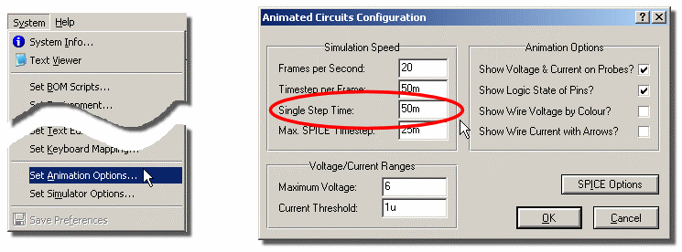

*Configuring the Step time for Animation.*

** Note that the single step button on the animation control panel is used for incremental system advances but not for single stepping through code where specific granularity is required - debugging code is discussed in detail here.

During an animation, the current simulation time and average CPU loading are displayed on the status bar. If there is insufficient CPU power to run the simulation in real time, the display will read 100% and the simulation time will cease to advance in real time. Aside from this, no harm results from simulating very fast circuits as the system automatically regulates the amount of simulation performed per animation frame.

**Indicators and Actuators**

Aside from ordinary electronic components, interactive simulations generally make use of special *Active Components*. These components have a number of graphical states and come in two flavours: *Indicators* and *Actuators.* Indicators display a graphical state which changes according to some measured parameter in the circuit, whilst Actuators allow their state to be determined by the user and then modify some characteristic of the circuit.

Actuators are designated by the presence of small red marker symbols which can be clicked with the mouse to operate the control. If you have a mouse with a wheel, you can also operate actuators by pointing at them and rolling the wheel in the appropriate direction.

**Setting Up an Interactive Simulation**

Most of the skills required to set up and run an interactive simulation centre around drawing a circuit in ISIS. This subject is best grasped by working through the tutorial in the ISIS manual. However, the process may be summarized as follows:

• Pick the components you want to use from the device libraries by selecting the component icon and then using the ‘P’ button on the Device Selector. You can use any component with a simulation model and these parts are indicated at theright of the schematic preview before the device is sele

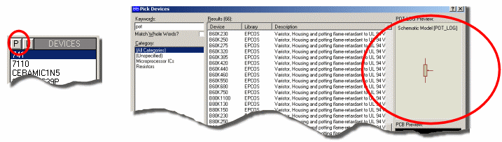

*Selecting parts with simulation models via the Library Browser.*

• Left Click to enter placement mode, move the mouse to the point you want to deposit the component and click left again to commit.

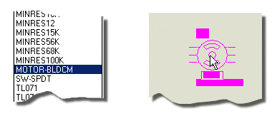

*Placing components in ISIS.*

• Edit them - double click on the object or right click and select Edit Properties from the resulting context menu - in order to assign appropriate values and properties.

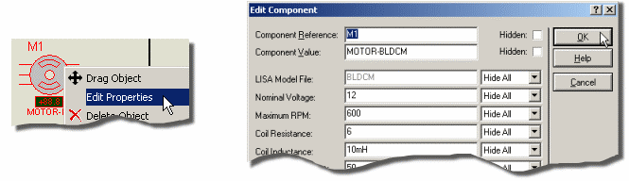

*Editing the components properties in ISIS prior to simulation.*

• Micro-processor source code can be brought under the control of *PROTEUS VSM* using the commands on the Source menu or imported via an object file from your favourite compiler. Don’t forget also to assign the object code (COF, ELF,HEX etc.) to the micro-processor component on the schematic. More information on supported formats and how to 'program the microcontroller can be found here.

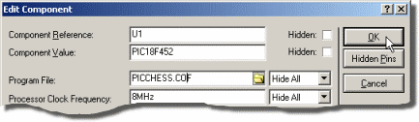

*Attaching the source code to the microcontroller prior to simulation.*

• Wire the circuit up by clicking on the pins.

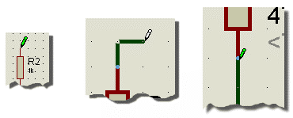

*Wiring up the schematic.*

• Delete components by right clicking on the component and selecting Delete from the resulting context menu.

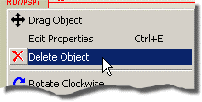

*Deleting unwanted components via the context menu.*

• Move components by clicking left to select and then dragging with the left button.

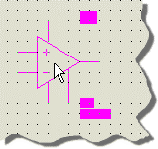

*Positioning parts in ISIS.*

Click the PAUSE button on the Animation Control Panel to kick the simulation. This will initialise/boot the simulation but zero simulation time will have elapsed at this point.



The Animation Control Panel when the simulation is paused at time 0.

Where you have used virtual instruments, or microprocessor models, popup windows related to this components may be displayed using the commands on the Debug menu. These can be configured as desired at this stage (prior to advancing simulation time).

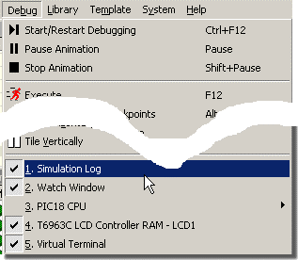

*Launching the Simulation Advisor from the Debug Menu.*

Press the PLAY button to run the simulation.

**INTERACTIVE SIMULATION**

**TAKING MEASUREMENTS**

**Overview**

There are several different ways of taking measurements during an interactive simulation. These include

• Animation Effects.

• Point and shoot operating parameter information.

• Voltage and Current Probes

• Virtual instruments.

**Animation Effects**

As well as any active components in the circuit, a number of other animation effects may be enabled to help you study the circuit operation. These options may be enabled using the *Set Animation Options* command on the *System* menu. The settings are saved with the design.

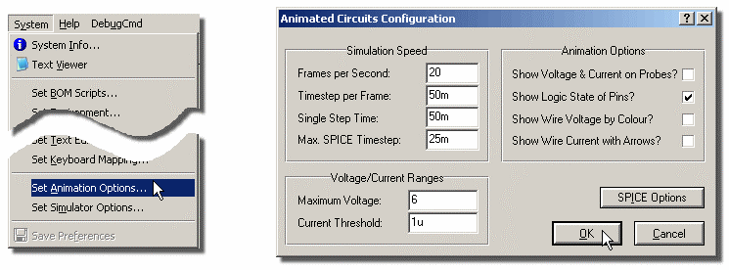

*Configuring Animation Options in Proteus.*

***Pin Logic States***

This option displays a coloured square by each pin that is connected to a digital or mixed net.By default, the square is blue for logic 0, red for logic 1 and grey for floating. The colours may be changed via the *Set Design Defaults* command on the *Template* menu as shown below:

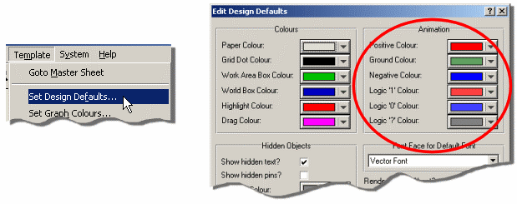

*Configuring Logic State Colours in Proteus.*

Enablingthis option incurs a modest extra burden on the simulator, but can be very, very useful when used in condition with breakpoints and single stepping as it enables you to study the state of a micro-controllers output port pins as the code is single stepped.

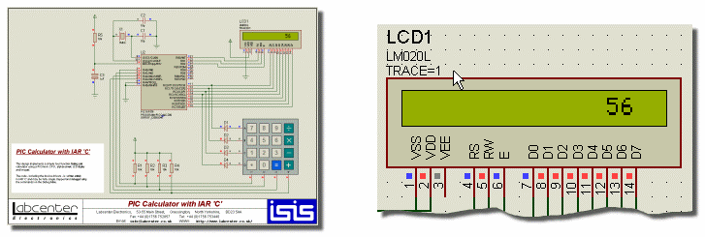

*Logic States on Pins in Proteus.*

***Show Wire Voltage as Colour***

This option causes any wire that is part of an analogue for mixed net to be displayed in a colour that represents its voltage. By default, the spectrum ranges from blue at -6V through green at 0V to red at +6V. The voltages may be changed on the *Set Animation Options* dialogue, and the colours via the *Set Design Defaults* command on the *Template* menu.

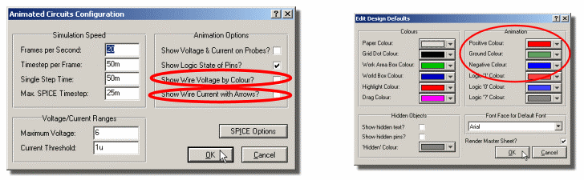

*Configuring Wire Voltage thresholds and colours in Proteus.*

Enabling this option incurs a modest extra burden on the simulator but is very effective for helping novices understand a circuits operation, especially when used in conjunction with the *Show Wire Current as Arrows* option.

***Show Wire Current as Arrows***

This option causes an arrow to be drawn on any wire that carrying current. The direction of the arrow reflects conventional current flow, and it is displayed if the magnitude of the current exceeds a threshold. The default threshold is 1uA, although this can be changed on the *Set Animation Options* dialogue.

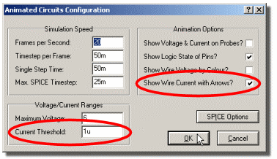

Specifying Current thresholds and animation in Proteus.

Computing the wire currents involves the insertion of a zero value voltage source in every wire segment in the schematic (apart from inside models) and this can create a large number of extra nodes. Consequently the burden on the simulator can be significant.However, the arrows are most useful in teaching basic electricity and electronics where the circuits tend to be fairly simple.

**Point and Shoot Parameter Information**

You can interrogate any of the components in the schematic to obtain information about their current status whenever the simulation is paused.At the least this will be a summary of their node voltages and/or pin logic states but some components will display additional data such as relative (pin-pin) voltages and power dissipation.

**To display parameter values:**

**1.** Ensure that the simulation is paused using the *Animation Control Panel*.

**2.** Select the Multimeter icon in ISIS.

**3.** Click left on any component to view its parameters.

***DC Operating Point***

If you view parameter information at time zero, then you are viewing the DC operating point of the circuit. Otherwise, the parameters displayed represent instantaneous values as at the time you paused the simulation. This is particularly significant for power dissipation values; these numbers are not averaged in any way whatsoever and represent a simple multiplication of instantaneous voltage multiplied by instantaneous current.

***Analogue or Digital?***

Where a component pin is on a net which carries only digital logic states (i.e. there are no analogue components connected to it), Proteus VSM will display the terminal voltage as a logic state. Otherwise an analogue node voltage is displayed.

**Voltage and Current Probes**

The voltage and current probe objects within ISIS are most commonly used in graph based simulations where the voltages and currents being measured can be plotted out on a graph. However, you can also use them during interactive simulation to display node voltages or currents which update in real time.

Theprobe objects have two advantages over the virtual ammeters and voltmeters:

• They can be added and removed to any point in the circuit without drawing wires.

• They take up much less room on the schematic.

• They can be used to trigger a Hardware Breakpoint.

Voltage probes dropped onto nets which carry only digital signals (i.e. to which no analogue components are connected) will display logic states rather than node voltages.

**To place voltage or current probes**

**1.** Select the Voltage Probe or Current Probe within ISIS as appropriate.

**2.** Click left on the wire that you wish to measure to add the probe.

Note that current probes are directional, and measure conventional current as indicated by their arrow symbol.The arrow must be parallel to the wire segment on which the probe is placed.

**Virtual Instruments**

A selection of virtual instruments can be displayed by clicking the Multimeter icon in ISIS. The Object Selector list of instrument types which you can select and place just like ordinary components within ISIS. Further information about how to use each instrument is given in the section on Virtual Instruments.

**INTERACTIVE SIMULATION**

**ANIMATION TIMESTEP CONTROL**

**Overview**

Two parameters control how an interactive simulation evolves in real time. The *Animation Frame Rate* determines the number of times that the screen is refreshed per second, whilst the *Animation* *Timestep* determines by how much simulation is progressed during each frame. For real time operation, the timestep should be set to the reciprocal of the frame rate.

**Frames Per Second**

Normally, it is unnecessary to adjust the frame rate as the default value of 20 frames per second gives smooth animation without overburdening the (considerable) graphics performance of a modern PC. It is, however, occasionally useful to slow it right down when debugging the operation of animated compute models.

**Timestep Per Frame**

The *Animation Timestep* can be used to make fast circuits run slowly, or slow circuits run quickly. For real time operation, the timestep should be set to the reciprocal of the frame rate.

Of course, the entered timestep will always be a desired value. Achieving it is dependent on there being sufficient CPU power to compute the necessary simulation events within the time allocated to each frame. The CPU load figure displayed during animation represents the ratio of these two times. If insufficient CPU power is available, the CPU load will be 100%, and the *achieved* timestep per frame will drop off.

**Single Step Time**

The remaining timestep control parameter is the *Single Step Time*. This is the time by which the simulation will advance when the single step button on the Animation Control Panelis pressed.

**INTERACTIVE SIMULATION**

**HINTS AND TIPS**

**Circuit Timescale**

Interactive simulations will be generally be viewed in real time, so it is no use drawing circuits with 1MHz clocks, or 10kHz sine wave inputs unless you also adjust the *Timestep per Frame* value in the *Animated Circuits Configuration* dialog box.

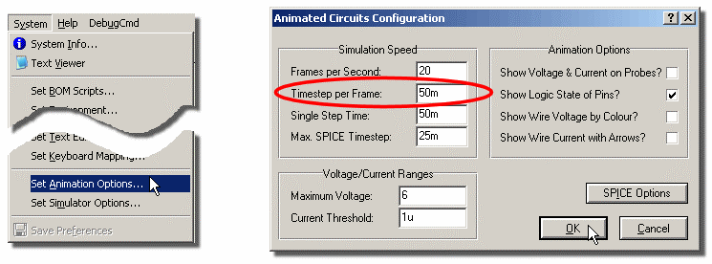

*Adjusting Timestep per Frame in the Animated Circuits Configuration Dialogue.*

If you do attempt to simulate something that operates very quickly, there are several things to bear in mind:

• Given finite CPU power, only a certain amount of simulation time can be computed in a fixed amount of real time. PROTEUS VSM is designed to maintain its animation frame rate (frames per second) whatever, and to cut short any frames which are not completed in the available time. The consequence of this is that very fast circuits will simulate slowly (relative to real time) but smoothly.

• Analogue component models simulate very much more slowly than digital ones. On a fast PC you can simulate digital circuitry operating up to several MHz in real time but analogue circuit electronics will manage only about 10-20kHz.

Consequently it is very silly to attempt to simulate clock oscillators for digital circuitry in the analogue domain. Instead, use a *Digital Clock* generate and set its *Isolate Before* checkbox so that the analogue clock is not simulated.

**Voltage Scaling**

If you intend to use coloured wires to indicate node voltages you need to give some thought as to the range of voltages that will occur in your circuit.The default range for displayed voltages is +/-6V so if the circuit operates at significantly different voltages from this you may need to change the *Maximum Voltage* value in the *Animated Circuits Configuration* dialog box.

**Earthing**

PROSPICE will attempt to define a sensible earth point for any active circuit which does not specifically include a ground terminal. In practice this is usually chosen as the mid-point of the battery, or the centre tap if the circuit has a split supply. It follows that the positive terminal of the battery will sit above ground and the negative terminal below it, corresponding to red and blue wire colours. However, if this behaviour is not what is required, you always have the option of explicitly defining the ground reference point using a ground terminal in ISIS.

**High Impedance Points**

The automatic earthing logic also checks for any device terminals which are not connected to ground, and will insert high value resistors automatically in order to ensure convergence of the SPICE simulation. This means that ill formed circuits (e.g. circuits with unconnected, or partially connected) components will generally simulate - although there can sometimes be strange results.

**VIRTUAL INSTRUMENTS**

**VOLTMETERS & AMMETERS**

A number of interactive voltmeter and ammeter models are provided in the ACTIVE device library.These operate in real time and can be wired into the circuit just like any other component. Once the simulation is started they display the voltage across their terminals or the current flowing through them in an easy to read digital format.

The supplied models cover FSDs of 100, 100m and 100u with a resolution of 3 significant figures and a maximum number of two decimal places. Thus the VOLTMETER object can display values from 0.01V up to 99.9V, whilst the AMMETER-MILLI can display from 0.01mA to 100mA and so on.

The voltmeter models support an internal load resistance property which defaults to 100M but can be changed by editing the component in the usual way. Leaving the value blank disables the load resistance element of the model. The AC voltmeters and ammeters display true RMS values integrated over a user definable time constant.

**VIRTUAL INSTRUMENTS**

**OSCILLOSCOPE**

**Overview**

The VSM Oscilloscope is supplied as standard with all versions of ProSPICE and models a basic dual beam analogue unit and is specified as follows:

Dual channel or X-Y operation.

Channel gain from 20V/div to 2mV/div

Timebase from 200ms/div to 0.5us/div

Automatic voltage level triggering locked to either channel.

AC or DC coupled inputs.

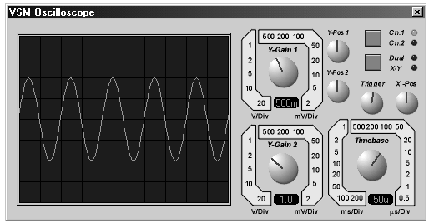

**Using the Oscilloscope**

**To display analogue waveforms:**

**1.** Pick the OSCILLOSCOPE object from the ACTIVE component library, place one on the schematic and wire its inputs to the signals you want to record.

**2.** Start an interactive simulation by pressing the play button on the *Animation Control Panel*.The oscilloscope window should appear.

**3.** If displaying two signals, select *Dual* mode.

**4.** Set the *timebase* dial to a suitable value for the circuit. You will need to think about the waveform frequencies present in your circuit, and convert these to cycle times by taking their reciprocal.

**5.** If displaying signals with a DC offset, select AC mode on either or both input channels as appropriate.

**6.** Adjust the *Y-gain* and *Y-pos* dials so that the waveforms are of a suitable size and position. If a waveform consists of a small AC signal onof a large DC voltage you may need to connect a capacitor between the test point and the oscilloscope, as the *Y-pos* controls can compensate for only a certain amount of DC.

**7.** Decide which channel you want to trigger off, and ensure that the *Ch1* or *Ch2* led is lit, as appropriate.

**8.** Rotate the *trigger* dial until the display locks to the required part of the input waveform. It will lock to rising slopes if the dial points up, and falling slopes if it points down.

 See Rotary Dialsfor details of how to adjust the rotary controls featured in the oscilloscope.

***Modes of Operation***

The oscillscope can operate in 3 modes, indicated as follows:

• Single Beam - neither *Dual* nor *X-Y* leds are litIn this mode, the *Ch1* and *Ch2* leds indicate which channel is being displayed.

• Dual Beam - the *Dual* led is lit. In this mode, the *Ch1* and *Ch2* leds indicate which channel is being used for triggering.

• X-Y mode - the *X-Y* led is lit.

The current mode may be cycled through these options by clicking the button next to the *Dual* and *X-Y* mode leds.

***Triggering***

The VSM oscilloscope provides an automatic triggering mechanism which enables it synchronize the timebase to the incoming waveform.

• Which input channel is used for triggering is indicated by the *Ch1* and *Ch2* leds.

• The *trigger* dial rotates continuously round 360 degrees and sets the voltage level and slope at which triggering occurs.When the mark is pointing upwards, the scope triggers on rising voltages; when the mark points downwards it triggers on a falling slope.

• If no triggering occurs for more than 1 timebase period, the timebase will free run.

***Input Coupling***

Each input channel can either be directly coupled (DC coupling) or coupled through a simulated capacitance (AC coupling). The latter mode is useful for displaying signals which carry a small AC signal onof a much larger DC bias voltage.

The inputs may also be temporarily grounded which can be useful when aligning them to the graticule prior to taking measurements.

**VIRTUAL INSTRUMENTS**

**LOGIC ANALYSER**

**Overview**

The VSM Logic Analyser is supplied as standard with both ProSPICE Professional and ProSPICE Lite.

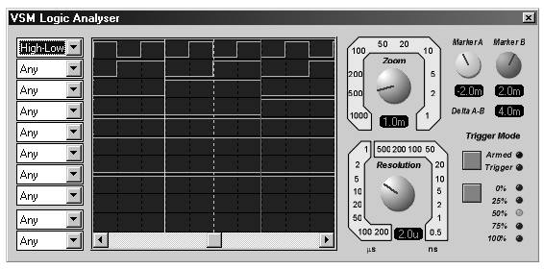

A logic analyser operates by continuously recording incoming digital data into a large *capture buffer*. This is a sampling process, so there is an adjustable *resolution*which defines the shortest pulse that can be recorded. A *triggering* *section* monitors the incoming data and causes the data capture process to s a certain time after the triggering condition has arisen.; capturing is startedby *arming* the instrument. The result is that the contents of the capture buffer both before and after the trigger time can be displayed. Since the capture buffer is very large (10000 samples, in this case) a means of zooming and panning the display is provided.Finally, movable *measurement markers* allow accurate timing measurements of pulse widths and so forth.

The VSM Logic Analyser models a basic 24 channel unit specified as follows:

• 8 x 1 bit traces and 2 x 8 bit bus traces.

• 10000 x 24 bit capture buffer.

• Capture resolution from 200us per sample to 0.5ns per sample with corresponding capture times from 2s to 5ms.

• Display zoom range from 1000 samples per division in to 1 sample per division.

• Triggering on ANDed combination of input states and/or edges, and bus values.

• Trigger positions at 0, 25, 50, 75 and 100% of the capture buffer.

• Two cursors provided for taking accurate timing measurements.

**Using the Logic Analyser**

**To capture and display digital data:**

**1.** Pick the LOGIC ANALYSER object from the ACTIVE component library, place one on the schematic and wire its inputs to the signals you want to record.

**2.** Start an interactive simulation by pressing the play button on the *Animation Control Panel*.The logic analyser popup window should appear.

**3.** Set the *resolution* dial to a value suitable for your application. This represents the smallest width of pulse that can be recorded. The finer the resolution, the shorter will be the time during which data is captured.

**4.** Set the combo-boxes on the left of the instrument to define the required *trigger condition.*For example, if you want to trigger the instrument when the signal connected to channel 1 is high and the signal connected to channel 3 is a rising edge, you would set the first combo-box to "High" and the third combo-boxto "Low-High".

**5.** Decide whether you want to view data mainly before or after the trigger condition occurs, and click the button next to the *percentage* leds to selected the required trigger position.

**6.** When you are ready, click the button to the left of the *armed* led to arm the instrument.

The *armed* led will light and the *trigger*led will be extinguished. The logic analyser will now capture incoming data continuously whilst monitoring the inputs for the trigger condition. When this occurs, the *trigger* led will light. Data capture will then continue until the part of the capture buffer after the trigger position is full, at which point the *armed* led will extinguish and the captured data will appear in the display.

***Panning and Zooming***

Since the capture buffer holds 10000 samples, and the display is only 250 pixels wide, a means is needed to pan and zoom within the capture buffer. The *Zoom* dial determines the number of samples per division, whilst the scroll-bar attached to the display itself allows you to pan left and right.

Note that he readout located beneath the *Zoom* dial displays the current time per division in seconds, not the actual setting of the dial itself. The division time is calculated by multiplying the zoom setting by the resolution.

***Taking Measurements***

Two adjustable markers are provided which can be used for taking accurate time measurements. Each marker can be positioned using the correspondingly coloured dial. The readout below each dial displays the time point occupied by the marker relative to the trigger time, whilst the *Delta A-B* readout displays the time difference between the markers.

 See Rotary Dials for details of how to adjust the rotary controls featured in the logic analyser.

**VIRTUAL INSTRUMENTS**

**AUDIO SIGNAL GENERATOR**

**Overview**

The VSM Signal Generator is supplied as standard with both ProSPICE Professional and ProSPICE Lite.

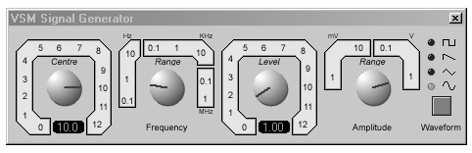

The VSM signal generator models a simple audio functional generator with the following features:

• Square, saw-tooth, triangle and sine output waveforms.

• Output frequency range from 0-12MHz in 8 ranges

• Output amplitude from 0-12V in 4 ranges.

• Amplitude and frequency modulation inputs.

**Using the Signal Generator**

**To set up a simple audio signal source**

**1.** Pick the SIGNAL GENERATOR object from the ACTIVE component library, place one on the schematic and wire its outputs into the rest of the circuit. In most circumstances (i.e. unless the circuit you are driving requires a balance input source), you will want to ground the -ve terminal of the generator. You most easily achieve this using a ground terminal.

The amplitude and frequency modulation inputs can be left unconnected unless you are using these features.

**3.** Start an interactive simulation by pressing the play button on the *Animation Control Panel*.The signal generator popup window should appear.

**3.** Set the *frequency range*dial to a value suitable for your application. The range values indicate the frequency that is generated when the *center* vernier control is set at 1.

**4.** Set the *amplitude range* dial to a value suitable for your application. The range values indicate the amplitude that is generated when the *level* vernier control is set at 1. The amplitude values represent peak output levels.

**5.** Push the *waveform* button until the LED next to the appropriate waveform icon is lit.

***Using the AM & FM Modulation Inputs***

The signal generator model supports both amplitude and frequency modulation of the output waveform. Both the amplitude and frequency inputs have the following features:

• The gain of the modulation input in terms of Hz/V or V/V is set by the *Frequency Range* and *Amplitude Range* controls respectively.

• The modulation input voltages are clamped at +/- 12V.

• The modulation inputs have infinite input impedance.

• The voltage at the modulation input is added to the setting of the appropriate vernier control before being multiplied by the range setting to determine the instantaneous output frequency of amplitude.

For example, if the frequency range is set at 1KHz, and the frequency vernier is set at 2.0, then a frequency modulation level of 2V will give an output frequency of 4kHz.

**VIRTUAL INSTRUMENTS**

**DIGITAL PATTERN GENERATOR**

**Overview**

The VSM Pattern Generator is the digital equivalent of the analogue Signal Generator and is provided as standard with all professional versions of the Proteus simulation software.

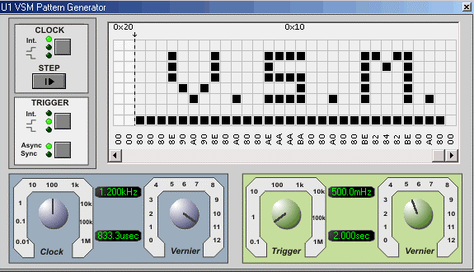

The VSM Pattern Generator allows for an 8-bit pattern of up to 1K bytes and supports the following main features:

• Will run in either graph based or interactive mode.

• Internal and External Clocking and Trigger modes.

• Vernier adjustment for both clock and trigger dials.

• Hexadecimal or Decimal grid display modes.

• Direct entry of specific values for greater accuracy.

• Loading and saving of pattern scripts.

• Manual specification of pattern period length.

• Single Step control allows you to advance the pattern incrementally.

• Tooltip Display allows you to see exactly where you are on the grid.

• Ability to externally hold the pattern in it’s current state.

• Block Editing commands on the grid for easier pattern configuration.

**Using the Pattern Generator**

**Outputting a pattern with the Pattern Generator in an interactive simulation.**

**1.** Pick the *PattGen* from the Active Library, place on the schematic and wire to the rest of the circuit.

**2.** Initialise an interactive simulation by pressing the pause button on the *Animation Control Panel*.The Pattern Generator window should appear.

**3.**Specify the pattern that you want to output by left clicking on grid squares to toggle their logic states.

**4.**Decide whether you are clocking internally or externally and set the clock mode button to reflect your choice.

**5.** If you are clocking internally adjust the clock dials to specify the desired clock frequency.

**6.** Decide whether you are triggering internally or externally and use the trigger buttons to set the mode accordingly. If you are triggering externally you need to think about whether you want to trigger asynchronously or synchronously with the clock.

**7.** If you are triggering internally adjust the trigger dials to specify the desired trigger frequency.

**8.** Press the play button on the *Animation Control Panel* to output the pattern.

**9.** To advance the pattern by a single clock cycle press the suspend button on the *Animation Control Panel* and then the step button to the left of the grid.

 See Rotary Dialsfor details of how to adjust the rotary controls featured in the Pattern Generator.

 See Trigger Modesfor details of the different trigger modes available with the Pattern Generator.

 See Additional Functionality for more information on configuring and using the Pattern Generator.

**Outputting a pattern with the Pattern Generator in a graph based simulation.**

**1.** Set up the circuit in the normal way.

**2.**Insert probes on the schematic at points of interest and add those probes to the graph.

**3.** Right click and then left click on the Pattern Generator on the schematic to get the *Edit Component* dialogue form.

**4.** Configure the Trigger and Clock options.

**5.**Load the desired pattern file into the Pattern Generator Script field.

**6.**Exit the Pattern Generator Dialogue form and hit the space bar to run the simulation.

**The Pattern Generator Component Pins**

***Data Output Pins (Tri-State Output)***

The Pattern Generator can output either on a bus and/or on individual pins.

***Clockout Pin (Output)***

When the Pattern Generator is clocking internally you can configure this pin to mirror the internal clock pulses. This is set as a property and can be changed via the Edit Component dialogue form. By default this option is disabled as it incurs a performance hit, particularly for high frequency clocks.

***Cascade Pin (Output)***

The Cascade Pin is driven high when the first bit of the pattern is being driven and remains high until the next bit is driven (one clock cycle later). This means it is high for the first clock cycle on starting the simulation and again for the first clock cycle subsequent to a reset.

***Trigger Pin (Input)***

This input pin is used to feed an external trigger pulse into the Pattern Generator. There are four external trigger modes which are discussed in detail here.

***Clock-In Pin (Input)***

This input pin is used to apply external timing to the Pattern Generator. There are two external clocking modes which are discussed in greater depth here

***Hold Pin (Input)***

This pin, when driven high can be used to pause the Pattern Generator. The pattern will remain at the point it was at until the hold pin is released. For internal clocking and/or trigger the timing will resume relative to the point at which is was paused. For example, on a 1Hz internal clock, if the pattern is paused at time 3.6 seconds and resumed at 5.2 seconds then the next falling clock edge will be at 5.6 seconds.

***Output Enable Pin (Input)***

This pin must be driven high in order to enable the output pins. If this pin is not high then the Pattern Generator, while still running the specified pattern, will not drive the pattern onto the output pins.

**Clocking Modes**

***Internal Clocking***

Internal clocking is negative edge. That is, the clock pulse will be low-high-low per clock cycle.

Internal clocking can be specified either prior to simulation via the Edit Component dialogue form for the Pattern Generator or during a pause in the simulation via the clock mode button.

The *Clockout* pin, when enabled, mirrors the internal clock. By default, this pin is disabled as it will cause some performance loss (particularly with high frequency clocks) but it can be enabled via the Edit Component dialogue form for the Pattern Generator.

***External Clocking***

There are two external clocking modes – negative edge (low-high-low) and positive edge (high-low-high).

To clock externally wire the clock pulse to the *Clockin* pin and select one of the two external clocking modes.

As with Internal clocking you can change the external clocking mode either by editing the component prior to simulation or via the clock mode button during a pause in the simulation.

**Trigger Modes**

***Internal Trigger***

The Internal Trigger Mode in the Pattern Generator triggers the pattern at specified intervals. If the clocking is internal the clock pulse is reset at this point. This behaviour is shown graphically below.

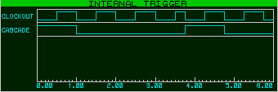

*We are clocking internally at 1Hz and the internal trigger time is set to 3.75sec. The Cascade pin is high while the first bit of the pattern is being driven on the pins and low at all other times.*

Note that at trigger time the internal clock is asynchronously reset. The first bit of the pattern is driven onto the output pins (as evidenced by the *Cascade Pin* being driven high).

***External Asynchronous Positive Edge Trigger***

The trigger is specified via a positive edge transition on the *Trigger Pin*. The Trigger actions immediately and the next clock edge will be a low-high transition at time bitclock/2 subsequent to the time of the reset as shown below.

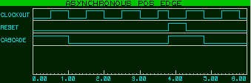

*We are clocking internally at 1Hz and the trigger pin goes high at time 3.75sec. Immediately on the positive edge of the trigger pin the clock is reset and the first bit of the pattern is driven onto the pins.*

***External Synchronous Positive Edge Trigger***

The trigger is specified via a positive edge transition on the *Trigger Pin.* The trigger is latched and will action synchronously with the next falling clock edge as shown below.

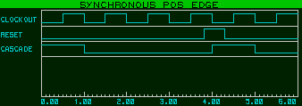

*We are clocking internally at 1Hz. Note that the clock is unaffected by the trigger and that the trigger actions on the falling clock edge subsequent to the positive edge pulse.*

***External Asynchronous Negative Edge Trigger***

The trigger is specified via a negative edge transition on the *Trigger Pin.* The trigger actions immediately and the first bit of the pattern is driven onto the output pins.

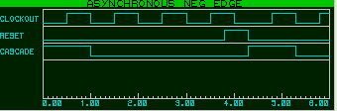

*We are clocking internally at 1Hz. We can see that clock resets on the negative edge of the trigger pulse and that the first bit of the pattern is driven at that time.*

***External Synchronous Negative Edge Trigger***

The trigger is specified via a negative edge transition on the *Trigger Pin.* The trigger is latched and actions synchronously with the next falling edge clock transition as shown below.

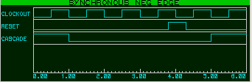

*We are clocking internally at 1Hz. Note that the trigger takes place on the falling edge of the trigger pulse and that the pattern does not reset until the falling edge of the clock pulse subsequent to the trigger action.*

**External Hold**

***Holding the pattern in it’s current state.***

If you want to hold the pattern for a period of time you can do so by arranging for the *hold* pin to be high during the period in which you want to pause. Releasing the hold pin will restart the pattern synchronously if you are using an internal clock. That is, should the hold pin go high halfway through a clock cycle, then when you release the hold pin the next bit will be driven onto the output pins half a clock cycle later.

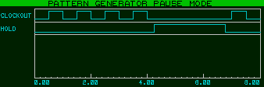

When the hold pin goes high the internal clock is paused. On release of the hold pin the clock resumes relative to the point in the clock cycle at which it was paused.

**Additional Functionality**

***Loading and saving a pattern script.***

Pattern Scripts can be loaded or saved by right clicking over the grid and selecting the relevant option from the popup menu. This is particularly useful if you want to use a particular pattern in several designs.

The pattern scripts are plain text and are simply a comma-separated list of bytes where each byte value represents a column on the grid. Any line beginning with a semi-colon is taken to be a comment line and is ignored by the parser. By default the byte format is hexadecimal though if you are creating your own script you can enter values is decimal, binary or hexadecimal.

***Setting specific values for dials.***

You can specify an exact value for both the bit and the trigger frequency by double clicking the mouse on the appropriate dials. This launches a floating edit box into which you can enter the value. By default the value entered is assumed to be a frequency but you can specify a value in seconds or fractions thereof by appending a suitable suffix to the value (sec, ms, etc.). Additionally, should you wish the trigger to be an exact multiple of the bit clock you can append the suffix ‘bits’ to the multiple desired (e.g. 5bits).

To confirm input press the *Enter* button or to cancel press the *Escape* key or click elsewhere on the Pattern Generator window.

These values can also be specified prior to simulation via the appropriate properties in the *Edit Component* dialogue form.

***Setting specific values for the pattern grid.***

You can specify a specific value for any column on the grid by left clicking the mouse on the text displaying the current value for that column. A floating edit box is launched into which you can enter the desired value. You can specify the value in decimal (e.g. 135), hexadecimal (e.g. 0xA7) or binary (e.g. 0b10110101).

To confirm input press the *Enter* button or to cancel press the *Escape* key or click elsewhere on the Pattern Generator window.

For convenience you can set a column via the CTRL+1 keyboard shortcut and clear a column via the CTRL+SHIFT+1 keyboard shortcut with the mouse over the appropriate column.

***Specifying the period length of the pattern manually.***

You can specify a manual period by left clicking the mouse just above the grid itself at the column you want the pattern to finish on. To deselect the period right click the mouse once in the same area. This is shown below.

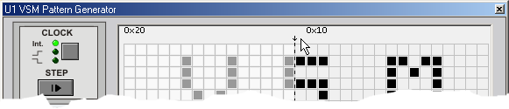

*The mouse is pointing at the area where period selection can be specified. We can see that the period bar is indicating the pattern termination point and that everything to the left of the selection is faded out to indicate that the pattern will s at the period bar.*

***Single stepping to advance the pattern.***

The step button can be used to advance the simulation in time periods equal to that of the bitclock specified either internally or from an external clock. The simulation will run until the next clock cycle is completed and then suspend again.

***Alternating the grid display mode.***

The grid display can be switched between hexadecimal and decimal display modes. This can be done either by right clicking on the grid and selecting the desired option from the menu or alternatively by using the CTRL+X (Hexadecimal display) and CTRL+D (Decimal display) shortcut keys.

***Specifying Output.***

Edit the Schematic part for the Pattern Generator to produce the *Edit Component* dialogue form. The property at the bottom allows you to configure whether you want to output the pattern on both bus and pins, pins only or bus only.

***Tooltip Display.***

You can enable a tooltip which will follow the mouse indicating the current row and column information. This can be toggled on and off either via the context mouse on the right mouse button or through the shortcut key CTRL+Q. Note that tooltip mode is disabled during a Block set or clear.

***Block Editing.***

You can use the *Block Set* and *Block Clear* commands to help you quickly configure the grid to the desired pattern. These are accessible via the context menu on the right mouse button or via their shortcut keys (CTRL+S for Block set and CTRL+C for Block clear). Note that the Block Editing commands are disabled when in tooltip mode.

**VIRTUAL INSTRUMENTS**

**VSM USER INTERFACE ELEMENTS**

**Rotary Dials**

The VSM Virtual Instruments use mouse operated rotary dials (knobs) for adjusting some parameters. The procedure for adjusting these is as follows:

**To set a rotary dial:**

**1.** Point somewhere inside the dial.

**2.** Press the left mouse button and hold it down.

**3.** Move the mouse pointer away from the dial and then around the centre of the dial, tracing out a circular arc to rotate the dial to the required setting.

**4.** The dial will track the angle subtended by the mouse pointer from its centre.The further away you move the mouse, the finer the degree of control that you will have.

**5.** Release the mouse button to fix the new position of the dial.

**WORKING WITH MICROPROCESSORS**

**INTRODUCTION**

The combination of mixed mode simulation and circuit animation becomes most potent when used in the context of micro-controller based systems. Many such systems involve a user interface, or at least complex sequences of external events that cannot easily be simulated in a non-interactive environment, and *PROTEUS VSM* was created primarily to address this problem. Consequently, a substantial chunk of its functionality centres around micro-processor development.

In particular, the editing and compiling of source code, is integrated into the design environment so that you can edit source code and observe the effects of your changes with maximum ease. A source file can be brought up for editing with two keystrokes and the simulation re-run from there with just two more.

**WORKING WITH MICROPROCESSORS**

**SOURCE CODE CONTROL SYSTEM**

**Overview**

The source code control system provides two major functions:

• To register source code files within ISIS so that they can be brought up for editing without manually switching to another application.

• To define the rules for compiling source code into object code. Once set up, these rules are carried out every time a simulation is performed so that the object code is kept up to date.

Note that it is not necessary to use the source code control system in order to simulate microprocessor based designs. Indeed, if your chosen assembler or compiler has its own IDE, you may prefer to work directly in that, and only switch to Proteus when you have produced an executable program. If you are planning to work this way, then see the section on Using a 3rd Party IDE

**Attaching Source Code to the Design**

**To add a source file to the design:**

**1.** Select the Add/Remove Source Files command from the *Source* menu.

**2.** Select the Code Generation Tool for the source file. If you are planning to use a new assembler or compiler for the first time, you will need to register it using the *Define Code Generation Tools* command.

**3.** Click the *New* button and select or enter a name for the source code file with the file selector. You can enter a filename textually if it does not yet exist.

**4.** Enter the flags required specifically for processing this source file in the *Flags* field. Flags required every time a particular tool is used can be entered when the tool is registered.

**5.** Click OK to add the source file to the design.

Don’t forget to edit the micro-processor and assign the name of the object code file (usually a HEX, S19 or symbolic debug data file) to its **PROGRAM** property. ISIS can’t do this automatically as you might have more than one processor on the diagram!

 The section on Supported Debug Formats provides important information on object files and recommended usage.

**Working on your Source Code**

**To edit a source file:**

**1.** Press ALT-S

**2.** Press the ordinal number of the source file on the source menu.

**To switch back to ISIS, build the object code and run the simulation:**

**1.** From the text editor, press ALT-TAB to switch back to ISIS.

**2.** Press F12 to execute, or CTRL-12 to start debugging.

Either way, ISIS will instruct the text-editor to save its files, examine the time-stamps of the source code and object code files, and invoking the appropriate code generation tools to build the object code.

**To rebuild all the object code:**

**1.** Select the Build All command from the source menu.

ISIS will execute all the code generation tools required to build the object code, irrespective of the time/date stamps of the object code files. The command line output from the tools will be displayed in a window. This provides an excellent way to check that everything has built without errors or warnings.

**Installing 3rd Party Code Generation Tools**

A number of shareware assemblers and compilers can be installed into the Proteus TOOLS directory from the system CD, and these will be set up automatically as code generation tools by the installation program. However, if you want to use other tools, you will need to use the Define Code Generation Toolscommand on the *Source* menu.

**To register a new code generation tool:**

• Select the Define Code Generation Tools command from the *Source* menu.

• Click *New* and use the file selector to locate the executable file for the tool. You can also register batch files as code generation tools.

• Enter extensions for the source and object code files. These determine the file types that ISIS will look for when deciding whether to execute the tool for a particular source file, or not. If you check *Always Build* then the tool is always invoked, and an object code extension is not required.

• Specify a proforma command line for the tool. Use %1 to represent the source code file and %2 for the object code file. You can also use %$ for the path to the PROTEUS directory and %~ for the directory in which the DSN file is located.

This is a good place to put command line flags that are needed to make tools run quietly (i.e. without pausing for user input),and to specify paths to include directories of processor specific header files etc.

If you want to use the source level debugging features of PROTEUS VSM, you will need either a Debug Data Extractor (DDX) for your assembler or compiler or preferably for your compiler to output one of the directly supported debug formats. The Debug Data Extractor is a small command line program, which extracts object code/source line cross reference information from the list file produced by the assembler or compiler.

If you have a DDX program, enter the extension for the list file or symbolic debug file that is produced by the code generation tool, and click Browse to select the path and filename of the DDX program.

If you're compiler can output COF, ELF/DWARF etc. then you have no need for a DDX - the additional data required is supplied by the debug format directly.

**Using a MAKE Program**

In some cases, the simple build rules implemented by ISIS may be insufficient to cater for your application - especially if you project involves multiple source and object code files, and a linking phase. In such cases, you will need to use an external ‘MAKE’ program, and you can proceed as follows:

**To set up a project with an external make program:**

**1.** Install your make program (usually supplied with the assembler/compiler environment) as a code generation tool. Set the source extension to MAK and check *Always Build.* For a typical make program, set the command line proforma as:

-f%1

**2.** Use the *Add/Remove Source Files* command to add the makefile (e.g. MYPROJECT.MAK) to the design.

**3.** Also add the source code files, but select the Code Generation Tool as <NONE>

Each time the project is built, ISIS will run the external MAKE program, with the project’s makefile as a parameter. It is then up to the make program to decide what code generation tools are run. A good make program will provide enormous flexibility.

**Using a 3rd Party Source Code Editor**

PROTEUS VSM is supplied with a simple text editor - SRCEDIT which you can use to edit source code files. SRCEDIT is essentially a modified version of NOTEPAD, which can open multiple source files, and can respond to a DDE request to save any modified buffers.

If you have a more advanced text editor, such as *UltraEdit*, you can instruct ISIS to use this instead. Note that IDE type environments probably won’t respond to DDE commands and so are unsuitable for integration in this way. However, you could always ask the vendor to add this support - it’s not hard.

**To set up an alternative source code editor:**

**1.** Select the *Setup External Text Editor* command from the *Source* menu.

**2.** Click the *Browse* button and use the file selector to locate the executable file of your text editor.

**3.** ISIS instructs the text editor to open and save files using a DDE protocol. Refer to the text editor’s documentation or supplier for details of the command syntax. If unsure of the service name, try the name of the product - e.g. ULTRAEDIT.

**Using a 3rd Party IDE**

Most professional compilers and assemblers come with their own integrated development environment or IDE. Examples include IAR's Embedded Workbench, Keil's uVision, Microchip's MP-LAB and Atmel's AVR studio. If you are developing your code with one of these tools, you may find it easier to carry out the editing and compilation steps within the IDE and then switch to Proteus VSM only when you have produced an executable image (e.g a HEX, ELF/DWARF, COF file) and are ready to simulate it.

Proteus VSM supports two ways of working with an external IDE

• Using Proteus as an external debugger - control of the debugging session is carried out from within ISIS, much as you would for a normal CAD simulation.

• Using Proteus as a plug-in simulator. - control of the debugging session is carried out from within the IDE's debugger. Proteus acts as a kind of virtual In Circuit Emulator, communicating with the IDE over TCP/IP. In this mode, you can run your IDE's debugger on one PC and the Proteus simulation on the other.

**Using Proteus VSM as an External Debugger**

To Proteus as an external debugger requires that the symbolic debug format produced by your compiler is supported by one of the *loaders* available in Proteus.A loader extracts both the addresses of each source line in the high level language program, and - where possible - the locations of the program variables.

Common debug formats are COD (used in the PIC world), UBROF - used by all IAR's compilers, ELF/DWARF (generic), COFF (generic) and OMF (used in 8051 circles). We also provide loaders for other proprietary formats such as the list files produced Crownhills Proton Development Suite.

 See Supported Debug Formats for more information on supported formats and loading programs produced by an external IDE..

Press the PLAY button on the animation control panel to begin real-time simulation or press the STEP button to run up to the first source level instruction. In the latter case, the *Source Window* will appear and you can commence stepwise debugging of your code.

**Using Proteus VSM as a Virtual In-Circuit Emulator**

At the time of writing, the virtual ICE approach is supported by the only Keil uVision environment, IAR’s Embedded Workbench, and Microchips MPLAB environment. It is a fast moving area and we would recommend you check our website under *"Supported Compilers"*for the latestinformation and documentation. Instructions for using setting up Proteus to run with these toolsuites can also be found on this webpage.

**WORKING WITH MICROPROCESSORS**

**Diagnostic Tools**

***Overview***

Proteus VSM includes extensive support for diagnostic tools or trace modes, which are invaluable in fault finding and verifying system operation. This is a mechanism by which all activity (or specified) activity is logged during simulation and displayed on the simulation advisor. Think of it as a way to 'lift the lid' on a part and examine internal behaviour, providing traceability of data through the part and across the system.

Being a system level simulator, Proteus VSM includes diagnostic modes not only for microprocessors but also for appropriate peripheral models (LCD displays, I2C memories, temperature control devices etc.) and these trace modes can be enabled granularly via the configure diagnostic dialogue form.

***Configuring Diagnostics***

**To configure a simulation with diagnostics enabled:**

• Launch the Configure Diagnostics dialogue form from the Debug Menu.

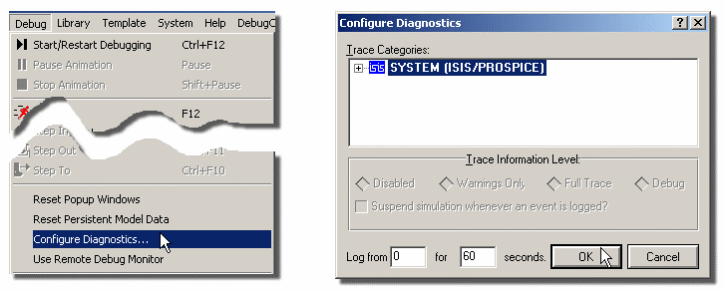

• Expand the 'trees' in the dialogue form to find the item(s) for which you wish to enable diagnostics.

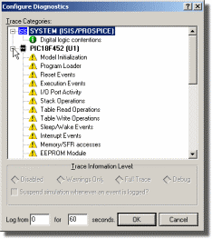

• Left click on the item of interest to select and then change the trace level to full trace. You can also set both an 'arm' time and a run time to control the time interval for which the diagnostics will be active.

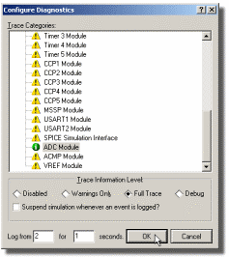

• Repeat the process for any other items of interest and then exit the dialogue form.

When you run the simulation the configured trace diagnostics will become active at the arm time, run for the specified period and all results will be displayed on the simulation advisor.

 Note that enabling trace diagnostics imposes a considerable load on the simulation. However, as they are typically used to identify obscure problems and for debugging purposes, the fact that the simulation will not run in realtime is not an issue.

***The Simulation Advisor***

The simulation advisor is the repository for all error, warning and diagnostics messages generated during a simulation run. It resides at the bottom of the ISIS application on the status bar next to the animation control panel. During a simulation run the status display will live update, indicating both the most severe type of message logged (errors, warnings, trace messages) and the number of such messages. You can launch the simulation advisor at any time during a simulation, or indeed after a simulation run (all messages are persistent!)by left clicking the mouse on the minimised display on the status bar.



*Launching the Simulation Advisor from the status bar.*

The simulation advisor provides severity indicators beside every message as a visual indicator, navigation capabilities (both to a net and to a component on the schematic) where appropriate on messages and context sensitive help on common errors.

*Navigation to a device with the Simulation Advisor*

All messages originating from a physical component (pretty much everything except system messages) have an associated source column at the right hand side of the message. This serves to indicate the component on the schematic which generated the message and left clicking the mouse on the source link will minimise the simulation advisor and both zoom to and tag the source component.

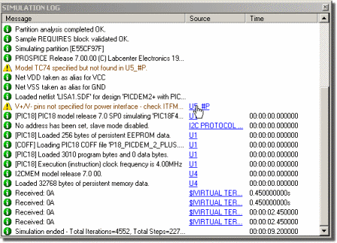

*Navigating to message source in the simulation advisor.*

This is extremely useful, particularly in more complex designs, where you want to examine the hardware design around a device to resolve a problem.

*Navigation to a net with the Simulation Advisor*

One of the most frustrating things about simulation errors is that some problems (net contentions, SPICE singular matrices etc.) are relevant to a net and not a specific component and it is therefore extremely awkward to isolate the offending circuitry on the schematic. The simulation advisor simplifies this task by including 'hyperlinks' where applicable on messages, which when clicked allow you to navigate the design.

**To navigate to a net from the simulation advisor:**

1. Click on the 'net link' contained in the message of interest within the simulation advisor.

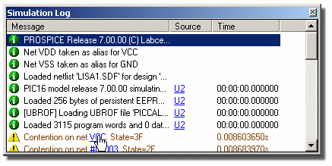

2. This will minimise the simulation advisor back to the status bar and launch the Design Explorer in ISIS, showing you a list of nets on the left hand pane and all the connections (pins) on the offending net in the right hand pane.

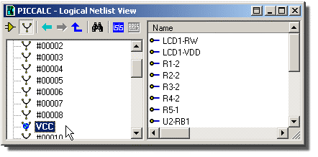

3. Right click on one of these pins and select the Goto Schematic Net option from the resulting context menu.

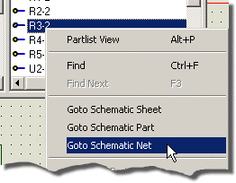

4. The net in question will now be highlighted on the schematic.

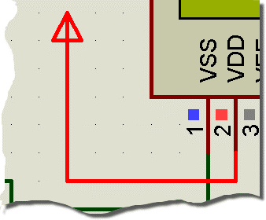

 Note that this method is not foolproof as, where a schematic part is modelled via equivalent circuits (that is, the functionality of the part is modelled in schematic form by wiring together parts which already have models) and the problem net exists within the model, it is not possible to navigate to the net. However, while this and other parasitic cases exist, the technique above will work in most all normal situations and provides a powerful analysis tool in such cases.

 The design explorer is discussed in detail both in the ISIS tutorial and in the ISIS reference manual.

*Context Sensitive Help in the Simulation Advisor*

Error messages which indicate common mistakes and/or design flaws include context sensitive help which details recommended solutions to the issue. This provides you not only with a clear indication of what has gone wrong but also with relevant suggestions for resolving the issue. You can launch the context sensitive help for an error message simply by left clicking the mouse on the help icon at the right of the message as shown below:

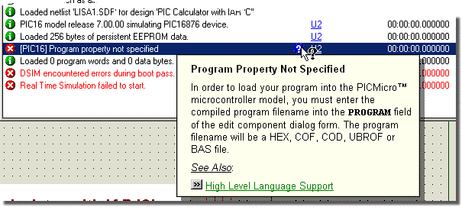

*Using Context Sensitive help in the simulation advisor.*

*The Context Menu*

Right clicking on the simulation advisor window produces a context menu with options to copy the contained data to the clipboard and/or to configure colours/grids and appearance of the window.

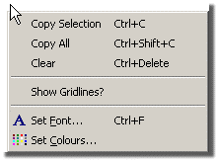

*Navigating to message source in the simulation advisor.*

**WORKING WITH MICROPROCESSORS**

**POPUP WINDOWS**

Most micro-processor models written for *PROTEUS VS*M will create a number of popup windows which can be displayed and hidden from the *Debug* menu. These windows come in four major types:

• Status Windows - a processor model will generally use one of these to display its register values.

• Memory Windows - typically there will be one of these for each memory space in the processor architecture. Memory devices (RAMs and ROMS) also create these windows.

• Source Code Windows - one of these will be created for each processor on the schematic.

• Variable Windows – one of these will be created for each processor on the schematic, provided that the program loader supports program variable display.

**To display a popup window:**

**1.** Start debugging mode by pressing CTRL-F12, or if it is already running, click the *Pause* button on the *Animation Control Panel*.

**2.** Press ALT-D and then the ordinal number of the required window on the *Debug* menu.

These window types can only be displayed when the simulation is paused and are hidden automatically when it is running to give you better access to the active components on the schematic itself.When the simulation is paused (either manually, or due to a breakpoint) the windows that were showing will re-appear.

The debug windows all have right button context menus - if you point at the window and click the right mouse button, a menu will appear from which you can control the appearance and formatting of the data within the window.

The positions and visibility of the debug windows are saved automatically to a PWI file with the same filename as the current design. The PWI file also contains the locations of any breakpoints that have been set, and the contents of the watch window.

**WORKING WITH MICROPROCESSORS**

**SOURCE LEVEL DEBUGGING WITHIN PROTEUS VSM**

**Overview**

PROTEUS VSM supports source level debugging through the use of debug loaders for supported assemblers and compilers. The current set of debug loaders is contained within the system file LOADERS.DLL, and the number tools that are supported is increasing quite rapidly. The latest information is available from the support area of our website under "3rd Party Compilers".

Assuming that you have used a supported assembler or compiler, PROTEUS VSM will create a source code window for each source file used in the project, and these windows will appear on the Debug menu when the simulation is paused.

Note that the following discussion assumes you are using Proteus as a stand-alone debugger. It is possible to use Proteus VSM as a Virtual ICE, notably under MPLAB control, and instruction on how to work in this way is provided here.

**The Source Code Window**

The source code window is the primary tool for debugging your designs in Proteus and allows you to single step your program, advancing the entire embedded system as you debug your software. Your program is loaded into the source window via the debug file output by your compiler or via the SDI file generated by the source code control system. When using a compiler you should provide the debug file to the schematic part via the **program property as shown below**:

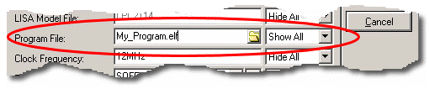

*Edit Component dialogue for a AVR processor showing with a program specified.*

**One of the most common errors people make is to supply the program file as a .HEX file and then query why they have no source level debugging. In order to provide source level debugging we need more information on addresses, high level source lines, variables etc. and so you should only use a .HEX file if you are either writing in assembler or if your tool cannot output any of the supported debug formats (which is extremely unlikely!).

When you start the simulation using the PAUSE button on the animation control panel the source window will appear by default, typically looking like the snapshot below. The reason for the message is that the simulation time is zero and the program counter in the processor at that time does not point to an executable line of code.

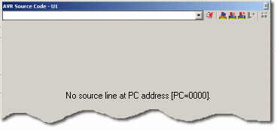

*A Typical source code window at simulation time zero.*

You can of course select your program from the drop down list at theof the source window and then single step or set breakpoints as required.

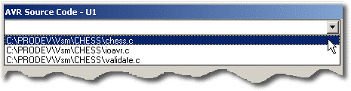

*The source file selector in the source window.*

If you are using a high level language you can single step at either high level or machine code level. To toggle machine code stepping use either the CTRL+D keyboard shortcut or the Disassembly option available from the context menu (right click on the source window).

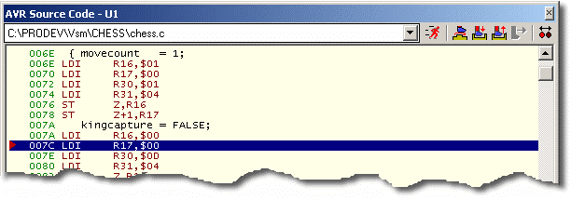

*An example of the AVR model stepping the chess program at machine code level.*

You can also view line numbers, opcodes and addresses in the source window by enabling/disabling the appropriate options in the context menu (right click on the source window to launch).

**Supported Debug Formats**

At the time of writing the following *Object Module Formats* are supported. As this is a rapidly evolving area of the software however, we recommend you look at the *Third Party Compilers* page on the website for up to date information :

***ELF/DWARF***

This is the recommended debug format for use with Proteus, being both rich in detail and generic. This is generally supported by most modern compilers and we anticipate it’s support extending across the compiler range in the foreseeable future. To use with Proteus simply specify the ELF file as the program property in the schematic part for the processor.

 At the time of writing ELF/DWARF is supported across the AVR and ARM7 models although this will shortly be extended to the PIC and other families.

 Both the ELF (the binary file) and the DWARF (the debug file) must exist in the same directory – this should happen by default when you select ELF/DWARF as the debug format from within your compiler.

***COFF***

This format, while supported, is not recommended where an ELF/DWARF option is available. This is because, unlike ELF/DWARF, the COF format is somewhat compiler dependant and open to interpretation. This means for example, that a PIC compiler may represent a float in COF as an IEEE float or in Microchip’s float format and provides no explicit information as to which format it has used. More information on supported compilers for the COF format can be found on the website. To use with Proteus specify COF as the debug format within the compiler and then use the .COF file in the program property of the processors *Edit Component* dialogue form.

***UBROF***

UBROF is the debug format of choice produced by the IAR compiler range. Specify UBROF8 (**not** a later version) as the debug format within the compiler and then use the UBROF file as the program property of the processors *Edit Component* dialogue form.

 You can also drive Proteus directly from within IAR’s Embedded Workbench – see Using Proteus as a Virtual ICE for more information

***OMF51***

OMF51 is the debug format produced by Keil compilers. Specify **standard** OMF51 as the debug format format within the compiler and then use the UBROF file as the programproperty of the processors *Edit Component* dialogue form.

 Newer versions of the Keil compilers will also produce ELF/DWARF and we recommend you use this option where available

 You can also drive Proteus directly from within Keil – see Using Proteus as a Virtual ICE for more information.

***COD***

COD is a debug format produced by Bytecraft and widely used in PIC circles. We do not recommend using this format if an alternative is available as the information provided is incomplete. Specifically, the limitations of the COD symbolic debug data format mean that the VSM debugging support for this product is limited to stepping through the machine code and watching specific memory locations Source level stepping and variable display are not supported.

To use with Proteus specify COD as the debug format within the compiler and then use the COD file as the program property of the processors *Edit Component* dialogue form.

***BAS***

Proteus currently provides a customer solution for Crownhill’s Proton Development Suite. After compiling your program simply specify the .BAS file as the program property in the *Edit Component* dialogue of the PIC processor.

***SDI***

The SDI format is only applicable for programs written in assembler and assembled via the source code control system in ISIS. To use, configure the *Code Generation Tools* dialogue form such that the correct *Debug Data Extraction* tool is specified (this will normally be set up for you at install time) and specify the HEX file in the program property of the processors *Edit Component* dialogue form.

 *Do* ***not*** *enter the name of the source file as the program property for a processor - Proteus VSM does not simulate 'C' or 'ASM' files; the CPU models load and execute binary machine code from the debug formats specified above.*

**Single Stepping**

A number of options for single stepping are provided, all available from the toolbar on the source window itself or from the Debug menu.

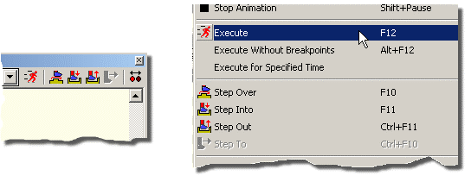

*Code stepping control with Proteus VSM*

• Step Over - advances by one line, unless the instruction is a sub-routine call, in which case the entire subroutine is executed.

• Step Into - executes one source code instruction. If no source window is active, it executes one machine code instruction. These are usually the same thing anyway unless you are debugging in a high level language.

• Step Out - executes until the current sub-routine returns.

• Step To - executes until the program arrives at the current line. This option is only available when a source code window is active.

 Note that apart from Step To, the single stepping commands will work without a source code window. It is possible – although not so easy – to debug code generated by a tool for which there is no loader support.

**Using Breakpoints**

Breakpoints provide a very powerful way to investigate problems in the software or software/hardware interaction in a design. Typically, you will set a breakpoint at the start of a subroutine that is causing trouble, start the simulation running, and then interact with the design such that the program flow arrives at the breakpoint. At this point, the simulation will be suspended. Thereafter you can single step the program code, observing register values, memory locations and other conditions in the circuit as you go. Turning on the Show Logic State of Pins effect can also be very instructive.

When a source code window is active, breakpoints can be set or cleared on the current line by pressing F9 or via the context menu launched by right clicking on the source window. You can only set a breakpoint on a source line that has object code and the breakpoint is identified.

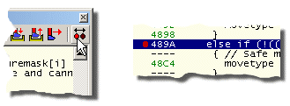

*Setting Breakpoints with Proteus VSM*

If the source code is changed, PROTEUS VSM will endeavour to re-locate the breakpoints based on sub-routine addresses in the file, and by pattern matching the object code bytes. Obviously, if you change the code radically this can go awry but generally it works very well and you shouldn’t need to think about it.

**Variables Window**

Most of the loaders provided with Proteus VSM are able to extract the location of the program variables as well as the source line number addresses. Whenever this is possible, Proteus displays a variables window as well as a source window.

The variables window is an extremely powerful debugging aid and provides a number of customisable features to make it easier for you to access and understand the information displayed.

***Expansion of Compound Types and Pointers***

The variables window will seamlessly handle compound types (structs, arrays, enums) and pointers, providing an expandable tree displaying the contents of the type or the de-referencing of the pointer.

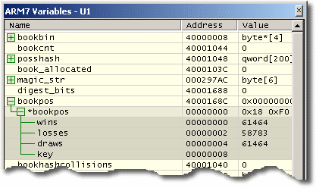

*Expansion of compound types in the variables window*

** The information loaded into the variables window is provided by the *Object Module File* produced by your compiler. As with most things, some formats are betterthan others. Where possible we recommend using ELF/DWARF as the output format from the compiler and specifying the .ELF file within the schematic part in ISIS. Failing that, the COFF format can be used and should provide full variables support.

***Change Notification and Previous Values***

A variable in the variables window will highlight when the value of that variable changes and the simulation is paused. You can also view the previous value of the variable by selecting the *Show Previous Values* option from the context menu (right click on the variables window).

If you have a compound type (such as a struct) and an element of the type changes then only that element will highlight. This means that, unless the type is expanded, you will not see a change in the variables window at the point the element changes.

***Drag and Drop to the Watch Window***

Although the variables window is hidden while the program is running, you can drag and drop variables onto the watch window where they will remain visible during free running simulation. This has the added advantage of then being able to set a watch condition on the variable to pause the simulation when the condition is reached.

 *If you drag a variable to the watch window and the variable then goes out of scope (or indeed, if you then recompile the program and re-simulate) then there is no guarantee that you will be viewing the contents of the variable in the watch window – this depends on how the compiler re-uses memory. The watch window simply monitors an address in memory.*

***Hiding and Showing Global Variables***

With large programs you may have quite a number of global variables. This option, found on the context menu (right click on the variables window) will allow you to hide all the globals, making it easier to focus on the local, in scope variables.

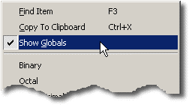

*Show Global Variables option on the context menu.*

***Colour Configuration***

Right clicking on the variables window and selecting the *Set Colours* option presents a dialogue form allowing you to specify custom colours for all variable window items.

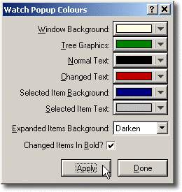

*Colour configuration dialogue for the variables window.*

**Multi-CPU Debugging**

Proteus VSM has no problem simulating designs containing more than one CPU on the schematic. Each CPU will produces its own set of popup windows including source code and variables, and these will be grouped together under sub-menus on the *Debug* menu.

When single stepping code, the processor whose source window has the focus will be treated as the master, and the other CPU s will free run, suspending their execution at whatever time-point the master CPU has completed an instruction.If you move the focus away from the source window, then the master CPU remains the one whose source window last had the focus; the master is changed by clicking on another CPU’s source window.

**WORKING WITH MICROPROCESSORS**

**THE WATCH WINDOW**

**Adding Items to the Watch Window**

Whereas the variables, memory and register windows belonging to processor models are only displayed when the simulation is paused, the *Watch Window* provides a means to display values that are updated in real time. It also provides a means to assign names to individual memory locations which can be more manageable than trying to find them in a memory window.

**To add an item to the Watch Window:**

**1.** Press CTRL-F12 to start debugging, or pause the simulation if it is already running.

**2.** Display the memory window containing the item to be watched, and the watch window itself using the numbered options on the *Debug* menu.

**3.** Mark a memory location or range of memory locations using the left mouse button. The selected range should appear in inverted colours.

**4.** Drag the selected item(s) from the memory window to the watch window.

You can also add items to the *Watch Window* by using the *Add Item by Name* or *Add Item by Address* commands on its right mouse button context menu. This is particularly useful for SFR’s in microcontrollers as they can be expanded to monitor individual bitfields (PIC, AVR and ARM models).

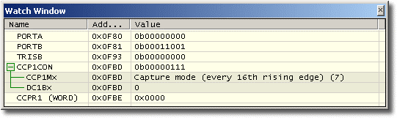

*Watch Window monitoring the CCP1CON register of the PIC18*

***Modifying Items in the Watch Window***

Having got an item or items in into the window, you can now select an item with the left mouse button and then:

• Rename it by pressing CTRL-R or F2.

• Change the data size to any of the options on the right mouse button context menu. For data sizes that comprise several bytes (e.g. 16 or 32 bit words, or strings) the second and subsequent bytes are assumed to follow on from the item address. Consequently, to display a multi-byte word or string you only need to drag in the first byte from the memory window.

• Change the number format to binary, octal, decimal or hex.

**Watchpoint Conditions**

The *Watch Window* provides a facility to suspend the simulation when a particular condition arises in the values of the items. At the simplest level, this can be when the value of a particular item changes but you can also specify more complex conditions if necessary.

**To specify a Watchpoint Condition**

**1.** Press CTRL-F12 to start debugging, or pause the simulation if it is already running.

**2.** Display the watch window itself using the option on the *Debug* menu.

**3.** Add the items on which the watchpoint condition will depend to the watch window as described in the previous section.

**4.** Select the *Watchpoint Condition* command from the right mouse button context menu.

**5.** Specify a *Global Break Condition.* This determines whether the simulation suspends when *any* item expression is true, or only when *all* item expressions are true.

**6.** Specify one or more *Item Break Expressions*. An item break expression consists of the watch-item on which it operates, a mask value (allowing you to activate the condition for particular bits of a register, for example), a conditional operator, and value.

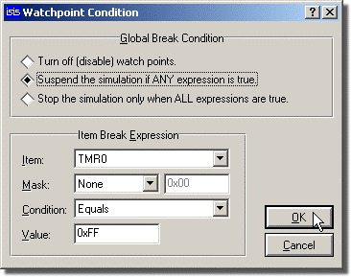

*An example of a configured Watchpoint condition.*

Activating a watchpoint condition will impose a modest overhead on the simulator since ProSPICE must re-test the condition at every time-point in the simulation (i.e. at or above the machine cycle rate in a micro-controller application).However, the facility can be a god-send when looking for obscure bugs and the fact that the simulation may take a few extra minutes to reach the point of interest is not normally an issue.

**WORKING WITH MICROPROCESSORS**

**BREAKPOINT TRIGGER OBJECTS**

**Overview**

A number of component objects are provided which trigger a suspension of the simulation when a particular circuit condition arises. These are especially useful when combined with the single stepping facilities, since the circuit can be simulated normally until a particular condition arises, and then single stepped in order to see exactly what happens next.

***Setting Up a Hardware Breakpoint:***

A hardware breakpoint is a mechanism by which you can pause your simulation on a hardware condition (as opposed to in software). It is extremely useful when debugging your design, particularly when an asynchronous stimuli is applied to the circuit and you need to trace/analyse it's effects on the circuit.

*To set up a hardware breakpoint:*

1. Place a voltage probe on the wire (or bus) on which you wish to trigger the breakpoint.

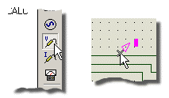

*Adding a Probe to a wire.*

2. Right click on the probe and select Edit Properties from the resulting dialogue form.

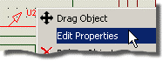

3. At the bottom of the dialogue form select either Digital or Analog according to the net on which the probe is attached and specify a trigger value. For a digital net and a single wire this will be either 1 or 0 corresponding to a logic high or a logic low respectively whereas for an analog net it will be a voltage value. You can also specify an arm time should you wish the breakpoint to become active after a period of time.

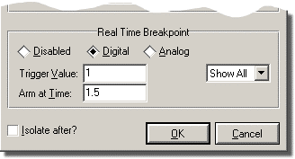

*Setting the Trigger value and Arm Time in the Edit probe dialogue form.*

4. Click OK to exit the dialogue form and then PLAY (or CTRL+F12) to run the simulation.

**Voltage Breakpoint Trigger - RTVBREAK**

This device is available in 1 and 2 pinned forms, and triggers a breakpoint when the voltage at its single pin, or the voltage between its two pins is greater than the specified value. You can couple this device to an arbitrary controlled voltage source (AVCS) to trigger a breakpoint on complex, formula basedconditions involving multiple voltages, currents etc.

Once the trigger voltage has been exceeded, the device does not re-trigger until the voltage has dropped below the trigger threshold and risen again.

**Current Breakpoint Trigger - RTIBREAK**

This device has two pins and triggers a breakpoint when the current flowing through it is greater than the specified value.

Once the trigger current has been exceeded, the device does not re-trigger until the current has dropped below the trigger threshold and risen again.

**Digital Breakpoint Trigger - RTDBREAK**

This device is available with various numbers of pins. and you can make other sizes yourself if you need to. It triggers a breakpoint when the binary value at its inputs equals the value assigned to the component.For example, specifying the value of an RTDBREAK_8

0x80

will cause a it to trigger when D7 is high and D0-D6 are low.

Once the trigger condition has arisen, the device does not re-trigger until the a different input value has been seen.

**Voltage Monitor - RTVMON**

This device is available in 1 and 2 pinned forms, and triggers a breakpoint, warning or error condition when the input voltage falls outside the specified minimum or maximum values. By incorporating these objects into your simulator models, you can warn the end user when voltages within the model (e.g. the power supply voltage) exceed the specified operating limits.

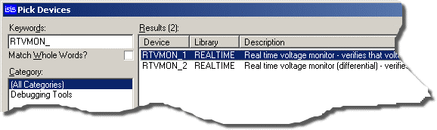

**Current Monitor - RTIMON**

This device has two pins and triggers a breakpoint, warning or error condition when the current through the device falls outside the specified minimum or maximum values. By incorporating these objects into your simulator models, you can warn the end user when currents within the model (e.g. current passing through the device output terminals) exceed the specified operating limits.

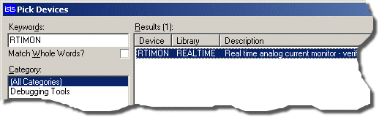  
*Selecting the CurrentMonitor from the Library Browser.*

**GRAPH BASED SIMULATION**

**GRAPH BASED SIMULATION**

**INTRODUCTION**

Although interactive simulation has many advantages, there are still some situations in which it is advantageous to capture the entire simulation run to a graph and study the results at your leisure. In particular, it is possible to zoom in on particular events within the simulation run and take detailed measurements. Graph based simulation is also the only way to perform analyses which do not take place in real time at all, such as small-signal AC analysis, Noise Analysis and swept parameter measurements.

 Graph Based Simulation is only enabled with purchase of the Advanced Simulation Features module of the Proteus Design Suite.

**GRAPH BASED SIMULATION**

**SETTING UP A GRAPH BASED SIMULATION**

**Overview**

Graph based simulation involves five main stages. These are summarized below, with detailed explanations of each stage being given in the subsequent sections:

• Entering the circuit to be simulated.

• Placing signal generators at points that require stimulus and test probes at points that you wish to inspect.

• Placing a graph corresponding with the type of the analysis you wish to perform - e.g. a frequency graph to display a frequency analysis.

• Adding the signal generators and test probes to the graph in order to display the data they generate/record.

• Setting up the simulation parameters (such as the run time) and executing the simulation.

**Entering The Circuit**

Entering the circuit you want to simulate is exactly the same as entering any other design in to ISIS; the techniques for this are covered in detail in the ISIS manual itself.

**Placing Probes and Generators**

The second stage of the simulation process is to set up signal generators at points that require stimuli and probes at points of interest. Setting up signal generators and probes is extremely easy as they are treated like other ISIS objects such as components, terminals, or junction dots. All that is required is to select the appropriate icon, pick the type of generator or probe object from the selector, and place it on the schematic where you want it. This can be either by placing it directly on to an existing wire, orby placing it like a component and then wiring to it later. Defining the signal produced by a generator is then just a matter of editing the object and entering the required settings on its dialogue form.

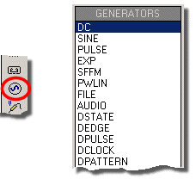

*Preparing to place a generator in ISIS*

At this stage you can also isolatea section of the design so that only certain components are involved in the simulation. This is achieved by checking the *Isolate Before* and *Isolate After* options in the probes and generators.The use of probes and generators in this way provides not only for faster simulations, but also means that errors do not creep in from removed wires being forgotten and never replaced.

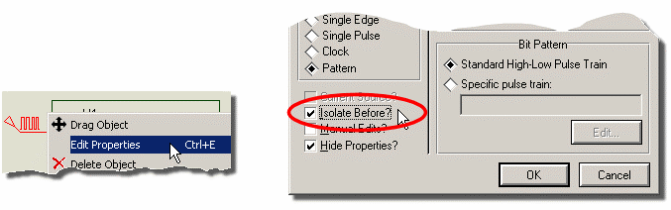

Configuring a generator to isolate from preceding circuitry.

**Placing Graphs**

The third stage of the simulation process is to define what analysis type or types you want performed. Analysis types include analogue and digital transient analyses, frequency analyses, sweep analyses, etc. Within ISIS, defining an analysis type is synonymous with placing a graph object of the required analysis type. Again, as graphs are just like most other objects within ISIS, placing one is simply a case of selecting the correct icon, selecting the required graph type, and placing the graph on the design, alongside the circuit. Not only does this allow you to view several types of analysis simultaneously, it fits very well with the 'drag-and-drop' methodology adopted throughout ISIS and has the added benefit that you can view (and generate hard-copy output with) the graphs alongside the circuit that generated them.

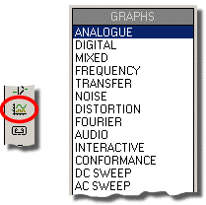

*Preparing to place a graph in ISIS*

**Adding Traces To Graphs**

Having placed one or more graph objects, you must now specify which probe/generator data you want to see on which graphs. Each graph displays a number of *traces*. The data for a trace is generally derived from a single probe or generator. However, ISIS provides for a trace to display the data from up to four separate probes/generators combined by a mathematical *Trace Expression*. For example, a trace might be set up to display the product of the data from a voltage probe and current probe (both monitoring the same point) so effectively displaying the power at the monitored point.

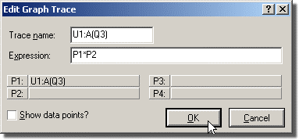

*Using Trace Expressions in ISIS*

Specifying the traces to be displayed on a graph can be done in a number of ways: youcan tag-and-drag a probe onto a graph or you can tag several probes/generators and add them all to a graph in a single operation, or for traces requiring trace expressions, you can must use a dialogue form to select the probes and specify the expression.

**The Simulation Process**

Graph based simulations is *Demand Driven*. This means that the emphasis is on setting up generators, probes and graphs in order to determine what you want to measure, rather than on setting up the simulator and then running some kind of post processor in order to examine the results. Any parameters that are specific to a given simulation run are specified by either editing the explicit properties of the graph itself (e.g. the start and s times for the simulation run) or by assigning additional properties to the graph (e.g. for a digital simulation, you can pass a 'randomise time delays' property to the simulator).

So what happens once you have initiated a simulation? In brief, the action proceeds through the following steps:

• Netlist generation - this is the usual process of tracing wires from pin to pin, and producing a list of components and a list of pin to pin connection groups, or *nets.* In addition, any components in the design that are to be simulated by *model files* are replaced by the components contained in these files.

• Partitioning - ISIS then looks at the points you where you have placed probes and traces back from these to where you have injected signals. This analysis results in the establishment of one or more partitions that may need to be simulated and the order in which they must be simulated. As each partition is simulated, the results are stored in a new *partition file*.

• Results Processing - Finally, ISIS accesses the partition files to build up the various traces on the graph. The graph is then re-displayed and can be maximized for measurement taking and so forth.

If errors occur during any of these stages, then the details are written to the simulation log file. Some errors are fatal, and others are just warnings. In the case of fatal errors, the log file is displayed for immediate viewing. If only warnings have occurred then the graph is re-displayed and you are offered the choice of viewing the log if you want to. Most errors relate either to badly drawn circuits (which cannot, for one reason or another, be mathematically solved), or to the omission or incorrect linking of model files.

**GRAPH BASED SIMULATION**

**GRAPH OBJECTS**

**Overview**

A *graph* is an object that can be placed on to the design. The purpose of a graph is to control a particular simulation and display the results of that simulation. The type of analysis type performed by the simulation is determined by the type of the graph placed. The part of the design that is simulated and the data that is displayed on the graph is determined by the probe and generator objects that have been addedto the graph.

**The Current Graph**

All graph-specific commands are on the *Graph* menu. The lower portion of this menu also contains a list of all the graphs in the design, with the *current* graph being marked by a small marker at the left of its name. The *current* graph is the last graph that was simulated or acted upon by a command.

Any command from the *Graph* menu can be invoked for a specific graph by pointing at the graph with the mouse and using the command's keyboard short-cut (shown on the menu to the right of the command). If the mouse pointer is not pointing at a graph, or if you select the command directly from the menu, the command is invoked for the *current* graph.

**Placing Graphs**

**To place a graph:**

1. Select the graph icon from the mode selector toolbar

2. Select the type of graph you wish to place from the *Object Selector*.

3. Place the mouse in the Editing Window and left click at the point you wish theleft corner of the graph to appear. Move the mouse to expand a rectangle of the size of the graph you want to place and then left click the mouse again to commit the placement.

**Editing Graphs**

All graphs can be moved, resized or edited to change their properties using the standard ISIS editing techniques.

The properties of a graph are changed via its *Edit...* dialogue form invoked asfor any object in ISIS by either first tagging it and then clicking the left mouse button on it, or by pointing at it with mouse and pressing CTRL+'E' on the keyboard.

**Adding Traces To A Graph**

Each graph displays one or more *traces*. Each trace normally displays the data associated with a single generator or probe. However, for analogue and mixed graph types it is possible to set up a single trace to display the data from between one and four probes combined by a mathematical formula which we call a *trace expression.*

Each trace has a label that is displayed alongside the y-axis to which the trace is assigned. Some graph types have only one y-axis and there is no option to assign the trace to a particular y-axis. By default, the name of a new trace is the same as the name of the probe (or the first probe in the trace's expression) - this can be changed by editing the trace.

Traces can be defined in one of three ways:

• Dragging and dropping an individual generator or probe on to the relevant graph.

• Tagging a selection of probes and using the *Quick Add* feature of the *Add Trace* command.

• Using the Add Trace command's dialogue form.

The first two methods are quick to use but limit you to adding a new trace for each generator or probe assigned to the graph. The third method is somewhat more involved but gives greater control over the type of trace added to the graph. In particular, traces that require *trace expressions* must be added to the graph via the *Add Trace* command's dialogue form.

**To drag-and-drop a probe or generator on to a graph:**

1. Tag the generator or probe you wish to add to a graph by left clicking on it.

2. With the mouse over the generator/probe (the cursor should change to an orthogonally pointing arrow) Depress the left mouse button on the generator or probe, drag over to the graph and release the mouse button.

A new trace is created and added to the graph; the new trace displays the data associated with the individual probe/generator. Note that any existing traces may be shrunk in order to accommodate the new trace.

For graphs with two y-axes, releasing the probe or generator on left or right half of the graph assigns the new trace to the respective axis. Furthermore, for the mixed analogue and digital transient analysis graph type, releasing the generator or probe over existing digital or analogue traces creates a new trace of the respective type (the first probe or generator released on a mixed graph type is always creates an analogue trace).

**To quick-add several generators or probes to a graph:**

**1.** Ensure the graph you wish to add the generators or probes is the *current* graph. The current graph is the graph whose title is shown selected on the *Graph* menu.

**2.** Tag each generator or probe you want to add to the graph.

**3.** Select the Add Trace command on the *Graph* menu. As a result of the tagged probes and generators, the command first displays a *Quick add* *tagged probes?*

**4.** Select the *Yes* button to add the tagged generators and probes to the current graph.

A new trace is created for each tagged generator or probe and is added to the graph in alphabetical order; each new trace displays the data associated with its associated individual generator or probe. Traces are always assigned to the left y-axis for graph types that support two axes.

**The Add Trace Command Dialogue Form**

Assuming you are not performing *Quick Add*, the *Add Trace* command will display an *Add Trace* dialogue form (each graph type has slight variations). This form allows you to select the name of the new trace, its type (analogue, digital, etc.), the y-axis (left or right) to which it is to be added, up to four generator or probes whose data it is to use, and an expression that combines the data of the selected generators and probes.

**To add a trace to a graph using the *Add Trace* command**

**1.** Invoke the *Add Trace*command on the *Graph* menu against the graph to which you want to a new trace.

If there are any tagged probes or generators, a *Quick addtagged probes?* prompt will be presented. Respond by selecting the *No* button.

The *Add Transient Trace* dialogue form is displayed.

**2.** Select the type of trace you wish to add to the graph by selecting the appropriate *Trace Type* button. Only those trace types applicable to the graph are enabled.

**3.** Select the y-axis to which the new trace is to be added. Only those axes applicable to the graph and trace type selected are enabled.

**4.** Select one of the *Selected Probes* buttons *P1* through to *P4*, and then select a probe or generator from the *Probes* list box to be assigned to the selected trace probe. The name of the selected generator or probe will appear alongside the *Selected Probes* button and the *Selected Probe* name (P1 through P4) will appear in the *Expression* field if it is not already present.

If a trace expression is not allowed, only the P1 trace will be enabled - and the new trace will display the data associated with the P1 probe selected.

**5.** Repeat steps [3] & [4] until you have selected all the generators or probes you require for the trace.

**6.** Enter the *trace expression* in the *Expression* field. Within the expression, the selected probes should be represented by the names P1, P2, P3 and P4 which correspond to the probes selected alongside the **P1**, **P2**, **P3** and **P4** buttons respectively.

If the trace type selected does not support a *trace expression* the contents of the *Expression* field will be ignored.

**7.** Select the OK button to add the new trace to the graph.

**Editing Graph Traces**

An individual trace on a graph can be edited to change its name or expression.

**To tag, edit and untag a graph trace:**

**1.** Ensure the graph displaying the trace to be edited is ***not*** tagged.

**2.** Tag the *trace* by clicking the right mouse button on the trace's name. A tagged trace displays its name highlighted.

**3.** Click the left mouse button on the trace's name. The trace displays its *Edit Graph Trace* dialogue form.

**4.** Edit the trace's name or expression as required. For a trace type that does not support trace expressions any changes to the *Expression* field will be ignored.

**5.** Select the OK button to accept the changes.

**6.** Untag the trace by clicking the right mouse button over the graph, but not over any trace names.

**Changing the Order and/or Colour of Graph Traces**

The order of the traces on a graph can be adjusted by dragging the labels with the left mouse button. The trace can be tagged or otherwise, as you wish.

• For digital traces the purpose of moving them is simply that of obtaining a particular stacking sequence on the graph.

• For an analogue graph, you can both drag the traces from the left to right axis and back. You can also change the colour assignments, which are made on the basis of the stack order, by shuffling the vertical stacking order.

The actual colours assigned to the sequence positions can be re-configured by maximising a graph (any one will do) and then using the Set Graph Colours command on the *Template*menu.

**Manual Y-Axis Configuration**

By default the Y-Axes of a graph are auto scaled to provide maximum visibility for the traces on the graph. In some situations, typically where you may want to compare two or more graphs on the schematic, this effect is not desirable. In these situations ISIS provides a mechanism to set and lock both the left and right Y-axis of appropriate graph types.

**To manually specify Y-axis ranges**

1. Place the graph, add the traces as normal and simulate the graph.

2. After the first simulation run the Y-axis of the graph will auto-scale. Right click on the graph object and then left click to edit. The *Edit Graph* dialogue will appear with a *Set Y-Scales* option at the bottom left.

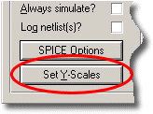

The Set Y-Scales option on the Edit Graph Dialogue Form

3. Click on this option to get the *Set Y-Axis Scaling* dialogue.

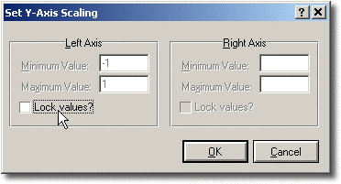

*The Set Y-Axis Scaling Dialogue Form*

4. Click the *Lock Values* checkbox on the appropriate axis and enter the minimum and maximum values as required.

 Note that these options will automatically gray out if they are not applicable to the graph in it’s current state. For example, where you only a left y-axis, the ability to manually specify the right y-axis is naturally not available. Also, if the graph has not been simulated at all, the entire dialogue will be unavailable for editing.

5. Close the dialogue and re-simulate.

**GRAPH BASED SIMULATION**

**THE SIMULATION PROCESS**

**Demand Driven Simulation**

When we designed Proteus, one of our major goals was to make the use of simulation software much more intuitive than it has previously been. Much of the problem with previous simulation packages stems from the fact that number crunching parts were written first and other aspects such as displaying the results graphically were added on later, almost as an afterthought. This tends to result in a fragmented way of working in which you run one program to draw the schematic, another to actually simulate the circuit, and yet another to display the results.

Proteus is very different in that, having drawn the circuit, you start by answering the question of what you want to see by means of placing and setting up a graph. This graph then persists until you delete it, and each time you want to see the effect of a change to the circuit, you just update the graph by pointing at it and pressing the space-bar. We call this *Demand Driven Simulation* since ISIS must work out from the graph what actually requires simulating, rather than you having to do it textually. Furthermore, you can place several graphs which perform different experiments with each one 'remembering' a different setup for the simulators.

The most important benefit of all comes from the fact that a given graph defines a set of points of interest in the design by virtue of the probes that have been assigned to its traces. ISIS is then able to use this information to figure out which parts of the design actually need to be simulated, rather than you having to calve the design up manually. It follows that a *complete* design, ready for PCB layout, can be simulated without massive editing, even if you only want to simulate particular parts of it.

A further benefit arises from the fact that there is no risk of forgetting to undo modifications made for simulation purposes because there are none to undo; the probe and generator gadgets that you do place are ignored when generating netlists for PCB layout.

**Executing Simulations**

Once a graph has been placed with probes and generators assigned to it, you can initiate a simulation by pointing at the graph and pressing the space-bar. ISIS then determines which parts of the design need to be simulated in order to update the graph, runs the simulations, and displays the new data.

Throughout the simulation process, a simulation log is maintained. In general, the log contains little of interest.However, if simulation errors occur, or you have requested the simulation netlist to be logged (see Editing Graphs for how to do this) or the analysis type results in data that is not amenable to graphical display (e.g. an analogue Noise analysis) then you will need to view the log at the end of the simulation run.

***To update a graph and view the simulation log:***

1. Either ensure the graph you want to update is the current graph and then select the Simulate command, or place the mouse pointer over the graph you wish to update and press the space bar.

2. At the end of the simulation, if errors have occurred, you will be prompted to Load partial results? If you reply YES simulation data is loaded up to the time of the error and displayed on the graph. If you reply NO the simulation advisor is displayed displaying log data.

If no errors occurred, or if you selected YES above, you can still view the simulation advisor by right clicking on the graph and selecting the View Log menu option.

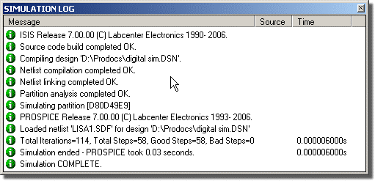

*Launching the Simulation Advisor from a graph.*

**What Happens When You Press the Space-Bar**

When you update a graph, either using the *Simulate* command on the *Graph* menu or its space-bar keyboard short-cut - a great deal of analysis and processing occurs over and above the actual analogue or digital analyses themselves. We now outline in brief various steps in this process:

• Netlist compilation - this is the usual process of tracing wires from pin to pin, and producing a list of components and a list of pin to pin connection groups, or *nets.* The resulting netlist is held in memory at this stage.

• Netlist linking - some components are modelled using sub-netlists or *model files* which are generally kept in the directory specified by the *Module Path* field of the *Set Paths* command's dialogue form. Many models are supplied with Proteus and you can, of course, create your own as well. You can think of a model as being a child sheet of a hierarchical design in which the parent object is the component to be modelled.

Each time a component modelled in this way is encountered, the original part is removed from the netlist and replaced by the contents of the model file, with the inputs and outputs of the model connected in where the original component's pins were.

At the end of this process, every component left in the netlist should have a **PRIMITIVE** property, which means that it can be directly simulated by PROSPICE.

• Partitioning - ISIS then looks at the points you where you have placed probes and traces back from these to where you have injected signals. A signal is deemed to be injected by any of: a power rail, a generator with its *Isolate Before* flag set or tape output. This analysis results in the establishment of one or more partitions that may need to be simulated.

Further analysis then works out the *order* in which they must be simulated. For example, if partition A has an output that connects to an input of partition B then clearly A must be simulated first. If it turns out that B has an output driving A as well, then all is lost - it is up to you to use tape objects in such a way that cyclic dependencies do not occur.

Yet more analysis then establishes whether there are any existing results in the directory specified by the *Results Path* field (as set by the Set Paths command on the *System* menu) that relate to identical simulation runs for any of the current set of partitions. If there are, and if the partition concerned is not driven by a partition which is itself being re-simulated, then ISIS does not bother re-simulating the partition, but uses the existing results instead. It follows that if you are working on the back end of a design, there is no need to keep re-simulating the front end.

You will appreciate that this part of the system is extremely clever!

• Simulator Invocation - ISIS now invokes PROSPICE on each partition in turn to carry out the actual simulation.

Each simulator invocation results in a new partition file, and progress information is also added to the simulation log which is maintained throughout the entire simulation process.

• Results Processing - Finally, ISIS accesses the partition files to build up the various traces on the graph. The graph is then re-displayed and can be maximised for measurement taking and so forth.

If errors occur during any of these stages then the details are written to the simulation log. Some errors are fatal, and others are just warnings. In the case of fatal errors, the simulation log is displayed for immediate viewing. If only warnings have occurred then the graph is re-displayed and you are offered the choice of viewing the simulation log if you want to. Most errors relate either to badly drawn circuits (which cannot, for one reason or another, be mathematically solved), or to the omission or incorrect linking of model files.

**ANALYSIS TYPES**

**INTRODUCTION**

There are thirteen types of graph available; each one displays the results of a different type of circuit analysis supported by PROSPICE:

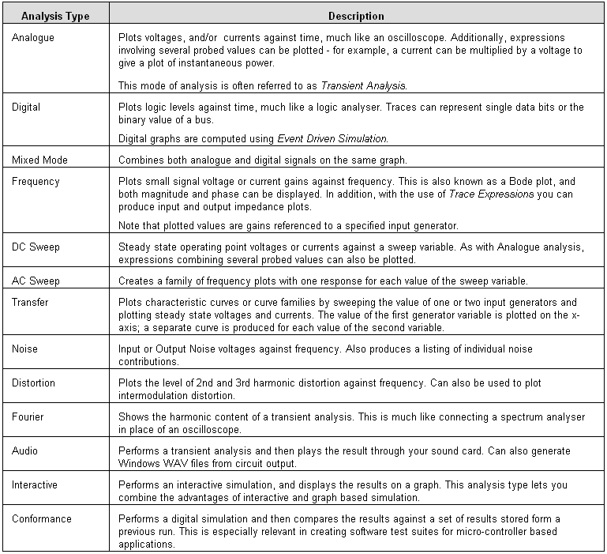

In addition, all types of analysis start by computing the operating point - i.e. the initial values of all node voltages, branch currents and state variables as at time 0. Information regarding the operating point is available from within ISIS via a point and shoot interface.

**ANALYSIS TYPES**

**ANALOGUE TRANSIENT ANALYSIS**

**Overview**

This graph type represents what you might expect to see on an oscilloscope. The x-axis shows the advance of time, whilst the y-axis displays voltage or current. We often refer to this type of analysis as *Transient Analysis* because it takes place in the time domain.

Transient analysis is perhaps the most commonly used form of analysis. Everything that you would measure with an oscilloscope on a real prototype can be measured on an analogue graph. It can be used to check that the circuit operates in the expected manner, to take quick measurements of gain, to assess visually the way in which a signal is distorted, to measure the current flowing from the supply or through individual components, and so on.

**Method of computation**

Technically speaking, this type of simulation can be referred to as *Non-Linear Nodal Analysis,* and is the form of computation used by all SPICE simulators. Considering a single point in time, every component in the circuit is representedas a combination of current sources and/or resistors. This arrangement can then be described as a set simultaneous equations using Ohms law and Kirchoff’s laws, and the equations solved by Gaussian Elimination. Each time the equations are solved, the values of the current sources and resistors are adjusted by laws built into the component models and the process is repeated until a stable set of values results.

For a simulation involving the advance of time there are two separate stages. The first task is to compute the *operating point* of the circuit - that is the voltages around the circuit at the very start of the simulation. This is then followed by considering the effect of advancing time on the circuit, and re-calculating the voltages at every step (iterating to convergence as described above). The size of each time increment is crucial to the stability of the calculations, and so PROSPICE will adjust it automatically within user defined limits. Circuits that are changing quickly, such as high switching speed line drivers, need smaller time steps and so require more effort to simulate than circuits that change more smoothly. The use of time step control and iterative solutions all adds up to a great deal of calculations, which can make transient analysis seem comparatively slow.

Since the algorithm involves iteration, there is always a possibility that the solution will not converge. Most commonly this happens at the initial time-point, meaning that the simulator cannot establish a stable or unique set of values for the operating point. Occasionally, however, it can occur further into a simulation where the circuit behaviour at a particular time becomes highly unpredictable. PROSPICE implements a number of techniques to help avoid such problems, but it is not impossible to defeat. This said, being based on Berkeley SPICE3F5 it is as good as you are going to get.

**Using Analogue Graphs**

Analogue graphs may have either just the left y-axis, or both left and right y-axes. Probes can be placed on a particular axis in two ways:

By tagging and dragging the probe to the appropriate side of the graph.

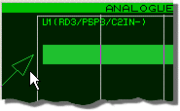

By using the Add Transient Trace dialogue form.

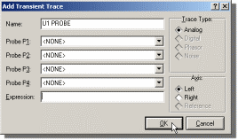

 See Adding Traces To A Graph for more information about adding traces to graphs.

It is often convenient to use the left and right y-axes to separate traces with different units. For example, if both voltage and current probes are displayed, then the left side can be used for voltage and the right side for current. It is possible to place a digital probe on an Analogue graph, but a Mixed graph is usually more appropriate.

***To perform a transient analysis of an analogue circuit***

1. Add generators as necessary around the circuit, to drive the circuit inputs.

2. Place probes around the circuit at points of interest. These may be at points within the circuit, as well as obvious outputs.

3. Place an Analogue Graph

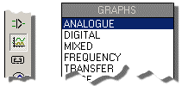

4. Add the probes (and generators, if desired) to the graph.

5. Edit the graph (point at it and press CTRL+'E', and set up the simulation s time required, as well as labelling the graph and setting control properties if required.

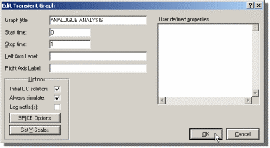

6. Start the simulation by either selecting the Simulate command or pressing the space bar.

 See Manual Y-Axis Configuration for information on defining y-axis limits.

 See Placing Generators for information on placing generators, and Generators and Probes for a discussion of the different types of analogue generators.

**Defining Analogue Trace Expressions**

You will normally want to add voltage and current probes to your graphs, to see the operation of a circuit. However, in an analogue transient analysis it is possible to create traces that are mathematical *expressions* based on probe values. For example, suppose a circuit output has both a voltage and current probe placed on it. By multiplying these values together, the output power at this point will be plotted.

**To plot the output power:**

1. Add a current probe and a voltage probe to the circuit output.

2. Invoke the *Add Transient Trace* dialogue form (press CTRL+'A') for the graph.

3. Assign the voltage probe to **P1**.

4. Assign the current probe to **P2**.

5. Alter the expression to read **P1*P2**.

6. Click on the **OK** button.

7. Press the space bar to invoke the simulation.

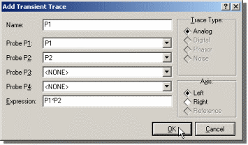

 See The Add Trace Command Dialogue Formfor a detailed description of the *Add Transient Trace* dialogue form.

**ANALYSIS TYPES**

**DIGITAL TRANSIENT ANALYSIS**

**Overview**

Digital graphs display what you would normally expect to see on a logic analyser. The x-axis shows the advance of time whilst y axis shows a vertical stack of signals. These can be either single data bits, or a representation of the binary values carried by a bus.

**Method of Computation**

Digital transient analysis is computed using a technique know as *Event Driven Simulation.* This is different from analogue transient analysis in that processing only occurs when some element of the circuit changes state. In addition, only discrete logic levels are considered and this enables component functionality to be represented at a far higher level. For example, we can think of a counter in terms of a register value that increments by one each time it is clocked, rather than in terms of several hundred transistors. These make event driven simulation several orders of magnitude faster than analogue simulation of the same circuit..

***The Boot Pass***

The purpose of the boot pass is to define the initial states of all nets in the circuit, prior to the simulation proper. The boot pass is carried out as follows:

• All input pins connected to the VCC and/or VDD nets are deemed to be high.

• All input pins connected to the GND and/or VSS nets are deemed to be low.

• All input pins connected to a net to which a generator is connected are to deemed to be at the same state as the **INIT** property of the generator.

• All remaining pins are deemed to be initially floating.

• All models are requested (in no set order) to evaluate their inputs and set their output pins accordingly. As each output pin is set, the state of the net to which the pin connects is re-evaluated.

• As nets change state, models connected to them are asked to re-evaluate their outputs. This process continues until a steady state is found.

***The Event Processing Loop***

Following the boot pass, DSIM begins the simulation process proper. The simulation is carried out in a loop which passes repeatedly through the following two steps:

• All the state change events for the current time are read off a queue and applied to the relevant nets. This process results in a new set of net states.

• Where a net changes state, all the models with input pins attached to the net are re-simulated. Where their outputs change state, this creates new events which are placed on the event queue.

Of course, different models will create events which fall due for processing at different times. The DSIM kernel thus has to order all the new events created at the end of each cycle round the loop.

It is also worth pointing out that our scheme quite happily supports models which have a zero time delay. In this context, events generated with the same time-code are processed in batches (one batch equals one trip round the loop), according to how they were generated.

***Termination Conditions***

Simulation ss when one of the following occurs:

• The specified s time is reached.

• The event queue becomes empty. This means that the circuit has reached a permanently stable condition.

• A logic paradox with zero time delay occurs such that the current time ceases to advance, despite repeated cycles round the event processing loop.

• A system error such as running out of event queue memory arises. This is unlikely to occur in normal use unless there is something unstable about your design, perhaps leading to a high frequency (e.g. 100MHz) oscillation somewhere.

**Using Digital Graphs**

**To perform a transient analysis of a digital circuit:**

• Add generators as necessary around the circuit, to drive the circuit inputs.

• Place probes around the circuit at points of interest. These may be at points within the circuit, as well as obvious outputs.

• Place a *Digital* graph.

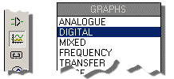

• Add the probes (and generators, if desired) to the graph.

• Edit the graph and set up the simulation S Time required, as well as labelling the graph and setting control properties if required.

• Invoke the Simualte Graph against the graph, or press the space-bar.

 Only Digital generators should be used to generate digital signals - note in particular that the Pulse generator is intended for generating analogue pulses.

 Only voltage probes should be used for probing digital nets - using current probes will force PROSPICE to perform a mixed mode simulation.

 See The Simulation Process for general information on how to simulate a graph.

 See Placing Generators for information on placing generators and Placing Probes for information on placing probes.

 See Adding Traces To A Graph for more information about adding probes to graphs

**How Digital Data is Displayed**

***Normal Traces***

All output values from the DSIM simulator engine is in terms of six digital states:

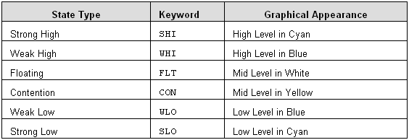

You can thus determine the state of a trace at a particular time, either by looking at the colour and position of the trace line, or by maximising the graph, positioning a cursor over the desired position, and reading the state off the status line. The logic levels at the cursor position are also displayed just to the right of the trace labels.

***Bus Traces***

Bus traces (resulting from the placement of voltage probes on bus wires) display the hex values of the bus bits between cross over lines:



Where one or more of the bus bits is neither high nor low, the bus line is drawn at the mid level. Also, if the edge transitions are too close together to display the hex value, then it is omitted. The value can still be established by positioning a cursor over it.

**ANALYSIS TYPES**

**MIXED MODE TRANSIENT ANALYSIS**

**Overview**

The mixed mode graph allows both digital traces and analogue waveforms to be displayed above the same x-axis which represents the advance of time. Mixed mode analysis is, in fact,used whenever a circuit contains both analogue and digital models, but the mixed mode graph is the only type capable of displaying both types ofwaveform simultaneously.

**Method of Computation**

Mixed mode transient analysis combines both the *Non-Linear Nodal Analysis* of SPICE3F5 with the *Event Driven Simulation* of DSIM. The detailed implementation of this is extremely complex, but the basic algorithm may be summarized as follows:

• Prior to simulation, each net is analysed to see whether analogue, digital or both types of model connect to it. Where analogue voltages drive digital inputs, *PROSPICE* inserts ADC interface objects, and where digital outputs drive analogue components, it inserts DAC interface objects.

Where several digital inputs are driven from the same net, multiple ADC objects are created so that different logic switching levels and loading characteristic can be modelled for each input. Similarly, in the rarer case of several digital outputs being connected together, multiple DAC objects are created.

• The operating point is established as described below.

• Simulation then proceeds as for a normal analogue analysis except that the ADC generate a digital event whenever their input voltages cross the switching threshold. As soon as this happens, the analogue simulation is suspended, and digital simulation is carried to establish the effect of these new events.

• When digital simulation results in a change of state for a DAC interface object, the analogue simulation is forced to simulate carefully around the switching time. In fact, the DAC outputs model a transition time (rise or fall) and a number of timepoints will be simulated during this period

***Finding the Operating Point***

Establishing the operating point is especially tortuous for mixed mode simulation, because the state of the analogue circuit affects the state of the digital components and vice versa. Essentially, PROSPICE proceeds as follows:

• Initial condition (IC) values are applied to both analogue and digital nets; other nets are assumed to start at zero volts.

• The nodal matrices are then constructed and solved as per normal SPICE simulation.

• For each such iteration, the digital circuit is re-processed to allow for changes in the input to the ADCs. Where such changes propagate through several digital models, the digital circuit is allowed to iterate to stability.

• DAC objects re-assign their outputs according to any changes of state in the digital circuit. If the digital circuit does not settle, this is ignored as it may be a transient citation.

• Iteration round this loop continues until a steady state is found, or until the iteration limit is reached.

**Using Mixed Graphs**

*Mixed* graphs are used in exactly the same way as Analogue graphs, except that you can add digital traces to them as well. To add the first digital trace to a mixed graph you should use the Add Trace dialogue form. Thereafter, dragging a probe on to the analogue part of the graph creates a new analogue trace, whilst dragging it onto the digital part creates a new digital trace.

**ANALYSIS TYPES**

**FREQUENCY ANALYSIS**

**Overview**

With *Frequency Analysis* you can see how the circuit behaves at different frequencies. Only one frequency is considered at a time, so the plots are *not* like those seen on a spectrum analyser, where all frequencies are considered together. Instead, the simulation is similar in effect to connecting a frequency generator to the input, and looking at the output with an AC voltmeter. As well as the *magnitude*, however, the *phase* of the probed signal can also be seen.

Frequency analysis produces frequency response or *Bode* plots. It is useful in checking that filters are behaving as expected, or that amplifier stages will work correctly across the required frequency range.

Frequency graphs can also be used to plot small signal input and output impedance against frequency.

**Method of computation**

Frequency analysis is performed by first finding the operating point of the circuit, and then replacing all the active components with linear models. The internal capacitances of the active devices are calculated at the operating point, and assumed not to vary much over the working voltage swings of the circuit. All the generators, apart from frequency reference generators (see below) are replaced by their internal resistances. This causes power lines to be effectively connected together, as is normally the case during frequency computations.

The analysis is then performed with complex numbers in a linear fashion. The frequency of interest is gradually increased from the starting to the concluding frequency in even increments. The linear nature of this analysis makes it typically much faster than transient analysis, even though complex numbers are used.

It is important to remember that frequency analysis assumes a linear circuit. This means that a pure sine wave at the input will produce a pure sine wave at the output, over all the frequencies probed. Of course, no real active circuit is purely linear but many are close enough to allow this form of analysis. There are also circuits which are not at all linear, such as line repeaters with schmitt trigger inputs. For non-linear circuits the term 'frequency response' has no real mathematical meaning, and so any frequency simulation will not produce meaningful results. Should you be interested in the frequency domain behaviour of such circuits, then *Fourier* analysis is much more appropriate.

**Using Frequency Graphs**

To calculate the magnitude of sine waves at the *output*, we must inject a reference sine wave at the *input*. PROSPICE will do this automatically, but needs to know where the input of the circuit is. To do this, you must give each frequency graph a '*Reference Generator*' to tell the simulator where to inject the reference signal. There are three ways of doing this:

• Use the *Reference* field on the *Edit Frequency Graph* dialogue form to select an input generator. This object can be any ordinary single pinned generator object, or the FREQREF primitive from the ASIMMDLS library.

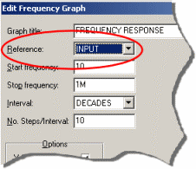

• Tag and drag any analogue generator onto the frequency graph.

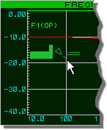

• Use the Add Trace dialogue form to add a generator as a **REF**.

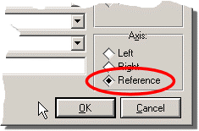

The FREQREF primitive is useful for defining models that drive the circuit - a microphone model for example. This could contain an explicit named generator, used as a reference when the effects of the rest of the microphone model (such as modelled frequency response) need to be taken into consideration.

The second and third techniques will be used more often. The action of dragging a generator onto a frequency graph is different to dragging it onto a transient graph. Instead of adding the generator's probe, the generator becomes the circuit reference point. The generator need not be a *Sine* generator - *DC*, *Pulse* and *Pwlin* will all work as well. If you want to add the generator as a probe, it can still be done using the Add Trace dialogue form.

The magnitude of the reference is always 1 volt, the phase is always 0 degrees. The internal resistance of the reference generator will follow whatever was defined for the generator in the first place. This is used for the dB calculations, i.e. 0dB = 1 volt. ISIS will limit very small values, to avoid log(0), to -200dB.

Frequency graphs always have both left and right y-axes. The left y-axis is used to display the magnitude of the probed signal, and the right y-axis is used to display the phase. If you drag a probe onto the left of the graph, it will display magnitude - if you drag it onto the right, the phase. The x-axis is used to display the frequency of the reference generator. A logarithmic scale is always used for the frequency. The left y-axis may be displayed either in dBs or normal units, and the right y-axis is always in degrees.

 See Manual Y-Axis Configuration for information on defining y-axis limits.

**To see the frequency response of a circuit:**

**1.** Place probes around the circuit at points of interest.

**2.** Place a *Frequency* graph.

**3.** Add the probes to it. Add to the left for magnitude, and to the right for phase. You may well want to add probes twice in order to see both phase and magnitude.

**4.** Edit the graph (point at it and press CTRL+'E') and set the required start and s frequencies, and any *Simulation Control Properties* required.

**5.** Press the space bar to invoke PROSPICE.

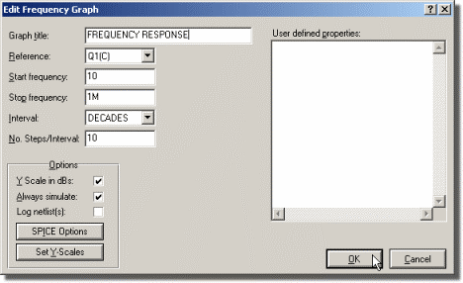

 The samples files ZIN.DSN and ZOUT.DSN show how to combine frequency graphs with trace expressions to plot input and output impedance.

**ANALYSIS TYPES**

**DC SWEEP ANALYSIS**

**Overview**

With a DC Sweep analysis you can see how *changing* a circuit will affect its operation. This is achieved using *Property Expression Evaluation* in the PROSPICE simulator engine. The sweep graph defines a variable that can be swept in even steps over a user-defined range. The sweep variable can appear in any property within the circuit, such as a resistor value, a transistor gain or even the circuit temperature.

A *DC Sweep* curve shows the steady state voltage (or current) levels of the probed points around the circuit, as the swept variable is increased. It can be used to plot the DC transfer characteristic of a circuit by assigning the swept variable to a generator value, as well as plotting the effect of changing component values on the operating point of the circuit.

**Method of computation**

In a *DC* sweep PROSPICE will repeatedly find the operating point of the circuit, incrementing the swept variable between calculations. PROSPICE will re-calculate all the variables used between steps, so the swept variable can be used as often as is required, and variables based on the swept variable can also be used. Any circuit initialisation parameters will be honoured for every operating point calculated.

**Using DC Sweep Graphs**

In common with analogue transient analysis (see Analogue Transient Analysis), either the left, right or both y-axes may be used. The graph x-axis shows the swept variable. Trace expressions, described in The Add Trace Command Dialogue Form, may be used in DC sweeps. When choosing the number of steps, bear in mind that simulation time is roughly proportional to the number of steps used.

**To plot the transfer function of a circuit:**

**1.** Place a *DC* generator on the input of the circuit. Set its value to be X.

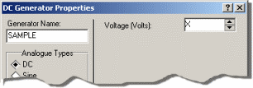

**2.** Place one or more probes at appropriate outputs of the circuit.

**3.** Place a *DC Sweep* graph, and add the probes to it - see Adding Traces To A Graph.

**4.** Edit the graph (CTRL+'E') and set the start and s values to the extremes of the input sweep that you want. Check that the swept variable is X.

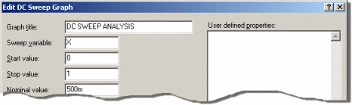

**5.** Press the space bar to invoke PROSPICE.

**6.** If the resulting traces look disjointed or angular when you zoom in on the graph, increase the number of steps in the *Edit DC Sweep Graph* dialogue form.

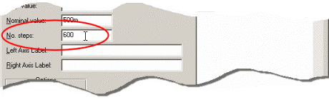

**To see the effect of altering circuit values:**

1. Set up the circuit as you would for a transient analysis. Add probes and generators at appropriate points in the circuit.

2. Edit the components whose values you are interested in. Set their values to be expressions containing X, the swept variable. You can edit just one, or several components.

3. Place a *DC Sweep* graph, and add the probes and generators to it - see Adding Traces To A Graph.

4. Edit the graph, and set the sweep parameters up accordingly.

5. Press the space bar to invoke PROSPICE.

 Remember that all dialogue forms in Proteus have context sensitive help available via a 'point and shoot'interface with the question mark at theright of the dialogue form.

**ANALYSIS TYPES**

**AC SWEEP ANALYSIS**

**Overview**

This type of analysis creates a family of frequency response curves for a different values of a swept variable.

The main use for this graph type is in seeing how a particular component value affects the frequency response of your circuit.

**Method of Computation**

This analysis is computed exactly as an ordinary frequency response except that multiple runs are performed, one run for each value of the sweep variable.

The restriction of a linear circuit applies to this analysis as it does for a normal frequency analysis - see Frequency Analysis.

**Using AC Sweep Graphs**

As with *Frequency* analysis, the left and right axes display gain and phase respectively. Also, an input generator must be specified as a reference point for gain calculations.

**To see the effect of altering a circuit parameter on frequency response:**

**1.** Set up the circuit as you would for a frequency analysis.



**2.** Edit the components of interest. Set their properties to be expressions containing **X**, the swept variable. You can edit just one, or several components.

**3.** Place an *AC Sweep* graph, and add the probes to it - see Adding Traces To A Graph.

**4.** If you do not have a generator on the input already, then place one.

**5.** Tag and drag a generator on the input of the circuit onto the graph to be the reference generator.

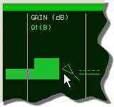

**6.** Edit the graph (CTRL+'E') and set the sweep parameters accordingly. Set the *Freq* parameter to the frequency of interest.

**7.** Press the space bar to invoke PROSPICE.

 See Manual Y-Axis Configuration for information on defining y-axis limits.

**ANALYSIS TYPES**

**DC TRANSFER CURVE ANALYSIS**

**Overview**

This graph type is specifically designed for producing characteristic curve families for semiconductor devices, although it occasionally finds other applications. Each curve consists of a plot of operating point voltage or current against the value of a nominated input generator which is swept from one DC value to another. An additional generator may also be stepped to produce a set of curves.

**Method of Computation**

This is very similar to the computation for a DC Sweep analysis except that two values can be swept. The operating point is found for the starting value of each generator and the first generator is then stepped through the specifiedrange. After each sweep of the first generator, the second generator’s value is incremented; a new curve is plotted for each discrete value of the second generator.

**Using Transfer Graphs**

In common with analogue transient analysis (see Analogue Transient Analysis), either the left, right or both y-axes may be used. The graph x-axis shows the first swept variable, and a separate curve results for each value of the second generator. Trace expressions, described in The Add Trace Command Dialogue Form, may also be used as required.

**To plot the transfer curves for an transistor:**

1. Set up a circuit similar to the one below:

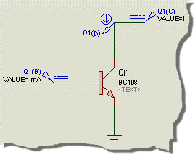

*Q1(B) is a current source and Q1(C) is a voltage source. Q1(D) measures collector current.*

2. Place a Transfer graph, and add the probe Q1(D) to it.

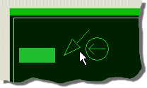

3. Point at the graph and press CTRL+E to edit it.

4. Assign Source 1 to Q1(C) and Source 2 to Q1(B).

5. Set the voltage and current ranges to something sensible for the transistor concerned - e.g. 0 -> 10V for Q1(C) and 100uA -> 1mA for Q1(B).

6. Adjust the number of steps for Q1(B) to give sensible intermediate values. Bear in mind that their will be one more curve than the number of steps, because one step implies two discrete values.

7. Close the dialogue form and select OK to simulate the graph.

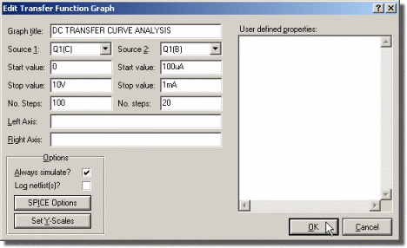

**ANALYSIS TYPES**

**NOISE ANALYSIS**

**Overview**

The SPICE simulator engine can model the thermal noise generated in resistors and semiconductor devices. The individual contributions of noise are summed together at a *voltage* probe in the circuit for a range of frequencies. The noise voltage, normalised with respect to the square root of the noise bandwidth, can then be plotted against frequency. Traces on a noise graph always have units of V/Hz.

Two types of noise figure are computed - *Output Noise* and *Equivalent Input Noise.* The computation of the latter enables comparison of the noise with the input signal, or input noise, since it represents the level of noise at the input that would be required to create the actually noise at the output taking into account the circuit gain at a particular frequency.

Placing a probe on the left axis displays output noise, whilst equivalent input noise can be displayed by dragging the probe onto the right axis.

Noise analysis tends to produce extremely small values (of the order of nanovolts). For this reason, there is the option to display them in dBs. The 0dB reference is 1V/Hz.

 *Correct modelling of noise for circuits involving IC macro models is not guaranteed in any way, because these models may well use linear controlled sources to model basic device behaviour only.*

**Method of calculation**

The operating point of the circuit is computed in the normal way, and then the circuit model is modified to correctly sum the noise contributions. All generators except the input reference are ignored in noise analysis (except during computation of the operating point) and so do not have to be removed before the analysis. The PROSPICE engine will compute the thermal noise for each voltage probe in the circuit, including those associated with generators and tapes, as it has no way of knowing which probes you wish to look at after the analysis. Noise currents are not supported, and the PROSPICE engine will ignore any current probes. A separate simulation is done for each probe in a noise analysis, so the simulation time is roughly proportional to the number of voltage probes placed.

**Using Noise Graphs**

When using noise analysis, it is important to remember that the effects of noise pick-up from external electric or magnetic fields are not modelled. In many situations where noise is critical the noise picked up in the input leads will dominate the noise performance of the system.

If you have partitioned the circuit using tapes (see TAPES AND PARTITIONING), you must be aware that only the current partition is considered by the PROSPICE simulator engine. A noise figure taken in isolation is still useful, but the tapes must be removed to see the equivalent noise of the entire circuit.

In order to determine the source of noise in the circuit, the individual noise voltages are entered in to the simulation log. Each probe is considered in turn, and the noise contribution for each component given. The contributions are computed, and printed, as squared values. This process is done at the starting and ending frequencies. If you have a large number of probes, there may well be a great deal of result data printed.

**To analyse the noise in a circuit:**

**1.** Place a *Noise* graph, and edit it to set the frequency range of interest, and the input reference generator.

**2.** Add the voltage probes at the circuit outputs, or other points of interest, to the graph. see Adding Traces To A Graph.

**3.** Press the space bar to invoke the PROSPICE simulator engine.

**4.** If the noise level needs to be reduced, examine the simulation log (CTRL+'V') to determine the source of the noise.

**ANALYSIS TYPES**

**DISTORTION ANALYSIS**

**Overview**

Distortion analysis determines the level of distortion harmonics produced by the circuit under test. These can be either the 2nd and 3rd harmonics of a single fundamental or the intermodulation products of two test signals.

Distortion is created by non-linearities in a circuit’s transfer function - a circuit comprising linear components only (resistors, capacitors, inductors, linear controlled sources) will not produce any distortion. SPICE distortion analysis models distortion for diodes, bipolar transistors, JFETs and MOSFETs.

 *Correct modelling of distortion for circuits involving IC macro models is not guaranteed in any way, because these models may well use linear controlled sources to model basic device behaviour only.*

Similar information can be established using a *Fourier* analysis, but the *Distortion* analysis is also able to show how the distortion varies as the fundamental frequency is swept.

**Method of Computation**

This analysis is based on the small signal (AC) models for the devices in the circuit so the first step is to compute the operating point. Each non-linear device model then contributes a complex distortion value for the appropriate harmonics, dependent on how much the device is seeing of the input fundamental. The extent to which these harmonics appear at the output determines the values plotted. The process is repeated across the specified range of input frequencies. In fact, the mathematics of this analysis is extremely complicated and involves the construction and manipulation of Taylor series to represent the device non-linearities.

Note that complex values are used, so the analysis yields information about both the magnitude and phase of each harmonic.

For single frequency harmonic distortion, two curves are produced for each trace on the graph - one for 2nd harmonic and one for 3rd harmonic.

For intermodulation distortion, two input frequencies are used, specified in terms of a ratio between the 2nd frequency (F2) and the fundamental (F1). Three curves per trace are displayed showing the intermodulation artefacts at F1+F2, F1-F2 and 2F1-F2.

Some care is needed in choosing the ratio F2/F1 since mathematically oddities can otherwise occur.For example, if F2/F1 is 0.5, the value of F1-F2 is F2 and the value of the F1-F2 plot will then be meaningless as it coincides with the second fundamental. In general you should try to choose irrational numbers for this ratio. F2/F1=49/100 would be a much better choice.

 Note that there is a constraint of F2/F1 < 1.

**Using Distortion Graphs**

Distortion graphs show the magnitude of harmonics on the left axis and the phase (normally of less interest) on the right axis. The test frequency (F1) is plotted on the x-axis.

For Harmonic Distortion analysis (one input frequency F1) two curves are plotted per trace, one each for the artefacts at 2F1 and 3F1.

For Intermodulation Distortion analysis (two input frequencies (F1 and F2) three curves are plotted per trace showing artefacts at F1+F2, F1-F2 and 2F1-F2.

In either case, which curve is which may be established by placing a cursor on the graph - the curve your are pointing at will be identified on the right hand side of the status bar.

**ANALYSIS TYPES**

**FOURIER ANALYSIS**

**Overview**

Fourier Analysis is the process of transforming time domain data into to the frequency domain and the result is similar to that obtained by connecting up a spectrum analyser instead of an oscilloscope. It is especially useful in analysing the harmonic content of signals, perhaps to look for particular types of distortion but has many other uses also.

**Method of Calculation**

Fourier analyses are created by first executing a *Transient Analysis* and then performing a Fast Fourier Transform on the resulting data. This process involves discrete time sampling of the time domain data with the result that the use Nyquist Sampling criterion applies. Put simply, this means that the highest frequency that can be observed is half that of the sampling frequency. However, other misleading effects can occur due to *aliasing* of the sampling frequency with harmonics of the input signal that are higher than half the sampling frequency. To minimize these effects, various types of *window* can be applied to the input data prior to the FFT.

**Using Fourier Graphs**

In the first instance, you need to set up your circuit as for a *Transient Analysis* except that you should use a *Fourier* graph instead of (or as well as!) an *Analogue* graph.

**To analyse the frequency content of a signal:**

**1.** Set up the circuit as for a *Transient Analysis*.

**2.** Add a *Fourier* graph to the design and drag probes connected to the points of interest onto it.

**3.** Choose start and s times and frequency/resolution values to suit the signal you are analysing. If possible, choose a time interval and frequency resolution that correspond to the fundamental frequency of the signal being analysed.

**4.** Press the space bar to invoke PROSPICE.

 See Manual Y-Axis Configuration for information on defining y-axis limits.

**ANALYSIS TYPES**

**AUDIO ANALYSIS**

**Overview**

*PROTEUS VSM* incorporates a number of features that enable you to *hear* the output from your circuits (providing you have a sound card, of course!). The major component of this is the *Audio* graph. This is essentially the same as an *Analogue* graph except that after simulation, a Windows WAV file is generated from the time domain data and played through your sound card.

The WAV files can also be exported for use in other applications.

**Method of Calculation**

Audio analyses are performed in exactly the same way as for *Transient Analysis* except that after simulation, the data is re-sampled at one of the standard PC sampling rates (11025, 22050 or 44100Hz) then written out in WAV format using the standard Windows functions provided for this purpose. Finally the command is sent to play the WAV file to your audio hardware.

**Using Audio Graphs**

In the first instance, you need to set up your circuit as for a *Transient Analysis* except that you should use an *Audio* graph instead of an *Analogue* graph.

**To listen to the audio output of a circuit:**

**1.** Set up the circuit as for a *Transient Analysis*.

**2.** Add an Audio graph to the design and drag a probe from the output of the circuit onto it.

**3.** Choose start, s times and loop times to generate a waveform of reasonable length with the minimum of actual simulation. Creating one second of audio by analysing 1ms and looping it 1000 times is dramatically faster than analysing the circuit for the whole 1s.

**4.** Choose a sample resolution and rate to suit the nature of the signal you want to hear. Use 16 bit resolution unless you are creating big files and/or are short of disk space. Most PC sound speaker systems will not benefit much from 44.1KHz sampling.

**5.** Press the space bar to invoke PROSPICE.

**6.** Press CTRL-SPACE to replay the audio, without resimulating, if required.

 You can also export audio data to a .WAV file and then, if required, load the WAV file (via an audio generator) into another schematic.

**ANALYSIS TYPES**

**INTERACTIVE ANALYSIS**

**Overview**

The Interactive Analysis type combines the advantages of interactive and graph based simulation. The simulator is started in interactive mode, but the results are recorded and displayed on a graph as with Transient Analysis.

This analysis is especially useful in examining what happens when a particular control is operated in a design, and may be thought of as combining a storage oscilloscope and logic analyser into one device.

**Method of Computation**

The method of computation is identical to that for a mixed mode transient analysis,except that the simulator is run in interactive mode. Consequently, the operation of switches, keypads and other actuators in the circuit will have an effect on the results. Also, the simulation will proceed at a speed determined by the *Animation Timestep¸* rather than at the maximum rate possible.

• Beware that very large amounts of data may be captured. A processor clocking at realistic speeds will generate millions of events per second and these will occupy many megabytes if captured and displayed on a graph - especially if you are probing data or address busses. You can quite easily crash your system if ISIS ends up loading 20 or 30Mb of results data.

You may do better to use the *Logic Analyser* if it is not possible to capture the required data in a relatively short simulation run.

• As with ordinary *Interactive Simulation*, multi-partitioning of the circuit is not supported and any tape objects not set to *Play* mode will be automatically removed from the circuit.

**Using Interactive Graphs**

The usual scenario for interactive analysis is that you are testing a design with interactive simulation, and find that something odd happens when particular controls are operated. In the first instance, you may try using the virtual instruments to see what is going on, but in some cases there is a need to capture the results to a graph and study them at your leisure.

**To perform an interactive analysis:**

**1.** Add probe objects to the points of interest.

**2.** Place an *Interactive* graph on a free part of the schematic and drag the probes onto it.

**3.** Edit the graph and choose appropriate start and s times. Note that PROSPICE will not capture data to the probes prior to the start time - this is to reduce the amount of data that will be pulled into ISIS.

**4.** Set any interactive controls on the schematic to suitable initial states.

**5.** Get ready to perform any interactive operations and then press the SPACE bar. You have to operate the active components within the time you chose in step 4 if the effect of these actions is to be recorded. If this proves difficult, you can either increase the s time, or reduce the *Timestep Per Frame* setting.

**ANALYSIS TYPES**

**DIGITAL CONFORMANCE ANALYSIS**

**Overview**

A conformance analysis compares one set of digital simulation results against another. The idea is that a design that has been previously accepted as working can be quickly re-tested after modification in order to prove that there have been no unwanted side effects from the change. This is particularly relevant in micro-controller based applications where the entire application may need to be re-tested after changes have been made to the firmware code.

**Method of Computation**

The method of computation is identical to that for a digital transient analysis, except that two sets of results can be stored in the graph. We call the two sets of results the *test results* and the *reference results.*

Conformance or non-conformance is determined by comparing the test and reference results at each edge of the first trace. We call this trace the *control* *trace* and it is displayed in a different colour to distinguish it from the others. Very significantly, there is no requirement for the edges in the test and reference copies of the control trace to occur at the same times. This means that changes in the absolute timing of events within the result data do not necessarily imply non-conformance. This is particularly relevant in micro-controller applications where *any* changes to the code will be bound to affect the absolute timing of events within the system. In such cases, the control trace may be generated by the code itself, on entry and/or exit to the software routines under test.

**Using Conformance Graphs**

Typically, conformance analyses will be used as part of atest strategy, most usually in an embedded systems application although we also use them in-house for testing our simulator models. In the simple example, below, will show how to use a conformance graph to test the operation of 555 monostable.



The circuit under test consists of U1, R1 and C2 which are wired as a classic 555 monostable. The circuit is triggered at 1ms by a digital pulse generator, and the resulting output waveforms are displayed on the analogue analysis graph. To test the correct operation of the circuit, it would be reasonable to establish the following facts:

• That the output is low before the trigger pulse.

• That the output goes high soon after the trigger goes low.

• That the output remains high when the trigger returns high.

• That the output remains high for a period of around 1.5ms.

• That the output returns low after this time.

To achieve this using the conformance graph, we need sample the output data around each edge transition of the trigger signal, and also at either side of the output signal. We can determine an tolerance for the delay time of the monostable by choosing the spacing between the last two sampling points.

This is achieved using a series of digital pulse generators whose outputs are combined using an OR gate. The width setting on each pulse generator determines the timing tolerance for each expected event. For example, the third pulse generator is set to trigger between 2.4ms and 2.6ms, giving timing tolerance of +/- 100us on the width of the expected output pulse.

Note that you could have use a digital clock or pattern generator to generate the control signal; the use of a simple clock will result in verification at regular time intervals which will, in fact, suffice for many applications.

The general procedure may be summarized as follows:

**To set up a conformance analysis:**

**1.** Decide on what exactly you want to test and at what times.

**2.** Design a test case schematic which generates the outputs you wish to verify and a control signal that changes state at each time you wish to validate the results.

**3.** Place a conformance graph and set it up exactly as you would for a *Digital Analysis,* making sure that the control trace is at theof the graph.

**4.** Run the simulation and verify that the results are as expected, and that the transitions on the control trace occur at the times that you wish to verify the results.

**5.** Edit the conformance graph and press the *Store Results* button. This will make the currently displayed results into the reference results. These then are displayed in a dimmed colour and the graph will compare any new results against them when it is re-simulated.

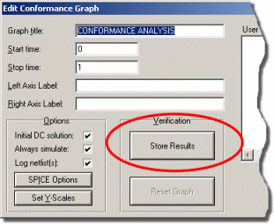

**6.** Save the design - it is now ready to be used for verification purposes at a future date.

Let us now suppose that due to component shortages, the values of R1 and C2 must be changed. If we make C2 100nf,can we make R1 15k, and will the design still work within spec? The results of this experiment are shown below:



The answer is no. The output pulse is now slightly too short, and the following information appears in the simulation log for the graph:

**Comparing Results...**

**Data mismatch at time 2.40m in trace 'Output'.**

**Data signatures were 'L' and 'H'.**

**Conformance analysis FAILED.**

 Note the graph cursor is positioned at the time of the first discrepancy i.e. 2.4ms

There are in fact three ways to invoke a conformance analysis:

• By re-simulating the graph in the usual way - e.g. by pressing the space bar or using the Simulate Graph command on the *Graph* menu.

• Using the Conformance Analysis command on the *Graph* menu. This re-simulates all the conformance graphs in the design and reports any errors.

• For advance users only - from the command line. Entering

ISIS <filename> /V

will perform a global conformance analysis as above.If any graph fails ISIS sets an error level of 1. This allows multiple test-cases to be automatically validated from a batch file.

**GENERATORS AND PROBES**

**GENERATORS**

**Overview**

A *generator* is an object that can be set up to produce a signal at the point at which it is connected. There are many types of generator, each of which generates a different sort of signal:

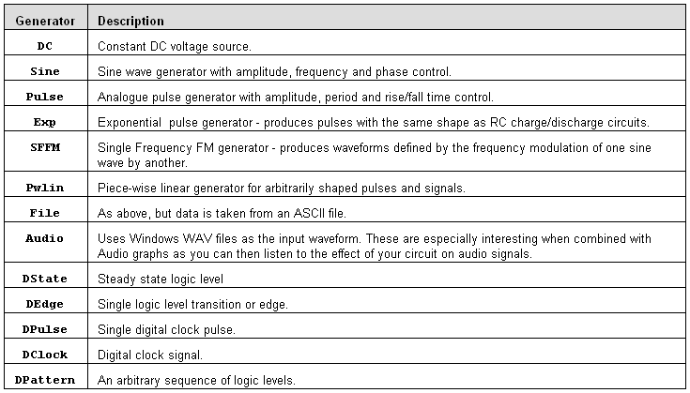

**Placing Generators**

**To Place a Generator:**

**1.** Obtain a list of generator types by selectingthe Generator icon. The list of generator types is then displayed in the Object Selector.

**2.** Select the type of generator you wish to place from the selector. ISIS will show a preview of the generator in the Overview Window.

**3.** Use the Rotation and Mirror icons to orient the generator according to how you want to place it.

**4.** Place the mouse in the Editing Window, press down the left mouse button and drag the generator to the correct position. Release the mouse button.

You can place a generator directly on to an existing wire by placing it such that its connection point touches the wire. Alternatively you can place several generators in a free area of your design, and wire to them later.

When a generator is placed unconnected to any existing wires, it is given a default name of a question mark (?) to indicate that it is unannotated. When the generator is connected to a net (possibly when placing it if it is placed directly onto an existing wire) it is assigned the name of the net, or, if the net itself is unannotated, the component reference and pin name of the first pin connected to the net. The name of the generator will automatically be updated as it is unwired or as it is dragged from one net to another. You can assign your own name to the generator by editing the object, in which case the name becomes permanent and is not updated.

 See the section on net names in the ISIS manual for an explanation of nets andnet-naming.

**Editing Generators**

Any generator may be edited using any of the general ISIS editing techniques, the easiest of which are either to click right (to tag) and then left (to edit), or to point at the generator and press CTRL+E.

The Edit Generator dialogue form provides a number of common fields and then a further set of fields that change according to the generator’s type. The common fields are explained below:

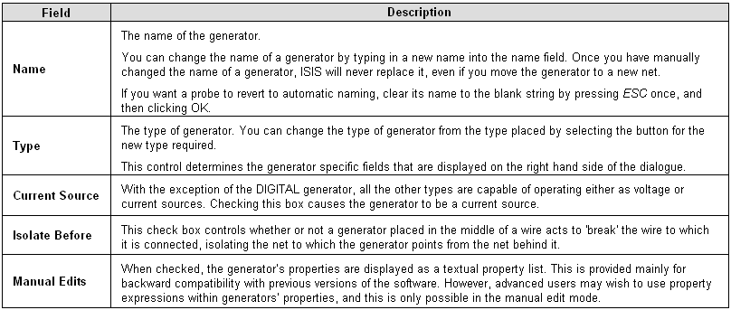

**DC Generators**

The *DC* generator is used to generate a constant analogue DC voltage or current level. The generator has a single property which specifies the output level.

**Sine Generators**

The *Sine* generator is used to produce continuous sinusoidal waves at a fixed frequency.A number of parameters can be adjusted:

• The output level is specified as a peak amplitude (VA) with optional DC offset (VO). The amplitude may also be specified in term of RMS or peak-peak values.

• The frequency of oscillation can be given in Hz(FREQ), or as a period (PER), or in terms of the number of cycles over the entire graph.

• A phase shift can be specified in either degrees (PHASE) or as a time delay (TD). In the latter case, oscillation does not start until the specified time.

• Exponential decay of the waveform after the start of oscillations is specifiedby the damping factor, THETA.

 Mathematically, the output is given by:



for t >= TD.For t < TD the output is simply the offset voltage, VO.

**Pulse Generators**

The *Pulse* generator is used to produce a variety of repetitive input signals for analogue analyses. Square, saw-tooth and triangular waveforms can be produced, as well as single short pulses.. Note that the rise and fall times cannot be zero, so a truly square wave is not allowed. This is because instantaneous changes in general are not allowed in PROSPICE. The operation of the pulse generator is best described by the following diagram:

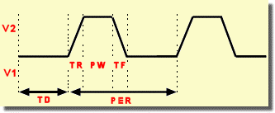

where

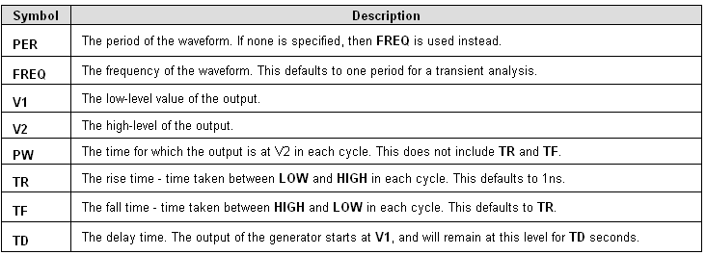

**Exponential Generators**

The *Exp* generator produces the waveforms as an RC circuit under charging and discharging conditions. The parameters are best described by the diagram overleaf.

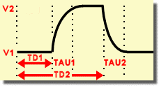

where the parameters are

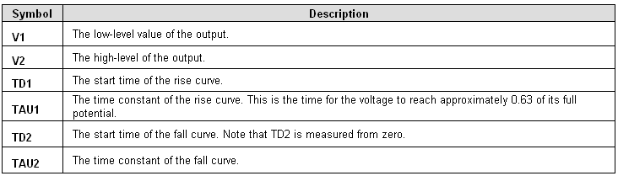

Mathematically, the waveform is defined in three sections:

0 to TD1 

TD1 to TD2 

TD2 to TS 

**Single Frequency FM Generators**

The *SFFM* generator produces a waveform that represents the result of frequency modulating one sine-wave with another. Mathematically, this is represented as:



where the parameters are:

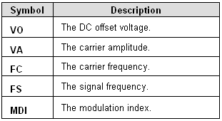

**Piece-wise Linear Generators**

The *Piece-wise Linear* generator is used to produce analogue signals which are too complicated for a pulse generator, or to re-produce a measured waveform. The output waveform is described using pairs of values for time and output magnitude. The output of the generator at intermediate times is then linearly interpolated between the given times.

The piece-wise linear generator dialogue form consists of a graph editor onto which you can drag and drop data points. Operation can be summarized as follows:

• To place a new data point click left.

• To move a data point, drag it using the left mouse button.

• To delete a data point click right.

The following constraints apply:

• There must always be a point at time zero, although its y-value can be changed- i.e. you can only drag it up or down.

• If you attempt create a vertical edge, the graph editor will separate the two data points by the minimum rise/fall time value.

If you have tabular data, you may find it easier to use manual edit mode. In this case, each data point is specified by a property of the form **V(t)**. The following example shows how this works.

V(0)=0

V(2n)=0

V(3n)=1

V(5n)=1

V(6n)=0

If you have a large amount of data, you may find it easier to use a FILE generator instead.

**File Generators**

The *File* generator is used to drive a circuit from an analogue signal that is specified by series of time points and data values contained in an ASCII file. It is thus very similar to the piecewise linear generator except that the data values are held externally rather than being given as device properties.

The dialogue form has only one field, which specifies the name of the data file. There is no default extension for these files, and the file should be located in the same directory as the design file unless a full path is specified.

***Data File Format***

The ASCII data file should be formatted with one time/voltage pair on each line separated by white space (spaces or tabs, not commas). The time values must be in ascending order, and all values must be simple floating point numbers (no suffixes allowed).

***Example***

The following example data file produces three cycles of a saw-tooth waveform with rise time 0.9ms,fall time 0.1ms and amplitude 1V.

0 0

9E-4 1

1E-3 0

1.9E-3 1

2E-3 0

2.9E-3 1

3E-3 0

**Audio Generators**

The *Audio* generator is used to drive a circuit from a Windows WAV file. In conjunction with *Audio* graphs they make it possible to hear the results of processing a sound signal through a simulated circuit.

• The filename is assumed to have a default extension of WAV, and should be located in the same directory as the DSN file unless a full path is specified.

• The amplitude can be specified either in terms of the maximum absolute value for positive and negative excursions, or as a peak to peak value.

• A DC offset can be specified; if this is zero the output voltage will oscillate about zero.

• For stereo WAV files, you can select which channel is played, or whether to treat the data as mono.

**Digital Generators**

There are four sub-types of digital generator:

• Single Edge - a single transition from low to high or high to low.

• Single Pulse - a pair of transitions in opposite directions which together form a positive or negative pulse waveform. You can specify either the times of each edge (start time and s time) or the start time and the pulse width.

• Clock - a continuous pulse train of even mark-space ratio. You can specify the starting value and the time of the first edge as well as the period or frequency. The period specifies the time for a whole cycle, not the width of a single mark or space.

• Pattern - this is the most flexible and can, in fact, generate any of the other types. The pattern generator is defined in terms of the following parameters:

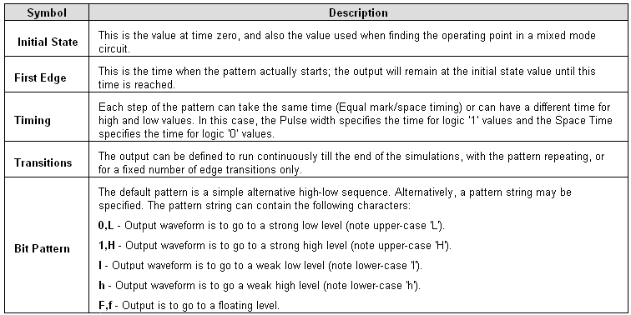

**Scriptable Generators**

Scriptable generators allow complex analogue or digital waveforms to be described using a simple programming language called *EasyHDL*. Not only can you programmatically define the waveform or signal stream to be injected into the simulation but you can also debug your script during simulation to verify correct operation. This, together with the simplicity and flexibility of the *EasyHDL* language, gives the user complete control over signal stimulus. More information can be found here.

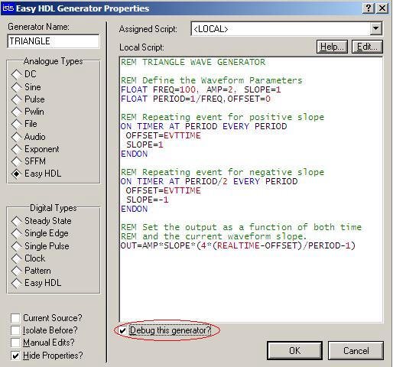

*Simple Triangle Wave Generator in EasyHDL specified as active for debugging.*

**GENERATORS AND PROBES**

**PROBES**

**Overview**

A *probe* is an object that can be set up to record the state of the net to which it is connected. There are two types of probe:

• Voltage probes - these can be used in both analogue or digital simulations. In the former they record true voltage levels, whilst in the latter they record logic levels and their strengths.

• Current probes- these can only be used in analogue simulations, and must be placed on a wire such the wire passes through the probe. The direction of measurement is indicated by the current probe graphic.

 *You cannot use current probes in digital simulations, or on buses.*

Probes are most normally used in Graph Based Simulations, but can also be used in interactive simulations to display operating point data and to partition the circuit.

**Placing Probes**

**To Place a Probe:**

**1.** Select the Voltage Probe or Current Probe icon. ISIS will show a preview of the probe in the Overview Window.

**2.** Use the Rotation and Mirror icons to orient the probe according to how you want to place it.

 Note that, for a Current Probe correct orientation is important. Current flow is measured in the direction indicated by the arrow enclosed in a circle which forms part of the probes symbol.

**3.** Place the mouse in the Editing Window, Click the left mouse button to attach the probe to the mouse, drag the probe to the correct position and then click left to drop the probe on to the wire.

You can place a probe directly on to an existing wire by placing it such that its connection point touches the wire. Alternatively you can place several probes in a free area of your design, and wire to them later.

When a probe is placed unconnected to any existing wires, it is given a default name of a question mark ('?') to indicate that it is unannotated. When the probe is connected to a net (possibly when placing it if it is placed directly onto an existing wire) it is assigned the name of the net, or, if the net itself is unannotated, the component reference and pin name of the first pin connected to the net. The name of the probe will automatically be updated as it is unwired or as it is dragged from one net to another. You can assign your own name to the probe by editing the probein which case the name becomes permanent and is not updated.

**Probe Settings**

The *Edit Probe* dialogue form allows two parameters to be adjusted:

***LOAD Resistance***

Voltage probes may be set to impose a load resistance on the schematic. This is useful where there would otherwise be no DC path to ground from the point being measured.

***Record Filename***

Both current and voltage probes can record data to a file which can then be played back using a *Tape Generator*. This feature allows you to create test waveforms using one circuit and then play them back into another.

 See *Tapes and Partitioning*for more information.

**USING SPICE MODELS**

**Overview**

Many of the major component manufacturers now provide SPICE compatible simulator models for their product lines. Since PROSPICE is based on the original Berkeley SPICE code, you should have relatively few problems in using such models. However, there are a number of issues which you need to understand before attempting to use 3rd party models:

• A SPICE model is an ASCII netlist file. It contains no graphical information at all and cannot therefore be placed directly on a schematic. This means that you will need an ISIS library part for the device concerned as well as the SPICE model. Sadly, there is no standard file format whatsoever for schematic library parts, so you will usually need to draw this yourself.

• In a SPICE netlist, a model is called up by referring to a subcircuit using an X card. The binding of circuit nodes to model nodes is determined by the order in which circuit nodes are given on the X card. For example

XU1 46 43 32

means that node 46 of the circuit is connected to node 1 of the model. Similarly node 46 binds to node 2 and node 32 binds to node 3.Unfortunately, this scheme means that the model nodes are not named. Worse still, there is rarely any tie up between the model node numbers and the physical device pin numbers - for one thing, the physical package may have NC (not connected) pins, and these are hardly ever accounted for in numbering the nodes of a SPICE model. There can also be major complications with a multi-element device such as a TL074 - does the model implement one op-amp or four?

In practice, this means that some kind of explicit cross-referencing is needed to tell ISIS which SPICE model node number to use for each pin on the device, since neither the ISIS pin name nor the pin number can be used for the reasons given above. A special device property **SPICEPINS** has been introduced to make this as painless as possible.

• There are many variants of SPICE in existence. The lowest common denominator is SPICE 2 and most models appear to be written to this standard. However, a significant number of manufacturers declare their models to be compatible with PSPICE™, a proprietary version of SPICE 2 which has been developed extensively beyond the original standard. Whilst SPICE3F5 has many features not supported by PSPICE ™, PSPICE ™ has some primitive types that are different, and also uses a different syntax for some of the newer things that have been added to both products. The implication is, of course, that models specifically written for PSPICE™ may not work with PROSPICE.

 In short, if a 3rd party model does not work properly, the first thing to check is that it was actually written for SPICE 2 or SPICE 3.

The really good news is that we ourselves have gathered together a large number (well over 1500 at the time of writing) of manufacturers’ models and created corresponding ISIS library parts for them.

***You must, of course, appreciate that we can accept no responsibility for the accuracy or even functionality of these models, and that both ourselves and the manufacturers concerned disclaim any liability for losses of any kind whatsoever arising out of their use. In any case, there is never any guarantee that a circuit simulation will exactly reflect the performance of the real hardware and it is always advisable to build and test a physical prototype before entering into large scale production.***

**USING SPICE MODELS**

**Using a SPICE Subcircuit (SUBCKT definition)**

Our first example is an LMC660 OPAMP model held in the SPICE file SPICEMOD.LIB. This is provided as the file SPICE1.DSN in the samples directory and is shown below.

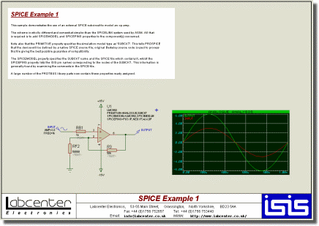

*A screenshot of the schematic SPICE1.DSN which is in the "..\samples\Simulation Directory"*

The op-amp component has been given three property assignments - **PRIMITIVE**, **SPICEMODEL** and **SPICEPINS**. Taking each of these in turn:

PRIMITIVE=ANALOGUE,SUBCKT

This assignment is the always the same for a component that is modelled by a SPICE subcircuit. It signifies that the component is to be simulated directly by SPICE3F5 and that it is represented by a SPICE subcircuit, rather than being an actual SPICE primitive.

SPICEMODEL=LMC660,SPICEMOD.LIB

This line indicates the name of the subcircuit to use, and the name of the ASCII file that contains the subcircuit definition. Alternatively you could use

SPICEMODEL=LMC660

SPICEFILE=SPICEMOD.LIB

Some manufacturers supply many models in one file, others supply one file per model. It matters not. The subcircuit name must match exactly that used in the model file, so if the subcircuit were called LMC660/NS you must include exactly this text in the **SPICEMODEL** property.

SPICE model files are searched for in the current directory, and on the *Module Path* as specified on the *Set Paths* dialogue form.

SPICEPINS=POS IP,NEG IP,V+,V-,OP

The **SPICEPINS** property deals with the issue of binding ISIS pin names to SPICE model node numbers. To understand how this property is used, you need to look at the comments in the original SPICE model file:

**\*/////////////////////////////////////////////////////////**

**\*LMC660AM/AI/C CMOS Quad OP-AMP MACRO-MODEL**

**\*////////////////////////////////////////////////////**

**\***

**\* connections:non-inverting input**

**\* | inverting input**

**\* | | positive power supply**

**\* | | | negative power supply**

**\* | | | | output**

**\* | | | | |**

**\* | | | | |**

**.SUBCKT LMC6601 2995041**

**\***

The ‘diagram’ lists the pin functions and their ordering on the SUBCKT line. It is important to realise that the *numbers* assigned relate to the internals of the model definition and are not in fact relevant to our purpose.The key information is that the non-inverting input is the first node, the inverting input the second and so on. This determines how you construct the value of the **SPICEPINS** property, in that you give the ISIS pin names in the corresponding order. Pin names with spaces are OK, but be careful not to leave spaces before the commas. Alternatively you can put each pin name in quotes - this is essential if you have a pin name that contains a comma.

You need, of course, to know the ISIS pin names which are often hidden. These can be established by moving the mouse over the pin ends of the component, and observing the status line.

**USING SPICE MODELS**

**Using a SPICE Model (MODEL card)**

For semiconductor devices, specifically diodes, transistors, JFETs and MOSFETs, SPICE models are usually specified in terms of a single MODEL card. This lists the parameter values for the appropriate SPICE primitive. The procedure is similar to that for a SUBCKT model, but actually a little simpler because the issue of pin name translation does not arise. Additionally, ISIS library parts already exist for the various types of SPICE primitive - you will find them in ASIMMDLS.LIB.

Our second example, then, is a 2N2222 transistor, again held in the ASCII file SPICEMOD.LIB. This is provided as the file SPICE2.DSN in the samples directory.

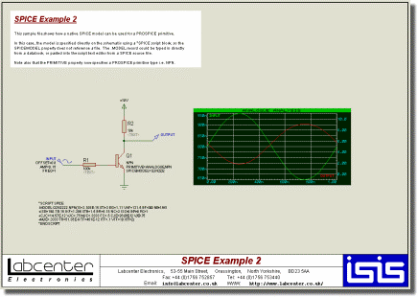

*A screenshot of the schematic SPICE2.DSN which is in the "..\samples\Simulation Directory"*

The transistor has been given two property assignments - **PRIMITIVE** and **SPICEMODEL**.

Taking each of these in turn:

PRIMITIVE=ANALOGUE,NPN

This assignment indicates that the device is to be simulated directly by PROSPICE as an NPN type primitive. If you pick a diode, transistor, JFET or MOSFET from the ASIMMDLS library, it will have the appropriate **PRIMITIVE** assignment already in place.

SPICEMODEL=Q2N2222,SPICEMOD.LIB

The SPICEMODEL assignment is essentially the same as for a SUBCKT model. It specifies the name of the model to use and the SPICE netlist file that contains it. Most manufacturers supply lots of MODEL definitions in a single file.

SPICE model files are searched for in the current directory, and on the *Module Path* as specified on the *Set Paths* dialogue form.

**USING SPICE MODELS**

**Spice Model Libraries**

The 3rd party SPICE model libraries supplied with PROSPICE are contained in *binary* library files similar to ISIS device and symbol libraries. We have done this for two reasons:

• Many model files are extremely small and numerous and would waste a tremendous amount of space on hard disks with large cluster sizes if stored individually.

• When many models are contained in a single ASCII file, PROSPICE has to parse the whole file to use just one model and this is relatively slow.

Where a SPICE model is contained in a SPICE model library (SML), the syntax for binding it to an ISIS library part is slightly different. For example, the LMC660 in the first example would instead have the properties:

**PRIMITIVE=ANALOGUE,SUBCKT *(as before)***

**SPICEMODEL=LMC660**

**SPICEPINS=POS IP,NEG IP,V+,V-,OP *(as before)***

**SPICELIB=NATSEMI**

The **SPICELIB** property gives the name of the SPICE model library file that contains the part. These files are searched for in the current directory, and on the *Module Path* as specified on the *Set Paths* dialogue form.

SPICE model libraries can be manipulated with the command line tools PUTSPICE.EXE and GETSPICE.EXE although we do not expect that ordinary users to create or gather sufficient numbers of models to warrant their use. Running either program without parameters will give usage information.

**USING SPICE MODELS**

**\*SPICE Scripts**

It is actually possible to type SPICE model definitions directly into ISIS and then call up the models from the relevant components on the schematic. For example, the transistor model for the 2N2222 could be entered into an ISIS script as follows:

**\*SCRIPT SPICE**

**.MODEL Q2N2222 NPN(IS=3.108E-15 XTI=3 EG=1.11 VAF=131.5 BF=300 NE=1.541**

**+ISE=190.7E-15 IKF=1.296 XTB=1.5 BR=6.18 NC=2 ISC=0 IKR=0 RC=1**

**+CJC=14.57E-12 VJC=.75 MJC=.3333 FC=.5 CJE=26.08E-12 VJE=.75**

**+MJE=.3333 TR=51.35E-9 TF=451E-12 ITF=.1 VTF=10 XTF=2)**

**\*ENDSCRIPT**

The transistor’s **SPICEMODEL** property would then be changed to

SPICEMODEL=Q2N2222

i.e. no filename specified.

This feature might be most useful where a model is obtained on paper, or where you want to experiment interactively with the parameter values.

**USING SPICE MODELS**

**Handling Model Simulation Failures**

Subcircuit models vary greatly in complexity and design. As a result, some models are easier to simulate than others. As a general rule, if PROSPICE could not simulate your circuit with its translated model, then not much else could either.

We have often found that problems are greatly worsened by poor circuit design. If you have an application note for the device, then compare it with your circuit to see if, for example, you are not allowing enough input current to bias the input stage successfully. The model designer almost certainly made the model work with circuits similar to those in an application note, rather than in a general case.

ProSPICE can be made more stable (but less accurate) by increasing the value of **GMIN**. The default is 1E-14, so good values to try are 1E-13 and 1E-12. At values like 1E-6, it is likely that any simulation results will bear no relation to reality at all, so pick the lowest value you can.

**ADVANCED ICS**

**GROUND AND POWER RAILS**

**Why You Need a Ground**

All simulations require a ground net be defined - otherwise, placing a probe on a particular net has no meaning as the voltage on that net must be defined in terms of a fixed reference point. In fact, there is a further requirement that all parts of the circuit must have a DC path to ground, as probing a point in the circuit that is attached to a floating network is equally meaningless. For example, in the circuit below, asking for the voltage atVB is meaningless

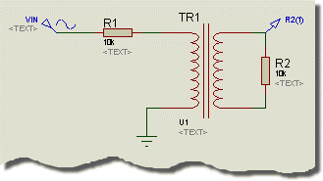

because the secondary side is floating. In theory, we could have provided two pinned probes (as with a real multimeter) but there are serious mathematical difficulties in solving circuits without a ground, and more to the point, Berkeley University have not addressed them in SPICE3F5.

The key point, then, is that all sections of your circuit must have a DC path to ground. The good news is that ProSPICE checks this for you, and will report as warnings any nets which it considers do not meet this criterion. In most cases, the simulation will then fail.

Another circuit configuration which has caused trouble in the past is shown below:

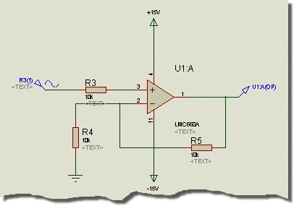

Here, the presence of coupling capacitor C1 means that the output probe has no DC path to ground. Consequently, the simulator cannot resolve the operating point for the output, because the operating point is computed with all capacitors open circuit. We have chosen to resolve this by making capacitors very slightly leaky. Therefore, in the absence of any other DC path, the operating point at the output is computed with C1 fully discharged.

The leakyness of capacitors is determined by the simulator control property GLEAK, which is an admittance with default value 1E-12Mho. Setting this value to zero makes capacitors non leaky, as with traditional SPICE simulators.

Apart from the simulation of the innards of DRAM memory circuitry we cannot foresee any problems with this scheme, and it will save relative beginners from many strange error messages. In any case, real capacitors generally have leakage considerably more than a million megohms.

The ground net in a circuit can be defined either explicitly or implicitly. An explicit ground is defined by placing an unlabelled *Ground* terminal, as on the bottom end of RF2, above. You can also label a wire with the text **GND** if space is tight.

An implicit ground can be created through the use of a power rail, single pinned generator, loaded probe or a digital output, as well as by using any model that contains an internal grounded node.

**Power**

In general you should specify the power supply voltages for your simulations using the *Power Rail Configuration* dialogue form in ISIS - you can access this from the *Design* menu.

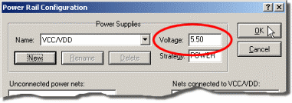

There are essentially two stages to using this form:

• Create one or more power supplies as required using the *New* button. Once you have created each supply, you can set its voltage via the *Voltage* field.

• Connect one or more power nets to each power supply by highlighting the names in the left hand list and then clicking the *Add* button.

Note also:

• Power nets are created as a result of placing power terminals on the schematic and also when your design uses devices which have hidden power pins.

• You cannot simulate a design which has unconnected power nets - attempting to do so will result in error(s) from the netlist compiler.

• You can also define power supplies on the schematic by placing power terminals with names of the form +5, -5 or +10V, -10V. The ‘+’ and ‘-‘ symbols are crucial; a label such as 5.0V will not do

• ISIS provides a default power rail configuration which powers VCC/VDD at +5V and VEE at -5V. VSS and GND are assumed to be interconnected. These defaults mean that most TTL, CMOS and microprocessor devices from the standard libraries can be simulated withoutthe need to explicitly define any power supply connections.

 Further information on *Power Rail Configuration* may be found in the ISIS manual.

**ADVANCED ICS**

**INITIAL CONDITIONS**

**Overview**

Whenever any type of simulation is performed, the first thing that PROSPICE does is to compute the operating point of the circuit - that is the steady state conditions that apply prior to any input signals being applied. There are two distinct modes of operation associated with computing these values:

• The operating point is found with all capacitors charged and inductors fluxed. In this case, a *Transient* Analysis will show the behaviour of the circuit as though power were applied sufficiently prior to time zero that by the start of the simulation everything had settled down. This is the default mode of operation, and given the ability to specify initial conditions for particular components and/or node voltages, serves for most purposes.

• The operating point is found with all capacitors short circuited and inductors open circuit. In this case, a *Transient Analysis* will show the behaviour of the circuit as though power were applied at time 0. This mode of operation can be selected by unchecking the *Compute Operating Point* option on the graph.

In either case, it is possible to specify the initial conditions for particular components or node voltages. This is especially useful for circuits which are oscillators, or for which circuit operation depends on particular capacitor being discharged at time zero. Indeed, the concept of a steady state operating point is meaningless for an oscillator, and the simulation may fail completely if some initial conditions are not given.

**Specifying Initial Conditions for a Net**

The easiest way to specify initial conditions is often to indicate the starting voltage for a particular net.

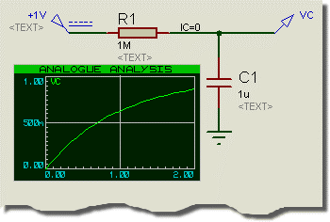

In the above circuit, this is achieved by adding a wire label with the text IC=0 to the probed net. Without this assignment, PROSPICE would compute the steady state value of the voltage on C1 i.e. 1 Volt and the graph would show VC as a horizontal straight line.

For nets which interconnect only digital components, you should use logic states for initial conditions - e.g. **1**,**0**,**H**,**L**,**HIGH**,**LOW**,**SHI**,**WHI**,**SLO**,**WLO** or **FLT** and assign them to the **BS** (Boot State) property. For mixed nets, you should specify an initial voltage - this will be automatically propagated as a logic level to the digital components.

**Specifying Initial Conditions for Components**

This option is only available when PROSPICE does not compute the initial operating point - i.e. when the *Initial DC Solution* option on the graph is not checked. In this case, all node voltages will be zero at time zero, except for nets with initial condition properties as described above. Under these conditions, it is then possible to specify initial conditions for particular components. For example, you could add the property

IC=1

to C1 in the previous example such that C1 started from its steady state value of 1 Volt.

Details of the IC properties supported by the various SPICE primitives are given in the chapter on modelling.

In some ways it is a shame that this option is not available when the operating point *is* computed, but this is how SPICE3F5 has been coded by Berkeley. However, we have added the **PRECHARGE** property as a remedy to this problem.

**NS (NODESET) Properties**

Occasionally, when a simulation fails to find the operating point, it can be useful to give SPICE a hint as to the initial values to use for particular nets. This is different from setting the initial conditions in that the value given is only used for the first iteration, and the net then ‘floats’ to whatever value the matrix solution converges at. It is, then, an aid to convergence and should not affect the actual operating point solution.

Such convergence hints can be specified using the **NS** net property, so placing a wire label with the text NS=10 will suggest a starting value of 10 Volts for that net.

**PRECHARGE Properties**

A further option for specifying the initial conditions is the **PRECHARGE** property. This may be assigned to any capacitor or inductor in the circuit and specifies either voltage across the device or the current flowing through it respectively.

The **PRECHARGE** property is a Labcenter specific addition to SPICE, and differs from the IC property in that it is applied irrespective of whether the *Initial DC Solution* option is selected or otherwise.

**ADVANCED ICS**

**TEMPERATURE MODELLING**

The SPICE3F5 kernel provides extensive support for modelling the effects of temperature. The scheme operates as follows:

• There is a global property **TEMP**, which will, if nothing else is done, apply to all components in the circuit.

• The temperature of individual components can be specified by giving them their own **TEMP** property.

• Where parameters for a device model vary according to the temperature at which they were measured, this temperature can be specified globally and/or individually by **TNOM** properties.

Temperature modelling is provided for resistors, diodes, JFETs,MESFETs, BJTs, and level 1, 2, and 3 MOSFETs. BSIM models are expected to have been created for specific temperatures. No temperature dependency is implemented for digital primitives.

However, it is very important to realize that most equivalent circuit models for ICs will not model temperature effects correctly. This is because such models usually use ideal controlled sources and other macro modelling primitives, rather than containing an exact replica of the device internals. Once such primitives are used, it is unlikely that the model will show correct temperature dependent behaviour unless someone has taken the trouble to make it do so.

**ADVANCED ICS**

**THE DIGITAL SIMULATION PARADIGM**

**Nine State Model**

You might think that a digital simulator would model just high and low states, but in fact DSIM models a total of nine distinct states:

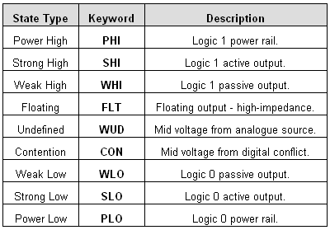

Essentially, a given state contains information about its polarity - high, low or mid-way -and its strength. Strength is a measure of the amount of current the output can source or sink and becomes relevant if two or more outputs are connected to the same net.

For example, if an open-collector output is wired through a resistor to VCC, then when the output is pulling low, both a *Weak High* and a *Strong Low* are applied to the net. The *Strong Low* wins, and the net goes low. On the other hand, if two tristate outputs both go active onto a net, and drive in opposite directions, neither output wins and the result is a *Contention* state.

This scheme permits DSIM to simulate circuits with open-collector or open-emitter outputsand pull up resistors, and also circuits in which tristate outputs oppose each other through resistors - a kind of poor man's multiplexer if you like. However, it is important to remember that DSIM is a digital simulator only and cannot model behaviour which becomes decidedly analogue. For example, connecting overly large resistors up to TTL inputs would work OK in DSIM but would fail in practice due to insufficient current being drawn from the inputs.

**The Undefined State**

Where an input to a digital model is undefined, this is propagated through the model according to what might be described as common sense rules. For example, if an AND gate has an input low, then the output will be low, but if all but one input is high, and that input is undefined then the output will be undefined.

• Edge triggered devices require a transition from a positively defined logic 0 to logic 1 (or vice versa) for an edge to be detected. Transitions from 0 or 1to undefined and back are not counted as edges.

• The more complex sequential logic devices (counters, latches etc.) will often undefined inputs to a logic 0 or logic 1, according to the coding of their internal logic. This is not unlike real life!

**Floating Input Behaviour**

It is common, if not altogether sound practice to rely on the fact that unconnected TTL inputs behave as though connected to a logic 1. This situation can arise both as result of omitted wiring, and also if an input is connected to an inactive tristate output. DSIM has to do *something* in these situations since the internal models assume true logical behaviour with inputs expected to be either high or low.

This is catered for through the **FLOAT** property. This may be assigned either directly to a component, or an an *Interface Model.* In particular, the interface model for TTL parts has the assignment:

FLOAT=HIGH

which causes floating inputs to be interpreted as logic 1 levels.

To specify that floating inputs be taken as logic 0, use

FLOAT=LOW

Otherwise, floating inputs will be taken to be at the *Undefined* state. See The Undefined State for more information.

**Glitch Handling**

In designing DSIM we debated at great length how it should handle the simulation of models subjected to very short pulses. The fundamental problem is that, under these conditions, a major assumption of the DSIM paradigm - that the models behave purely digitally - starts to break down. For example, a real 7400 subjected to a 5ns input pulse will generate some sort of pulse on its output, but not one that meets the logic level specifications for TTL. Whether such an output pulse would clock a following counter is then a matter dependent on very much analogue phenomena.

The best one can do is to consider the extremes, namely:

• A 1ns input pulse will not propagate at all.

• A 20ns pulse will come through nicely.

Somewhere in between, the gate will cease to propagate pulses properly and could be said to *suppress* glitches. This gives us the concept of a *Glitch Threshold Time*, which can be an additional property of the model along with the usual **TDLH** and **TDHL**.

Another subtlety concerns whether the glitch is suppressed at the input or the output of a model. To resolve this, consider a 4-16 decoder driven from a ripple counter as shown overleaf.

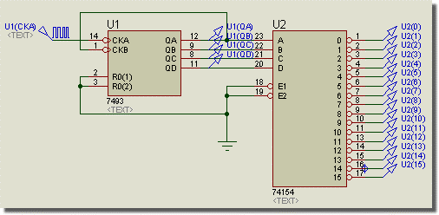

The outputs of the ripple counter are staggered, and thus the possibility arises of the decoder generating spurious pulses as the inputs pass through intermediate states. This situation is shown in the following graph:

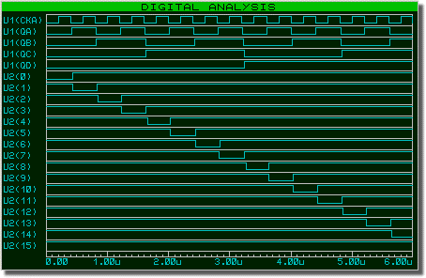

Taking the first glitch an example of the phenomenon, as U1(QA) falls for the first time, it beats the rise of U1(QB) and an intermediate input state of 0 is passed to the decoder for approximately 10ns. The question is whether the decoder can actually respond to this or not, and even more to the point, what would happen if the input stagger was only 1ns or 1ps? Clearly, in the last two cases the real device would not respond, and this tells us that we must handle glitches on the outputs rather than the inputs. This is because, in the above example, the input ***pulses*** are all relatively long and would ***not*** be considered glitches by any sensible criteria. Certain rival products make a terrible mess of this, and will predict a response even in the 1ps case!

The really interesting part of this tale is that, if you build the above circuit, it will probably not glitch. It is very bad design certainly, but the **TDLH** and **TDHL** of the '154 are around 22ns and this makes it a tall order for it to respond to a 10ns input condition. With theindividualcomponents we tried, no output pulses, other than perhaps the slightest twitches off the supply rails, were measurable.

To provide control over glitch handling, all the DSIM primitives offer user definable *Glitch Threshold Time* properties named **TG*xx***, where ***xx*** is the name of the relevant output. Our TTL models are defined such that these properties can be overridden on the TTL components, and the values are then defaulted such that the *Glitch Threshold Times* are the average of the main low-high and high-low propagation delays. Setting the *Glitch Threshold Times* to zero will allow all glitches through, should you prefer this behaviour. The graph, above, was thus created by attaching the property assignment **TGQ=0** to the 74154.

Finally, it is important to point out that if the *Glitch Threshold Time* is greater than either of the low-high or high-low propagation delays, then the *Glitch Threshold Time* will be ignored. This is because, after an input edge, and once the relevant time delay has elapsed, the gate output ***must*** change its output - it cannot look into the future and see whether another input event (that might cancel the output) is coming. Consider a symmetric gate with a propagation delay of 10ns and a *Glitch Threshold Time* of 20ns. At t=0ns the input goes high and t=15ns the input goes low. You might expect this to propagate, with the output going high at t=10ns and low again at t=25ns, so producing a pulse of width 15ns which would be suppressed, since it is less than the *Glitch Threshold Time*. The reason the pulse is notsuppressed is that, at t=10ns, the output ***must*** go high - it cannot remain low for a further 20ns on the off chance (as in our example) a second edge comes along so producing an output pulse it would need to suppress! Once the output has gone high at t=10ns then the second edge (at t=25ns) is free to reset it. You will need to think carefully about this to understand it.

**ADVANCED ICS**

**MIXED MODE INTERFACE MODELS (ITFMOD)**

**Overview**

In designing our scheme for mixed mode simulation within PROSPICE, we gave considerable thought to the problem of how to specify the analogue characteristics of a digital device family. These characteristics include:

• The input and output impedances of the devices.

• The logic thresholds of device inputs.

• The voltage levels for high and low outputs.

• The rise and fall times of device outputs.

• The default logic state for floating inputs.

A scheme which involved specifying all these parameters for every device in the TTL libraries, say, would be extremely unwieldy.

In addition, a significant problem arises (for beginners, at least) in the specification of power supplies - there is a tendency to plonk down a circuit such as the one below and expect sensible results. The problem here, of course, is an implicit assumption that the 7400 has a 5V power rail obtained from its hidden power pins which connect to VCC/GND.

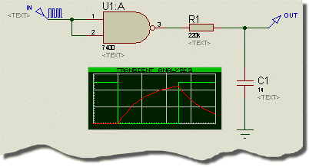

All these problems are solved by the introduction of the **ITFMOD** component property. This is very similar to the **MODEL** property in that it provides a reference to a set of property values but it also activates a special mechanism within the netlist compiler. Essentially this works as follows:

• For any device that has an **ITFMOD** property an additional model definition is called up during netlisting that will specify control parameters for ADC and DAC objects, and also the pin names of the positive and negative power supplies. In the above circuit, U1:A will have ITFMOD=TTL.

• Having obtained the names of the power supply pins (VCC, GND in this case), ISIS creates a special primitive and connects it across the power supply pins. ISIS names this object similarly to an object on the child sheet or model, so thatin the above circuit, the power supply object will be called U1:A_#P.

• When PROSPICE simulates a mixed mode circuit, it creates ADC and DAC objects and considers them to ‘belong’ to the objects to which they connect. In the case of the circuit above, a DAC object will be created with the name U1:A_DAC#0000 because it forms the interface from U1:A’s output.

The clever part is that on doing this, it also looks for a power supply interface object with the same name stem i.e. U1:A, and finds U1:A_#P. It then instructs U1:A_DAC#0000 to take its properties from U1:A_#P which in turn has inherited its properties from the model specified in the original ITFMOD assignment. Thus the DAC object operates with parameters defined for the TTL logic family.

• The power supply interface object also connects to the same voltage rails as its parent part and the digital device totem pole outputs can thus be modelled much as in real life, sinking or sourcing current from the device power supply rails.

**Using ITFMOD Properties**

Existing interface models have been defined as follows:

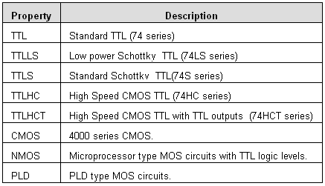

It follows that any new digital model can be assigned a device family by adding a property such as

ITFMOD=TTL

The family definitions are held in the file ITFMOD.MDF which is kept in the models directory.

Each definition can contain any or all of the properties defined for the ADC and DAC interface primitives. In addition, the following may be given:

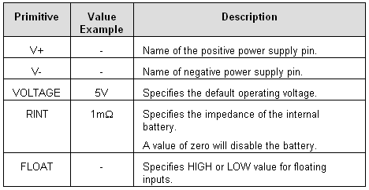

Finally, it is worth pointing out that any specific property e.g. TRISE, can be overridden on the parent device, so if you want simulate a 4000 series IC with a slow rise time, you could add TRISE=10u directly to its property list.

**ADVANCED ICS**

**PERSISTENT MODEL DATA**

Certain simulator models, particular those for EPROMS, and micro-processors containing EEPROM or flash memory are able to ‘remember’ data between simulation runs, just like their real life counterparts. This action is facilitated by the **MODDATA** property. Persistent model data blocks are stored in the DSN file, and so do not persist between PROTEUS sessions unless you save the design.

To reset the persistent model data to its initial condition, use the *Reset Persistent Model Data* command on the *Debug* menu.

**ADVANCED ICS**

**TAPES AND PARTITIONING**

**Overview**

A unique feature of the VSM system is its ability to divide a large design into one or more sections or *partitions* and simulate each individually.

There are two principal advantages associated with this:

• In a fully integrated CAD exercise, the circuit for the whole design of the product will contain some sections which you may not wish to or cannot simulate. To prevent the need for carving up the design, some mechanism is required for determining which components in the design are actually relevant to a given simulation experiment.

ISIS does this by considering the points being measured and, further back down the design, the points being driven by test sources and/or power rails.

• If the design consists of several stages, it will be a common requirement to see how later stages perform when driven by the outputs of earlier stages. Whilst this could be achieved by simulating all the stages together, this would tend to be unduly slow. Partitioning allows the results from simulating previous stages to be captured in tapes and played back as the input for subsequent stages.

ISIS contains logic to do this either under manual control or automatically. In the later case, it detects when the circuitry within given partitions has changed and re-simulates only those which have changed, or which are affected by those which have changed.

**Single Partition Operation**

Many simulation experiments will consist of testing a single section of a design in isolation from the rest. This will generally involve injecting a signal or signals at the input(s) of the section, and then monitoring its operation at points throughout it.

It should be self evident that signals can be injected by placing generator gadgets on appropriate input wires, and that circuit operation can be monitored by placing probes. However, these actions by themselves do not isolate the section under test from the rest of the design.

To do this, you need to set the *Isolate Before* checkboxes on the generators and the *Isolate After* checkboxes on the probes. Once this is done, only the section between the isolation points will be netlisted and simulated.

To work out which section to simulate, ISIS looks at the probes that have been assigned to the graph, and propagates through components and wires (including inter-terminal connections) outwards until one of the following conditions is met:

• There are no more components to process.

• An isolating probe or generator is reached.

• A tape input or output is reached.

• A power rail is reached. A net is made into a power rail by connected a POWER or GROUND terminal to it. A GND or VCC wire label will NOT do here.

**Tape Objects**

Tape objects have two distinct uses with the system:

• To define points at which it is reasonable to ignore circuitry to the right of when simulating circuitry to left. Such points are generally where low impedance outputs drive high impedance inputs. This can also be achieved by placing isolating probes.

• To provide the means to capture the output of one stage of a design, and use it to drive the next stage but without the overhead of simulating the first stage.

**To Place a Tape:**

1. Select the Tape icon.

2. Use the Rotation and Mirror icons to orient the tape according to how you want to place it. The little arrow symbol within the tape body designates the direction of the tape; in its normal orientation, the input is on the left and the output is on the right.

3. Click left in the Editing Window, once to attach a tape to the mouse, move the cursor to where you require the tape and left click again to place the tape.

4. You can place a tape directly on to an existing wire by placing it such that its connection point touches the wire. Alternatively you can place several tapes in a free area of your design, and wire to them later.

 *It is vital to place tapes only in sensible locations - that is where low impedance drives high. If you place tapes in other locations, you will change the operation of your circuit and invalidate any results that may then be produced.*

**Tape Modes**

To give the maximum degree of user control, tapes have three modes:- AUTO, PLAY and RECORD. In the following discussions, we use the terms left and right in terms of the logical dependency of the partition tree, reading the design input⇨output, left⇨right.

AUTO mode

This is the default scheme and defines a mode of operation in which ISIS decides which partitions need re-simulating, and which can use previously stored data. For most situations that require the use of tapes, AUTO mode will prove to be the most useful.

This automatic detection is based on considering all the text that occurs within the sub-netlist related to the partition. It follows that if any part names, values, properties, wiring etc. in that partition is changed, a re-simulation will be performed unless a partition file already exists for that set of information.

Note also that ALL models, scripts, design global properties and so forth are included in the sub-netlist, so changing any such object will cause a re-simulation of all automatic partitions. ISIS does not delve into the question of whether particular models, scripts etc. are used by components in a particular partition. If you need to overcome this, you can use the manual RECORD and PLAY modes.

Note that a TAPE object in auto mode will be removed from the circuit if an interactive simulation is performed.

PLAY mode

This mode enables you to play a named file that you have previously recorded, either with a tape or by adding a **RECORD** property to a probe. The filename of the data to be played should be entered into the *Filename* field of the tape; you cannot use PLAY mode unless a filename has been entered.

When a tape is in PLAY mode, the circuitry to its left is disconnected and ignored, unless it includes probes which are also included on the current graph.

Do bear in mind that you can only play data that has been recorded for the type of analysis currently being performed. Attempts to do otherwise will result in an error.

RECORD mode

This mode causes the data present at the input of the tape to be recorded into the file named into its *Filename* field; you cannot use RECORD mode unless a filename has been entered.

Another effect of record mode is to force the partition to the tape’s left to be re-simulated, irrespective of whether it has changed or not. If there is a partition to the right of the tape that is probed, then this will also be re-simulated since it will be deemed to depend on the one to its left.

The RECORD mode for tapes is probably must useful in situations in which you want to record a waveform once, and then lock it as the input for further experiments on the right hand side of the tape.

**ADVANCED ICS**

**SIMULATOR CONTROL PROPERTIES**

**Overview**

There are a large number of parameters that affect the details of how a simulation is performed. These include things such as the maximum number of iterations allowed to find the operating point, the tolerances that determine when a solution has converged, the integration method used and so forth.

These options are common to all types of analysis and can be adjusted separately for each graph by editing it and clicking the *SPICE Options* button.

**Tolerance Properties**

This group of parameters determine how accurately SPICE will compute the solution. Higher accuracy is generally achieved at the expense of longer simulation times, and in some circumstance the circuit may fail to converge at all if you ask for too high a set of tolerances.

The most useful value here is the *Truncation Error Estimation* factor, or **TRTOL** in traditional SPICE nomenclature. If you have results which appear overly spiky, or suffer from overshoots you should try a lower value here.

The minimum conductance value, **GMIN**, defines the leakage of reverse biased semiconductor junctions and other theoretical points of infinite impedance. Reducing this value may help achieve convergence for circuits which fail to simulate although this may be at the expense of simulation accuracy. See Convergence Problems for more information.

The leakage conductance, **GLEAK** is something we have introduced to enable solution of circuits with DC blocking capacitors. It defines the DC leakage of capacitors, and can generally be left alone unless you are simulating something unusual such as CMOS memory cells or the like.

**Mosfet Properties**

SPICE simulation of MOSFETs is based on the assumption that you are doing IC design, and consequently implements a scheme for scaleable geometries. In practice this means that there are a number of parameters which determine the default physical sizes for elements of the MOSFET devices. These are values are defined here.

In addition, some models have been created which rely on the behaviour of older versions of SPICE, and this MOSFET behaviour can be switched on or off here if you are using older MOSFET models.

**Iteration Properties**

The properties on the *Iteration* tab determine how SPICE deals with circuits that are hard to converge.

The integration method can be either *Gear* or *Trapezoidal.* The latter is provided mainly for backward compatibility with previous versions of SPICE since *Gear* integration generally gives more accurate results for a given number of time-steps. In *Gear* integration, high orders than 2 are possible; this involves SPICE using more of the past history of a time-point in predicting what happens at the next time-point.

When SPICE fails to get a convergent solution at the operating point, it tries two approaches: *Gmin Stepping* and *Source Stepping.* The number of steps tried in each method can be set here.

Three further options determine that maximum number of iterations that will be tried at each of the operating point, a step in a *Transfer* analysis, and a time-point in a *Transient Analysis.* Increasing these determines may help in getting a result out of a hard or near unstable circuit.

Finally, two options are given that may result in faster simulations. LTRA compaction applies only for circuits incorporating lossy transmission lines (LOSSYLINE model). The idea is that near identical values in the data pipeline get discarded so that this data points are processed. Bypassing unchanging elements is a general optimization that saves SPICE from re-computing the values of semiconductor devices whose node voltages have not changed since the last evaluation.

**Temperature Properties**

There are two global temperature properties:**TEMP** - the default operating temperature , and **TNOM** the parameter measurement temperature. **TEMP** defines the actual temperature of the circuit, whilst **TNOM** is the value at which temperature dependent device parameters are taken to have been measurement. For further discussion of temperature modelling in PROSPICE see Temperature Modelling.

**Digital Simulator Properties**

***TDSCALE, TDSEED, TDLOWER and TDUPPER***

The **TDSCALE** variable is used to control the scaling of all timing properties used by models in the simulation run that have not been explicitly referenced by the model as non-scaleable. The **TDSCALE** variable can be assigned either a constant floating-point value or the keyword **RANDOM**.

If a constant value is specified, then all timing properties specified in models used in the simulation are multiplied by the value; a value less than 1.0 reduces the timing properties whilst a value greater than 1.0 increases them. For example, the variable assignment:

TDSCALE = 1.1

has the affect of extending all timing properties used in the simulation by 10%. The default value for **TDSCALE** is the constant value 1.0; this causes all timing properties to be used unmodified.

If the **TDSCALE** variable is assigned the keyword **RANDOM**, the DSIM engine will randomly scale each timing property by multiplying it by a random floating-point time-scaling value. The range of time-scaling values chosen by the simulation engine can be limited by assigning the **TDLOWER** and **TDUPPER** variables; these define the lowest and highest random floating-point scale values allowed respectively. The default values for **TDLOWER** and **TDUPPER** are 0.9 and 1.1 respectively which has the affect of limiting random scaling to within ±10%.

The sequence of random values generated is said to be *pseudo-random* - that is, each successive value generated, whilst appearing to be random, is in fact determined by the previous value (and a complex formula). It follows that any sequence of random values is determined by a *seed* value and that for a given *seed* value the sequence of random values generated is always the same. The **TDSEED** property allows you to specify a seed value for the generation of random time-scaling values and thus guarantee that the sequence chosen from one simulation run to another is always the same. This avoids the problem of a timing design error based on random propagation delays appearing and then disappearing on successive simulation runs.

The **TDSEED** variable should only be assigned positive integer values in the range 1-32767. The default value for **TDSEED** is itself a random value (based on the date and time) and this provides a means for randomising the sequence of values generated from one simulation run to the next.

For example, the assignments:

TDSCALE = RANDOM

TDLOWER = 2.00

TDUPPER = 3.00

TDSEED= 723

have the affect of randomly increasing all timing properties by approximately 200-300% with a random sequence of scaling values. The seed value of 723 causes the same sequence of pseudo-random values to be generated for each simulation run.

***INITSEED***

The **INITSEED** property is used to seed the random initialisation value generator, used by DSIM primitive models whose initialisation properties have been assigned the **RANDOM** keyword.

As with the **TDSCALE** and **TDSEED** properties described above, whilst the sequence of values generated by the random initialisation value generator are random, the sequence as a whole is finite and determinate. The **INITSEED** property provides a means of selecting which sequence of random values is used by the DSIM simulator.

The **INITSEED** property should only be assigned positive integer value in the range 1-32767. The default value for **INITSEED** is itself a random value (based on the date and time) and this provides a means for randomising the sequence of values generated from one simulation run to the next.

**ADVANCED ICS**

**TYPES OF SIMULATOR MODEL**

**How to tell if a Component Has a Model**

PROTEUS is supplied with over 8000 library parts of which about 6000 have simulator models. The devices which do not have models are perfectly relevant for use in PCB design, and the notion that every part should have a model is quite untenable. It would imply, amongst other things, that we should create a model for the 68020 processor which is not exactly a trivial job.

So, for the purposes of circuit simulation, you need to be able to tell if a component you are using has a simulator model.In the first instance, an attempt at simulation will fail if it doesn’t, generally with a message something like:

ERROR [PSM] : No model specified for 'U1'.

The error is detected in the partitioning (PSM) phase, because up until this point, it may be that the un-modelled component is not actually in the part of the circuit being simulated.

Occasionally you will get:

ERROR [U1] : Value '74F00' of VALUE not found in parameter mapping table.

This means that there is a model file for the device, but that you have changed the value to a part type that is not modelled by the MDF file. In the above example, we have changed the valueof a 74LS00 gate (which is modelled) to a 74F00 gate, which isn’t.

The type of simulator model (if any) available for a component is displayed at theleft of the preview window in the device library browser. For example, if you open the library browser and select the 74LS00 device in the 74LS library, you will see

Schematic Model [74NAND.MDF]

Further information about the various types of models is given in the following sections

**Primitive Models**

A significant number of basic component types are built directly into PROSPICE. These device types are called *Primitives* and include resistors, capacitors, diodes, transistors, gates, counters, latches, memories and many more.

Primitive models require no extra files to be simulated, and are indentified by the presence of a single PRIMITIVE property. Additional properties are specified directly within the component and are passed to PROSPICE via the netlist. For example, a resistor will have:

PRIMITIVE=ANALOG,RESISTOR

This identifies the part as a SPICE Resistor primitive.

The standard set of simulator primitives may be found in the ASIMMDLS and DSIMMDLS libraries. These parts provide context sensitive help for their properties, and examples of their use may be found in the VSM SDK Documentation.

**Schematic Models**

Where a more complex device is to be simulated, a common approach is to draw a circuit that mimics its action using simulator primitives. This circuit can be the actual internal electronics of the device, but more commonly will utilize ideal current sources, voltage sources and switches to speed things along.

A schematic model is specified with the **MODFILE** property, which by convention we make a read only property. For example, the 741 op-amp has the assignment:

MODFILE=OA_BIP

You will note from this, that the model file is able to model several devices - a feat which it achieves using a *Parameter Mapping Table.*

Schematic models are created by drawing a schematic in ISIS, and then compiling it with the *Model Compiler* to produce an MDF file. Further details of this process are provided in the VSM SDK documentation.

**VSM Models**

VSM models are really primitive models which are implemented in external DLLs as opposed to inside PROSPICE itself. They provide the means to simulate device functionality using the programming language of your choice, although it is generally easiest to use C++.

A VSM model will have both a PRIMITIVE property (because both ISIS and PROSPICE treat it as a primitive) and a MODDLL property which specifies the name of the DLL file in which the model’s code resides.

For example, the 8052 model has

PRIMITIVE=DIGITAL,8052

MODDLL=MCS8051

Note that a model DLL can implement more than one primitive type - MCS8051.DLL implements a number of 8051 variants.

VSM models can also implement functionality that relates to animation, such that the electrical and graphical aspects of a component’s operation can be combined in fairly astounding ways. The LCD display model is a good example of this.

Creating VSM models revolves around a number of C++ Interface classes (similar to COM). These are documented in the VSM SDK manual.

**SPICE Models**

Since PROSPICE is based on Berkeley SPICE3F5 it is directly compatible with standard SPICE models, and many of the components in the PROTEUS libraries are modelled using SPICE files obtained from component manufacturers. SPICE models can be specified either by SUBCKT blocks or by sets of parameters in a MODEL record.SUBCKT models will have the property assignments such as

PRIMITIVE=ANALOG,SUBCKT

SPICEMODEL=CA3140

whereas SPICE primitive model for a transistor might have the properties:

PRIMITIVE=ANALOG,NPN

SPICEMODEL=BC108

The model itself can be stored either in an ASCII file, or in a SPICE Model Library. The name of these files is specified by a either **SPICEFILE** or **SPICELIB** property.

Extensive detail on how to make use of manufacturers SPICE models is given in the chapter entitled USING SPICE MODELS.

**ADVANCED ICS**

**HOW TO MAKE INTERACTIVE SIMULATIONS RUN FASTER**

**Introduction**

Although Proteus VSM is able to run many interactive simulations in real time, it should be fairly obvious that this cannot be the case for all circuits. For example, it is perfectly possible to draw a circuit that will oscillate at 1GHz, but there is no way that this can be simulated in real time on a computer that may not even execute one machine instruction in 1ns.In this section, we will explain in a little more detail what determines the complexity of a simulation and how you can optimize a circuit to maximize the simulation speed.

**Using Digital Resistor and Diode Models**

First and foremost in this context, it is vital to understand the difference between analogue and digital simulation within ProSPICE. This is because the simulation of digital circuitry is two or three orders of magnitude (i.e. up to 1000 times) faster than the simulation of analogue circuitry. It is for this reason that ProSPICE contains a digital simulator at all - that by representing the operation of digital components as an event driven process, a great deal of unnecessary computation can be avoided.

For example, whilst a PC with 600MHz P3 processor can simulate around 2 million digital events per second, the same computer will only be able to simulate a sine wave generator running up to about 2kHz before the CPU load reaches 100%.Such a waveform will require about 60,000 analogue timepoints to be computed per second, and each timepoint will require a convergent solution of the circuit nodal equations to be established - a process vastly more complex than processing a simple digital event.

For many components, it should be fairly intuitive as to whether analogue or digital simulation will be required. For example, nearly all TTL and CMOS parts are represented by digital models, whereas analogue ICs such as op-amps, comparators and so forth are represented by analogue models. All components which are represented by standard SPICE models require analogue simulation.

However, a grey area arises for components which - though strictly analogue in nature - can be represented by a digital model for some purposes. In particular, diodes - and perhaps more surprisingly - resistors fall into this category. This becomes highly relevant in the context of wire-or logic, pull-up resistors,devices with open-collector outputs, and in diode-resistor logic networks.

***Example 1 - Wire-Or Logic***

The following circuit section shows a typical wire-or logic network:

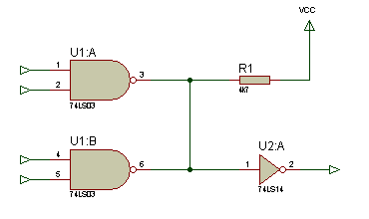

U1:A and U1:B have open-collector outputs and can only sink current. A logic 1 output level results in a high impedance condition. In terms of DSIM, this means that the gate outputs drive either an **SLO** (strong low) or a **FLT** (floating) logic state. Now if resistor R1 is modelled in the analogue domain, PROSPICE must insert a digital to analogue interface object between the logic gates and the resistor, and then an analogue to digital interface object between the resistor and the input to U2:A. This will result in wonderfully detailed simulation of the rise-fall waveforms at this node, and the current flow through R1, but will also result in a great deal of computation every time the output of U1:A or U1:B changes state.

All this can be avoided if R1 is modelled digitally. In this case, its behaviour is to convert the **SHI** logic state of VCC to a **WHI** (weak high) logic level. When either NAND gate pulls low, the **SLO** state overrides the **WHI** state from the resistor and the net state is resolved to be logic low. But when neither gate sinks current, the **WHI** state beats the **FLT** state and the net rises to logic high. All this can be managed within the digital simulation paradigm and no analogue simulation is required.

*Therefore, pull up resistors of any kind should almost always be modelled digitally.*

***Example 2 - Diode-Resistor Logic***

Another case where seemingly analogue circuitry can be modelled in the digital domain is diode-resistor networks of the sort shown below. These are often found around keypad scanning circuitry where the diodes serve to prevent short circuits between the row driving lines if more than more than one key is depressed simultaneously.

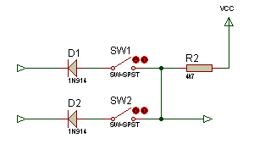

As with the wire-or logic example, ProSPICE will quite happily model this in the analogue domain but it will be computationally expensive. If a digital resistor model is used as above, and a diode is seen as a device which will pass only low logic level from cathode to anode and only a high logic level from anode to cathode, then the whole network can once again be modelled digitally.

Since keypad scanning routines tend to operate at some speed, and there are often numerous diodes and resistors, this is a very important optimization to be aware of.

**How to Select the Digital Resistor Model**

**1.** Point at the resistor you wish to change and press CTRL-E.

**2.** Click the *Edit All Properties as Text* checkbox.

**3.** Change the **PRIMITIVE** property to read

PRIMITIVE=DIGITAL,RESISTOR

If you are building a circuit from scratch, and know that you will want a particular resistor to be modelled digitally, you can also achieve this by picking the PULLUP or PULLDOWN models from the component library. This devices already contains the **PRIMITIVE** property as above.

**How to Select the Digital Diode Model**

**1.** Point at the diode you wish to change and press CTRL-E.

**2.** Click the *Edit All Properties as Text* checkbox.

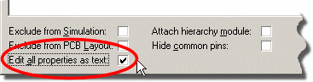

**3.** Change the **PRIMITIVE** property to read

PRIMITIVE=DIGITAL,DIODE

**4.** Delete any **MODEL** property, as SPICE parameters have no meaning for the digital diode model.

If you are building a circuit from scratch, and know that you will want a particular diode to be modelled digitally, you can also achieve this by picking the DIODE-DIGITAL devicethe component library. This device already contains the **PRIMITIVE** property as above.

**Optimizing Memory Accesses to External RAM and ROM**

Many larger microprocessor designs make use of ROM, RAM or EEPROM memory devices external to the microcontroller itself. These may store the program code,or be used to supplement internal SRAM present within the CPU chip itself. Given a correct address decoding circuit, and assuming that the memory device is modelled, Proteus VSM will correctly simulate such designs as drawn. When the CPU accesses external memory, the model will drive the address, data and control lines appropriately, and external decode logic and memory model will respond by reading or writing the appropriate locations.

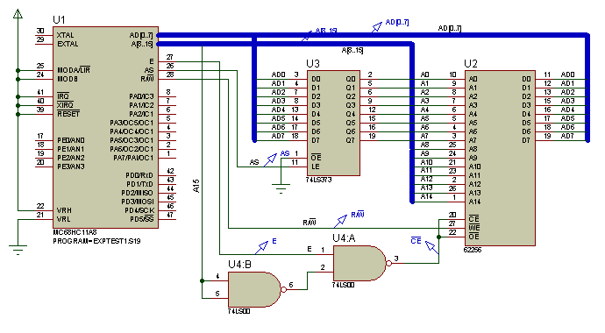

This is quite useful if you wish to verify that your memory decoding circuitry works as designed, but is also extremely expensive in terms of computation. Setting up a 16 bit address will create a minimum of 16 digital events and reading or writing a byte of data to/from data bus will generate another 8. Removing the data from the bus afterwards will create another 8 events. Where address and data lines are multiplexed, as in the above HC11 design, even more events will be generated. All this compares very unfavourably with the ability of a VSM CPU model to execute an instruction using just one event per machine cycle.

Therefore, we have provided the CPU models with the ability to simulate accesses to external memory internally to the model. At the time of writing this applies to the 8051, HC11 and the larger AVR CPU models. External memory may be declared using **EXTRAM**, or **EXTROM** properties which specify the memory range for each block of external memory. Full details are provided in the model specific help for these processors, which you can access from the *Edit Component* dialogue form, or from the *Start Menu*.

Once the external memory map has been defined in this way, instructions which access external memory within the specified ranges can be simulated without generating large numbers of digital events. Accesses to memory mapped peripherals can still be fully simulated, since these will lie at locations outside the memory ranges specified in the **EXTRAM** and **EXTROM** properties.

**TROUBLESHOOTING**

**The Simulation Log**

Whenever a simulation is performed a *Simulation Log* file is created. The simulation log file contains all information, warning and error messages from both the simulator itself and from individual models. Where a message originates from a model, it is prefixed with the models component reference in square brackets, so you might see:

[U1] Loaded 26 files from PROGRAM.HEX

During an interactive simulation*¸* the contents of this file can be displayed in a popup window from the *Debug* menu whilst for a graph based simulation,the file can be viewed by pointing at the graph and pressing CTRL+V.

In the case where the simulation fails completely, the log file will be displayed automatically in order than you can see the cause of the problem immediately.

**Netlisting Errors**

Netlisting errors occur as a result of a problem when ISIS tries to create a netlist from the schematic - you will also encounter these if you try to export the schematic to ARES for PCB layout. Common ones are:

• Having two components with the same name, or unnamed components e.g. two resistors labelled R?

• Badly formed script files such as **MAP ON** tables etc. Refer to the syntax definitions in the ISIS manual if you are can’t spot the problem immediately.

**Linking Errors**

Model linking is the process whereby ISIS calls up MDF files for components which are modelled by equivalent circuits. By far the most common problem is where the specified model file does not exist. The model file must be in the current directory, or in the *Module Path* as set on the *Set Paths* dialogue form.

Other common linker errors include:

• Value not found in parameter mapping table. This means that the part type - e.g. CA3140 is not listed in the mapping table of the specified model file. Model files such as OA_MOS.MDF are design to model several different components using the same circuit but with different values. This error means that the model file specified does not have parameters for the device type you are using - you can edit the MDF file with a text editor to see which devices are modelled.

• Unresolved module pin. This is a warning rather than an error, and means that the parent component body has a pin which is not present in the model. This is often OK - for example, most op-amp models do not model the offset null pins, but it can be a mistake, and if a new model doesn’t work this is a common cause - especially if there are also ‘No DC path to Ground’ warnings.

**Partitioning Errors**

Partitioning is the mechanism by which ISIS decides which part(s) of the circuit need to be simulated. Problems that can occur here are:

• Cyclic dependencies detected. This means that an arrangement of tapes is such that the partitions behind and in front of a tape are mutually dependent. Assuming that you have correctly set any *Isolate Before* and *Isolate After* flags on probes and generators your simplest action here will probably be to delete the tape object(s) and simulate the whole circuit in one go.

• No model specified - this means that the component indicated does not have a PRIMITIVE, MODFILE property, and has appeared in that part of the circuit which needs to be simulated. If the device is irrelevant (e.g. a connector) then you must specify PRIMTIVE=NULL, otherwise you need a model!

 See TYPES OF SIMULATOR MODEL for more information about simulator model types.

**Power Rail Configuration Errors**

All power nets in the design must be bound to a power supply either on the schematic or via the *Power Rail Configuration* dialogue form. If one or more power nets is unbound, and appropriate error will be reported in the simulation log.

Note that a net is defined as power net in the following circumstances:

• Any net that is wired to a power terminal is deemed to be a power net.

• Any device with hidden power pins will create power nets with the same names as the pins. For example, a 74LS00 will create power nets VCC and GND.

Note also that connecting a battery or SPICE voltage source to a power net is not sufficient to prevent this error - you must define a power supply and bind the net to it in the *Power Rail Configuration* dialogue form

**Simulation Errors**

Simulation errors are generated by PROSPICE rather than ISIS, and therefore occur after a netlist file has been successfully generated. Common problems that get detected here include:

• **Device type not recognized** - This means you have specified a primitive type that is not supported, or that a model file has used one.

• **No DC path to ground -** This is discussed further under GROUND AND POWER RAILS.

• **Could not find probe -** you have tried to reference a probe or voltage generator that does not exist. Remember that you *must* use an IPROBE object from ASIMMDLS.LIB - you cannot reference a current probe gadget.

• **Cannot open SPICE source file -** The source file specified in a **SPICEMODEL** property cannot be located. It should be in the current directory or in the *Module Path* as set on the Set Paths dialogue form.

• **Cannot find library model -** The SUBCKT or MODEL you have specified does not exist in the specified library or on disk.

• **Model DLL not found -** The specified VSM model DLL cannot be located. It should be in the current directory or in the *Module Path* as set on the *Set Paths* dialogue form.

**Convergence Problems**

This final set of errors relate to what happens if SPICE itself fails to simulate the circuit. There are basically three error messages that indicate this:

• **Singular matrix**. This is akin to having more unknowns than equations and usually relates to circuits which are mis-drawn, or in which some initial conditions need to be given in order to define the starting state.

 This error will often be preceded by "No DC path to ground" warnings, and you need to investigate the wiring around the pins listed after this message. If part of your circuit is not ground, the simulator can resolve its voltage relative to ground - it’s as simple as that.

• **To many iterations without convergence**. This means that circuit solution is unstable. Circuits with VSWITCH or CSWITCH primitives can create this condition easily, but any circuit whose transfer function is discontinuous can give SPICE serious problems.

• **Timestep too small**. This means that the circuit has switched in such a way that advancing the time even by very small amounts (typically 1E-18s) still does not produce an acceptably small change in circuit voltages.

Often, this is caused by a badly designed model, or bynot supplying sufficient parameters to a diode or transistor model. In a particular, if the junction capacitance values are not chosen correctly, these devices will exhibit zero switching times which can lead directly to this error message.

Most convergence errors are due to badly drawn circuits or incorrect models - time after time we have had circuits sent in that ‘won’t simulate’ only to find that something isn’t connected. Please check the simulation log for clues, and re-check your circuit before jumping to the conclusion that PROSPICE is at fault.

 *Where 3rd party SPICE or VSM models have been used, we cannot spend time debugging them unless you can supply a simple circuit demonstrating the problem.*

Beware also of using 3rd party SPICE models which use features not supported in standard SPICE 2 or SPICE 3. Models developed for PSPICE™ can include all manner of elements and syntax constructs that are not standard SPICE.

Oscillators cause special problems because the initial solution for the operating point will fail. After all, an oscillator has no steady state! Use **IC** , **NS** or **OFF** properties to define a starting state as discussed under INITIAL CONDITIONS.

If the problem really is numerical convergence, you can try the following tactics:

• Increase the value of **GMIN**. This is a leakage resistance for reverse biased semiconductor junctions, and lower values make the circuit look more and more like a network of resistors (which will always solve). But this is at the expense of accuracy. The default is 1E-12; values above 1E-9 will give fairly meaningless results.Note in any case, that SPICE3F5 will try what is called *GMIN stepping* if at first the circuit will not converge. This means that a large GMIN is used to find an initial solution, and the value is then ramped back to its original value in order to maintain accuracy.

• Increase the value of ABSTOL and/or RELTOL. These values control the accuracy that is required for the simulation to be deemed to have converged. However, the larger you make these tolerances, the less accurate the results will actually be.

• If the circuit uses op-amps, try specifying MODFILE=OA_IDEAL instead of a specific device type - this model is much easier to simulate.

• Lower the value of **TRTOL**. This will make SPICE use smaller timesteps so it will be less likely to ‘lose’ a convergent solution, but at the expense of longer run times. This will only work if the simulation has failed part way through a transient analysis.

• You should also try reducing **TRTOL** if plotted traces look ‘spiky’, or contain mathematical noise. This often manifests itself as oscillation of a value after a rapid level transition.

**AC Sweep Graph**

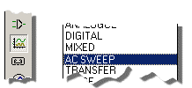

**Add / Remove Source Code**

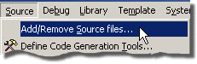

**Add a Trace**

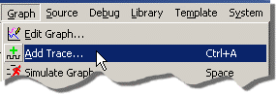

**Audio Graph**

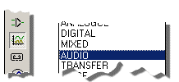

**Build All**

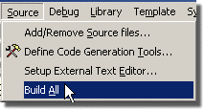

**Conformance Analysis**

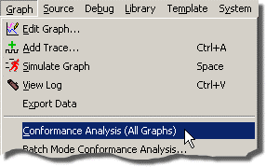

**Current Probe**



**Define Code Generation Tools**

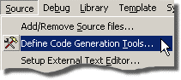

**Generators**



**A List of Generators**

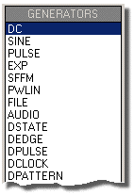

**Configuring Power Rails**

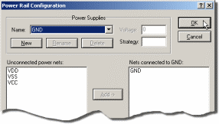

**Set Paths**

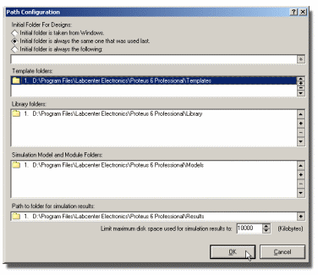

**Simulate Graph**

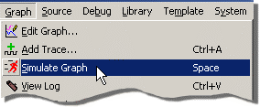

**Virtual Instruments**

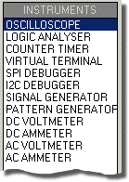

**Voltage Probe**



**Set Paths Command**

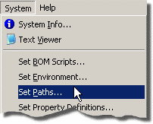

**Reset Persistent Model Data**

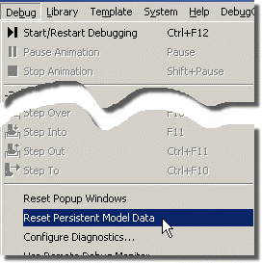

**Graph Colours**

